|  |  |
| --- | --- |
|  | **NEOSTEL** |

|  |  |  |  |  |  |  |  |  |  |  |
| --- | --- | --- | --- | --- | --- | --- | --- | --- | --- | --- |
| Tipo Doc.:  *Doc.Type:* | Detailed Design Document | | | | | N° DRD:  *DRD N°:* |  | | | |
| N° Doc.:  *Doc. N°:* | **NEOSTEL-DD-CGS-005** | Ediz.:  *Issue:* |  | Data:  *Date:* |  | | Pagina  *Page* | **1** | Di  *Of* |  |
|  | | | | | | | | | | |
| Titolo :  *Title :* | **- Draft** | | | | | | | | | |

|  |  |  |  |  |  |  |  |  |
| --- | --- | --- | --- | --- | --- | --- | --- | --- |
|  | Nome & Funzione  *Name & Function* | Firma  *Signature* | Data  *Date* |  | LISTA DI DISTRIBUZIONE  *DISTRIBUTION LIST* | N | A | I |
| Preparato da:  *Prepared by:* | Konrad Zgaga (Creotech)  Paweł Zienkiewicz (Creotech)  Marek Burza (Creotech)  Piotr Zdunek (Creotech)  Mikolaj Jamrozy (Creotech) |  | 09/03/2015 | Interna / *Internal* |  |  |  |
|  |  |  |  |
| Approvato da:  *Approved by:* | Jacek Kosiec (Creotech)  Grzegorz Kasprowicz (Creotech)  Lorenzo Cibin  Massimo Vitta  Cristiano Cinquepalmi |  |  |
| Applicazione autorizzata da:  *Application authorized by:* | Lorenzo Cibin |  |  | Esterna / *External* |  |  |  |
|  |  |  |  |
| Customer / Higher Level Contractor | | | |
| Accettato da:  *Accepted by:* |  |  |  |
| Approvato da:  *Approved by:* |  |  |  |
| N=Numero di copie A=Applicazione I=Informazione  *N=Number of copy A=Application I=Information* | | | |

|  |  |  |  |  |
| --- | --- | --- | --- | --- |
| Gestione documenti:  *Data Management:* |  |  |  |  |
| Firma / *Signature* Data / *Date* |  | File: | .doc |

| **REGISTRAZIONE DELLE MODIFICHE / *CHANGE RECORD*** | | | |
| --- | --- | --- | --- |
| EDIZIONE  *ISSUE* | DATA  *DATE* | AUTORIZZAZIONE  *CHANGE AUTHORITY* | OGGETTO DELLA MODIFICA E SEZIONI AFFETTE  *REASON FOR CHANGE AND AFFECTED SECTIONS* |
| 1 |  |  | First Issue |
|  |  |  |  |
|  |  |  |  |

| **LISTA DELLE PAGINE VALIDE / *LIST OF VALID PAGES*** | | | | | | | | | |
| --- | --- | --- | --- | --- | --- | --- | --- | --- | --- |
| PAGINA  *PAGE* | EDIZIONE  *ISSUE* | PAGINA  *PAGE* | EDIZIONE  *ISSUE* | PAGINA  *PAGE* | EDIZIONE  *ISSUE* | PAGINA  *PAGE* | EDIZIONE  *ISSUE* | PAGINA  *PAGE* | EDIZIONE  *ISSUE* |
| 1 - | 1 |  |  |  |  |  |  |  |  |
|  |  |  |  |  |  |  |  |  |  |
|  |  |  |  |  |  |  |  |  |  |
|  |  |  |  |  |  |  |  |  |  |

**TABLE OF CONTENTS**

1. INTRODUCTION 8

1.1 DOCUMENT SCOPE AND ORGANIZATION 8

1.2 ACRONYMS 10

1.3 APPLICABLE DOCUMENTS 12

1.4 REFERENCE DOCUMENTS 12

2. NEOSTEL PROGRAMME 13

2.1 NEOSTEL SCIENTIFIC REQUIREMENTS 13

3. CAMERA PRINCIPALS 14

4. CAMERA GENERAL DESCRIPTION 16

4.1 Main camera blocks and their functions 16

4.1.1 MECHANICAL CASE 18

4.1.2 COOLING SYSTEM INCLUDING COOLING RACK 18

4.1.3 SHUTTER MODULE 18

4.1.4 BI CCD AND ANALOG FRONT END (AFE) 19

4.1.5 SENSOR CONTROLLER, TRIGGERING AND COMMUNICATION INTERFACE 19

4.1.6 CAMERA HOUSEKEEPING AND CONTROL WORKSTATION 20

5. CAMERA DETAILED DESCRIPTION 21

5.1 MECHANICAL DESIGN 23

5.1.1 HARDWARE INTERFACE OF THE NEOSTEL CAMERA (IFC) 23

5.1.2 CCD MECHANICAL MOUNTING AND ALIGNMENT ASPECTS 31

5.1.3 NOBLE GAS THERMAL INSULATION CIRCUIT 34

5.1.3.1 COOLING SYSTEM, EXTERNAL COOLING AND FLUIDIC SYSTEM DESIGN 37

5.1.3.2 CAMERA COOLING 38

5.1.3.3 TEC COOLER 41

5.1.3.4 CAMERA COOLING ARCHITECTURE: PELTIER MODELS AND DRIVING CIRCUITS 45

5.1.3.5 CHILLER 46

5.1.3.6 FLUIDIC SYSTEM ANALYSIS 47

5.1.4 SHUTTER MECHANICAL DESIGN 48

5.2 CAMERA ELECTRONICS - ARCHITECTURAL OVERVIEW AND SUBSYSTEM DECOMPOSITION 52

5.2.1 CONTROL AND COMMUNICATION BOARD 54

5.2.1.1 ZYNQ SOC 55

5.2.1.2 CLOCK GENERATORS 55

5.2.1.3 VOLATILE MEMORY 55

5.2.1.4 NON-VOLATILE MEMORY 55

5.2.1.5 SEARAY CONNECTOR 56

5.2.1.6 MINI-SAS CONNECTOR 56

5.2.1.7 USB 56

5.2.1.8 SFP+ 56

5.2.1.9 RS485 AND OPTO-INTERFACE 56

5.2.1.10 POWER SUPPLY 57

5.2.1.11 LAN INTERFACE AND DATA LINK TRANSFER ASPECTS 58

5.2.1.12 TIME AND SYNCHRONIZATION INTERFACE (NTP,PTP ETC) 59

5.2.1.13 TRIGGER 61

5.2.2 MAINBOARD 62

5.2.2.1 CCD AND CCD DRIVING SIGNAL 64

5.2.2.2 SENSORS AND MONITORING HARDWARE 66

5.2.3 ANALOG FRONT END 66

5.2.3.1 NOISE MITIGATION 69

5.2.3.2 OVERSAMPLING 69

5.2.3.3 ANALOGUE SIGNAL PATH NOISE 70

5.2.4 SHUTTER ELECTRICAL DESIGN 72

5.2.4.1 SHUTTER POSITION SENSOR 73

5.2.4.2 SHUTTER DRIVER 73

5.3 FIRMWARE (ARM SOFTWARE + FPGA DESIGN) 75

5.3.1 SOFTWARE 75

5.3.1.1 OPERATING SYSTEM ARCHITECTURE 75

5.3.1.2 RTOS 76

5.3.1.3 LINUX OS 76

5.3.1.4 EPICS SERVER 77

5.3.1.5 FITS FORMAT 77

5.3.1.6 BOOT SEQUENCE 78

5.3.1.7 LINUX START 80

5.3.1.8 NORMAL SYSTEM OPERATION 81

5.3.1.9 CAMERA PROCESS 82

5.3.1.10 TASKS ON FREERTOS 86

5.3.1.11 SOFTWARE 87

5.3.1.12 CODING STANDARDS AND TESTING 87

5.3.1.13 MONITORING AND CONTROL SW INTERFACE AND EPICS COMPATIBILITY 87

5.3.2 DIGITAL SYSTEM DESIGN 88

5.3.2.1 CCD IP CORE 88

5.3.2.1.1 ADC READOUT 88

5.3.2.1.2 ADC DATA POST-PROCESSING 89

5.4 OTHER PROJECT ASPECTS 91

5.4.1 OVERALL BUDGET ANALYSIS (POWER, THERMAL, MECHANICAL, VIBRATION) 91

5.4.2 RELIABILITY, AVAILABILITY, MAINTAINABILITY, MTBF  ANALYSIS 92

5.4.3 CE MARK ASPECTS 92

6. COMPLIANCE MATRIX 93

**LIST OF FIGURES**

[*Figure 4‑1: NEOSTEL camera general block diagram 17*](#_Toc414241759)

[*Figure 4‑2: Functional description of NEOSTEL camera 17*](#_Toc414241760)

[*Figure 5‑1: NEOSTEL camera model - isometric view 21*](#_Toc414241761)

[*Figure 5‑2: NEOSTEL camera model - side view 22*](#_Toc414241762)

[*Figure 5‑3: Camera dimension requirements 23*](#_Toc414241763)

[*Figure 5‑4: Camera external I/F flange 24*](#_Toc414241764)

[*Figure 5‑5: Camera shutter module dimension requirements 25*](#_Toc414241765)

[*Figure 5‑6: Camera overview 26*](#_Toc414241766)

[*Figure 5‑7: Camera Back panel 27*](#_Toc414241767)

[*Figure 5‑8: Electronic boards assembly 28*](#_Toc414241768)

[*Figure 5‑9: Camera fixing (I) 28*](#_Toc414241769)

[*Figure 5‑10: Shutter module 29*](#_Toc414241770)

[*Figure 5‑11: Tip-till adjustment 30*](#_Toc414241771)

[*Figure 5‑12: CCD assembly on the cold-finger and PCB 31*](#_Toc414241772)

[*Figure 5‑13:CCD assembly on the cold-finger and PCB 32*](#_Toc414241773)

[*Figure 5‑14: CCD assembly 33*](#_Toc414241774)

[*Figure 5‑15: CCD electrical connection 33*](#_Toc414241775)

[*Figure 5‑16: Noble gas filled CCD chamber 34*](#_Toc414241776)

[*Figure 5‑17: CCD chamber 35*](#_Toc414241777)

[*Figure 5‑18: Slots for electronic connectors filled with epoxy resin 36*](#_Toc414241778)

[*Figure 5‑19: External cooling system 37*](#_Toc414241779)

[*Figure 5‑20: TEC cooling system 38*](#_Toc414241780)

[*Figure 5‑21: TEC cooling system overview 39*](#_Toc414241781)

[*Figure 5‑22: Liquid cold plate 40*](#_Toc414241782)

[*Figure 5‑23: Thermal flow 41*](#_Toc414241783)

[*Figure 5‑24: TEC Characteristics 42*](#_Toc414241784)

[*Figure 5‑25: CCD Cooling - System Schematic View 43*](#_Toc414241785)

[*Figure 5‑26: TEC control circuit 46*](#_Toc414241786)

[*Figure 5‑27: Rack mount chiller 46*](#_Toc414241787)

[*Figure 5‑28: Chiller characteristics 47*](#_Toc414241788)

[*Figure 5‑29: Shutter overview 48*](#_Toc414241789)

[*Figure 5‑30: Shutter mechanism construction 49*](#_Toc414241790)

[*Figure 5‑31: Shutter mechanism opened and closed 50*](#_Toc414241791)

[*Figure 5‑32: Coil-magnet arrangement 50*](#_Toc414241792)

[*Figure 5‑33: Linear bearing 51*](#_Toc414241793)

[*Figure 5‑34: Capacity sensor 51*](#_Toc414241794)

[*Figure 5‑35: NEOSTEL camera block schematic 52*](#_Toc414241795)

[*Figure 5‑36: Communication board block diagram 54*](#_Toc414241796)

[*Figure 5‑37: Power supply chain of the Communication Board 57*](#_Toc414241797)

[*Figure 5‑38: View of the communication board 58*](#_Toc414241798)

[*Figure 5‑39: Data path 59*](#_Toc414241799)

[*Figure 5‑40: PTP Synchronization 60*](#_Toc414241800)

[*Figure 5‑41: Triggering Scheme 61*](#_Toc414241801)

[*Figure 5‑42: Mainboard, CCD and shutter block diagram 62*](#_Toc414241802)

[*Figure 5‑43: AFE block schematic 68*](#_Toc414241803)

[*Figure 5‑44: CCD signal oversampling (Reset pulse not shown) 69*](#_Toc414241804)

[*Figure 5‑45: Analog signal path 70*](#_Toc414241805)

[*Figure 5‑46: Filtering Results 71*](#_Toc414241806)

[*Figure 5‑47: Shutter's module block diagram 72*](#_Toc414241807)

[*Figure 5‑48: Position sensor schematic (describe how it works) 73*](#_Toc414241808)

[*Figure 5‑49: Shutter driver channel (shutter actuator) 73*](#_Toc414241809)

[*Figure 5‑50: Operating System Architecture 75*](#_Toc414241810)

[*Figure 5‑51: Boot sequence 79*](#_Toc414241811)

[*Figure 5‑52: Linux start sequence 80*](#_Toc414241812)

[*Figure 5‑53: OS processes 81*](#_Toc414241813)

[*Figure 5‑54: Camera process 82*](#_Toc414241814)

[*Figure 5‑55: CCD acquisition process 83*](#_Toc414241815)

[*Figure 5‑56: Other processes running in background 84*](#_Toc414241816)

[*Figure 5‑57: Errors handling processes 85*](#_Toc414241817)

[*Figure 5‑58: RTOS tasks 86*](#_Toc414241818)

[*Figure 5‑59: CCD and AFE control state machine 88*](#_Toc414241819)

[*Figure 5‑60: Video data path 90*](#_Toc414241820)

[*Figure 6‑1: Camera External Interface Flange 95*](#_Toc414241821)

[*Figure 6‑2: Camera ICD 96*](#_Toc414241822)

[*Figure 6‑3: Shutter Available Volume and IF Area 97*](#_Toc414241823)

[*Figure 6‑4: Shutter Available Volume 97*](#_Toc414241824)

**LIST OF TABLES**

[*Table 3‑1: Camera technical principals 14*](#_Toc414241825)

[*Table 5‑1: Thermal analysis boundary conditions 44*](#_Toc414241826)

[*Table 5‑2: Thermal analysis materials definition 44*](#_Toc414241827)

[*Table 5‑3: Thermal analysis results 45*](#_Toc414241828)

[*Table 5‑4: Fluid System Data 47*](#_Toc414241829)

[*Table 5‑5: Clock generators 55*](#_Toc414241830)

[*Table 5‑6: CCD Sensors Comparison 64*](#_Toc414241831)

[*Table 5‑7: Communication board maximum power estimation 91*](#_Toc414241832)

[*Table 6‑1: CCD and Camera General Requirements 93*](#_Toc414241833)

[*Table 6‑2: CCD and Camera Functional Requirements 94*](#_Toc414241834)

[*Table 6‑3: Camera Mechanical Requirements 94*](#_Toc414241835)

[*Table 6‑4: Camera Mass and Material Requirements 98*](#_Toc414241836)

[*Table 6‑5: CCD Design & Technical Requirements 98*](#_Toc414241837)

[*Table 6‑6: Shutter Design & Technical Requirements 100*](#_Toc414241838)

[*Table 6‑7: Camera Design Requirements 102*](#_Toc414241839)

[*Table 6‑8: Chiller Requirements 103*](#_Toc414241840)

[*Table 6‑9: Software Requirements 104*](#_Toc414241841)

[*Table 6‑10: Reliability and Maintenance Requirements 105*](#_Toc414241842)

[*Table 6‑11: Safety and Human Engineering Requirements 105*](#_Toc414241843)

# INTRODUCTION

This document is a preliminary report of camera design for NEOSTEL programme. At the beginning the description and scientific requirements of the whole programme are presented. Then camera specification is presented in relation to the whole system. Next section contains functional description of the camera and at the end a technical description of the whole camera subsystems is presented.

## DOCUMENT SCOPE AND ORGANIZATION

This document contains the detailed design for the NEOSTEL CCD Camera System. The document is divided into several sections:

* Section 1 provides an introduction to the document
* Section 2 describes the NEOSTEL programme and its requirements
* Section 3 describes camera principal parameters
* Section 4 contains general camera description
* Section 5 contains detailed description of the camera; this section is divided into four main subsections regarding: mechanical design of the camera, electronics hardware, software and general technical aspects of the project
* Section 6 contains a Compliance Matrix which relates the required parameters to the possible achievable values.

The subsections of the Section 5 are further divided as follows:

* Mechanical design
  + CCD mechanical mounting and comments on alignment aspects
  + Camera cooling system and architecture ; external cooling and fluidic system design
  + Noble gas thermal insulation circuit
  + Shutter mechanical design
* Electronics hardware
  + Architectural overview and a subsystem decomposition of the camera electronics
  + Control/communication board and the mainboard of the camera
  + CCD chip and CCD driving solution
  + Analogue Front-End electronics for ultra low-noise readout
  + Noise minimization concept
  + Lens heating driver and the shutter electrical design
  + Sensors and monitoring hardware
* Firmware
  + Software
    - Monitoring, control SW interface
    - CPU processing core description
    - LAN interface and data link transfer aspects
    - Time and synchronization interface
    - Operating system and software architecture
    - Coding standards and testing
    - Data output format EPICS compatibility
  + Digital system design
    - Description of ADC readout IP core
    - Description of shutter control IP core

## ACRONYMS

|  |  |
| --- | --- |
| **AD** | Applicable Document |
| **ADC** | Analog-to-Digital Converter |
| **ADCI** | ADC Interface |
| **AFE** | Analogue Front End |
| **AMP** | Asymmetric MultiProcessing |
| **API** | Application Programming Interface |
| **ARM** | Advanced RISC Machine |
| **AXI** | Advanced eXtensible Interface |
| **BGA** | Ball Grid Array |
| **BI** | Back Illuminated (CCD sensor) |
| **BRAM** | Block RAM |
| **BSP** | Board Support Package |
| **CAN** | Controller Area Network |
| **CCD** | Charged Coupled Device |
| **CDS** | Correlated Double Sampling |
| **CGS** | Compagnia Generale per lo Spazio (formerly Carlo Gavazzi Space) |
| **CNV** | Contingent Negative Variation |
| **CPU** | Central Processing Unit |
| **DAC** | Digital-to-Analogue Converter |
| **DC** | Direct Current |
|  |  |
|  |  |
|  |  |
|  |  |
| **DDR3** | Double Data Rate RAM, third generation |
| **DMA** | Direct Memory Access |
| **DNL** | Differential Non-Linearity |
| **DRAM** | Dynamic RAM |
| **EMI** | Electro-Magnetic Interference |
| **EPICS** | Experimental Physics and Industrial Control System |
| **FFT** | Full Frame Transfer |
| **FITS** | Flexible Image Transport System |
| **FoV** | Field of View |
| **FPGA** | Field Programmable Gate Array |
| **FSBL** | First Stage Boot Loader |
| **FSM** | Finite State Machine |
| **FY** | Fly-Eye |
| **GbE** | Gigabit Ethernet |
| **GPOS** | General Purpose Operating System |
| **HDL** | Hardware Description Language |
| **I2C** | Inter-Integrated Circuit bus |
| **INL** | Integral Non-Linearity |
| **IP** | Intellectual Property |
| **IP68** | International Protection Rating against – degree of protection provided against intrusion, dust, accidental contact, and water |
| **IPC** | Inter Processor Communication |
| **LPM** | Liter Per Minute |
| **LDO** | Low Drop Out |
| **LVDS** | Low Voltage Differential Signaling |
| **LSB** | Least Significant Bit |
| **MMU** | Memory Management Unit |
| **MLVDS** | Multipoint LVDS |
| **MOSFET** | Metal-Oxide Semiconductor Field-Effect Transistor |
| **MP** | Mega Pixel |
| **NEOSTEL** | NEO Survey Telescope |
|  |  |
| **NFS** | Network File System protocol |
| **ONFI** | Open NAND Flash Interface standard |
| **OS** | Operating System |
| **OCM** | On Chip Memory |
| **OPAMP** | Operational Amplifier |
| **PCB** | Printed Circuit Board |
| **PCS** | Physical Coding Sublayer – a networking protocol sublayer in the Fast Ethernet, gigabit Ethernet, and 10 Gigabit Ethernet standards |
| **PID** | Proportional, Integral and Derivative |
| **PL** | Programmable Logic |
| **PMA** | Physical Medium Attachment sublayer – a networking protocol sublayer in the Fast Ethernet, gigabit Ethernet, and 10 Gigabit Ethernet standards |
| **PS** | Processing System (Arm on Zynq) |
| **PTP**  **PWM** | Precision Time Protocol IEEE1588  Pulse-Width Modulator |
|  |  |
|  |  |
|  |  |
|  |  |
|  |  |
|  |  |
|  |  |
| **QSPI** | Quad SPI |
| **RAM** | Random Access Memory |
| **RTOS** | Real-time Operating System |
| **SAR** | [Successive Approximation Register](http://en.wikipedia.org/wiki/Successive_approximation_ADC) |
| **SCADA** | Supervisory Control and Data Acquisition |
| **SD** | Secure Digital memory card standard |
| **SDRAM** | Synchronous Dynamic RAM |
| **SGMII** | Serial Gigabit Media Independent Interface |
| **SFP** | Small Form-factor Pluggable |
|  |  |
| **SoC**  **SNR** | System on a Chip  System to Noise Ratio |
| **SPI** | Serial Peripheral Interface |
| **SSH** | Secure Shell |
| **TEC** | ThermoElectric Cooler |
| **TCP** | Transmission Control Protocol |
| **UART** | Universal Asynchronous Receiver/Transmitter |
| **Uboot** | DENX Universal Bootloader |
|  |  |
| **USB** | Universal Serial Bus |
|  |  |
|  |  |
|  |  |
|  |  |
|  |  |
|  |  |
|  |  |
|  |  |
|  |  |

## 

## APPLICABLE DOCUMENTS

1. Statement of Work P2-NEO-V “NEO Survey Telescope Detailed Design”, SSA-NEO-TEL-SOW-0001, Issue 1, 17/12/2013
2. Space Situational Awareness – NEO System Requirements Document, SSA-NEO-RS-RD-0001, Issue 1, Revision 4, 05/04/2013
3. CGS Proposal “NEO Survey TELescope Design NEOSTEL”, S14-003 Is.1, April 2014

## REFERENCE DOCUMENTS

1. TELAD Design Report, TELAD-RP-CGS-001, version 1, 25/10/2011

# NEOSTEL PROGRAMME

The NEOSTEL (Near Earth Object Survey TELescope) programme will lead to the detailed design of a telescope able to fulfil the specific requirements for the survey of Near Earth Objects (NEOs). In particular, NEOSTEL must provide the performances needed to guarantee NEO catalogue build-up and maintenance, accurate tracking capabilities, and so called “Wide Survey” observation strategies. Therefore the telescope design provides the necessary resolution over a very wide FoV. A suitable diameter primary mirror must be provided to allow the detection of NEO objects down to the required limiting magnitude.

For this purpose, an important concept is introduced, that greatly simplifies the overall optical design, consisting in the so-called Fly-Eye (FY) architecture. The FY design consists in splitting the overall FoV in sub-FoVs on which an array of corrector elements is placed. The corrector elements consist of small sized lenses. The Fly-Eye Telescope design is modular in nature, allowing for “serial” production.

## NEOSTEL SCIENTIFIC REQUIREMENTS

The Near Earth Object Survey Telescope (NEOSTEL) is an innovative project of the NEO-SSA Segment and will in particular focus on the Survey and Tracking of Near Earth Objects (NEOs). It will represent the core Optical Sensor of the NEO-SSA Segment Ground Based Optical Observation Network.

NEOSTEL, based on the Fly-Eye concept, will allow a Wide Survey Strategy, which consists in scanning the full visible sky at least twice per night to detect NEO objects characterized by apparent magnitudes down to 21.5. NEOSTEL shall also allow the detection of fast approaching NEO objects, moving at apparent speeds up to 1.5 arcsec/min. NEOSTEL shall also be able to perform all required Follow-up-activities, necessary for Catalogue maintenance/upgrading, Impact Monitoring, Alert and Mitigation, etc.

The operating wavelength band of NEOSTEL shall be limited to the visible (VIS) spectral range, in particular to 450-770 nm. NEOSTEL observations shall be accompanied by infrared and spectroscopic observations, performed with additional telescopes at different observational sides.

The aim of targeting objects at above mentioned magnitude while scanning the full visible sky twice per night, requires an one meter class aperture together with a very large FoV (>44 sq. deg) and exposure times in the order of 40s. [R.D. 1].

The above reported requirements are realized in the Fly-Eye architecture, resulting in fast optics (EFL = 2000mm, i.e. F/#<2) and in a seeing limited optical resolution (80% Encircled Energy enclosed in <1” radius) at 1.5" Pixel Scale .

From the opto-mechanical point of view, the above reported requirements impose a stiff structure that ensures the tolerance budget imposed by the optical design also during telescope fast repositioning in all pointing directions.

The Specifications reported in the following, are addressed to satisfy the above summarized NEO-SSA scientific targets and requirements.

# CAMERA PRINCIPALS

This section describes the NEOSTEL camera principals. Technical parameters of the camera are presented in . Fulfilling these principals is the main objective of this project.

Table 3‑1: Camera technical principals

|  |  |  |  |
| --- | --- | --- | --- |
|  | **Parameter** | **Value** | **Remarks** |
| 1 | Resolution | 4096x4096 |  |
| 2 | Pixel size | 15x15 um |  |
| 3 | Sensor architecture | Full Frame Transfer., back illuminated |  |
| 4 | Shutter life time | Mechanical, 106 cycles |  |
| 5 | Multi pinned phase | Yes, user controllable |  |
| 6 | Linearity | <1% | 100e – 95% saturation |
| 7 | Dark current | < 0.1 e-/s/pix |  |
| 8 | Fill factor | 100% |  |
| 9 | Well depth | 150-200ke- |  |
| 10 | Chamber medium | Sealed filled with noble gas |  |
| 11 | Readout noise | 10e- RMS | @2 MHz |
| 12 | Dynamic range | 20ke/e | 16 bit depth |
| 13 | Readout time | <~~2~~ 2.5 s | 4 channels |
| 14 | Cooling | Liquid, -50 °C, glycol-water |  |
| 15 | QE | >95% peak, >75% mean |  |
| 16 | Shutter time synchronisation | <100 us, PTP, NTP |  |
| 17 | External shutter input | Yes, RS485 | Controlled also internally. Consider a trigger line for the 16 channels |
| 18 | Camera operational temperature | -20 ...+30 °C |  |
| 19 | Camera diameter | <200 mm |  |
| 20 | Supply | External, DC |  |
| 21 | Communication interface | Gigabit Ethernet | SFP interface |
| 22 | OS drivers | Linux |  |
| 23 | Camera diagnostics | Temperatures (operational), TEC current, CCD voltages, exposure time, camera state (idle, readout, etc), cooling system status |  |
| 24 | Supply cable length | 25 meters |  |
| 25 | Window material | Sapphire glass (antireflection coating) | 5 mm thick, the position of the CCD surface should be set as a function of the window thickness |
| 26 | AUX accessory port  (control shutter interface) | Yes, UART, shutter power supply |  |
| 27 | Shutter non-uniformity | <0.5 ms | <5 ms for NEO |
| 28 | File format | FITS |  |

# CAMERA GENERAL DESCRIPTION

This section describes the general camera design.. Then functional aspects are presented in Section 5 which provide more detailed information on the way the camera works. Furthermore, main camera subsystems are described.

## Main camera blocks and their functions

NEOSTEL camera is a state-of-the-art astronomical camera which provides extremely low noise capabilities as well as remote control via EPICS protocol and vibration free mechanical shutter.

The camera main blocks and their functions are shown in *Figure 4-1* and 4-2. shows the general block diagram of the NEOSTEL camera. provides a functional block diagram of the NEOSTEL camera. The camera consists of:

* Camera Assembly
  + Mechanical Case
  + Cooling system including cooling rack
  + Shutter mechanism
  + BI CCD and Analog Front End (AFE)
  + Sensor controller and communication interface
* Camera Housekeeping and control workstation
  + TEC chiller
  + Set of multicore industrial grade computers, each one dedicated to one camera
  + Gigabit Ethernet Switch with PTP support

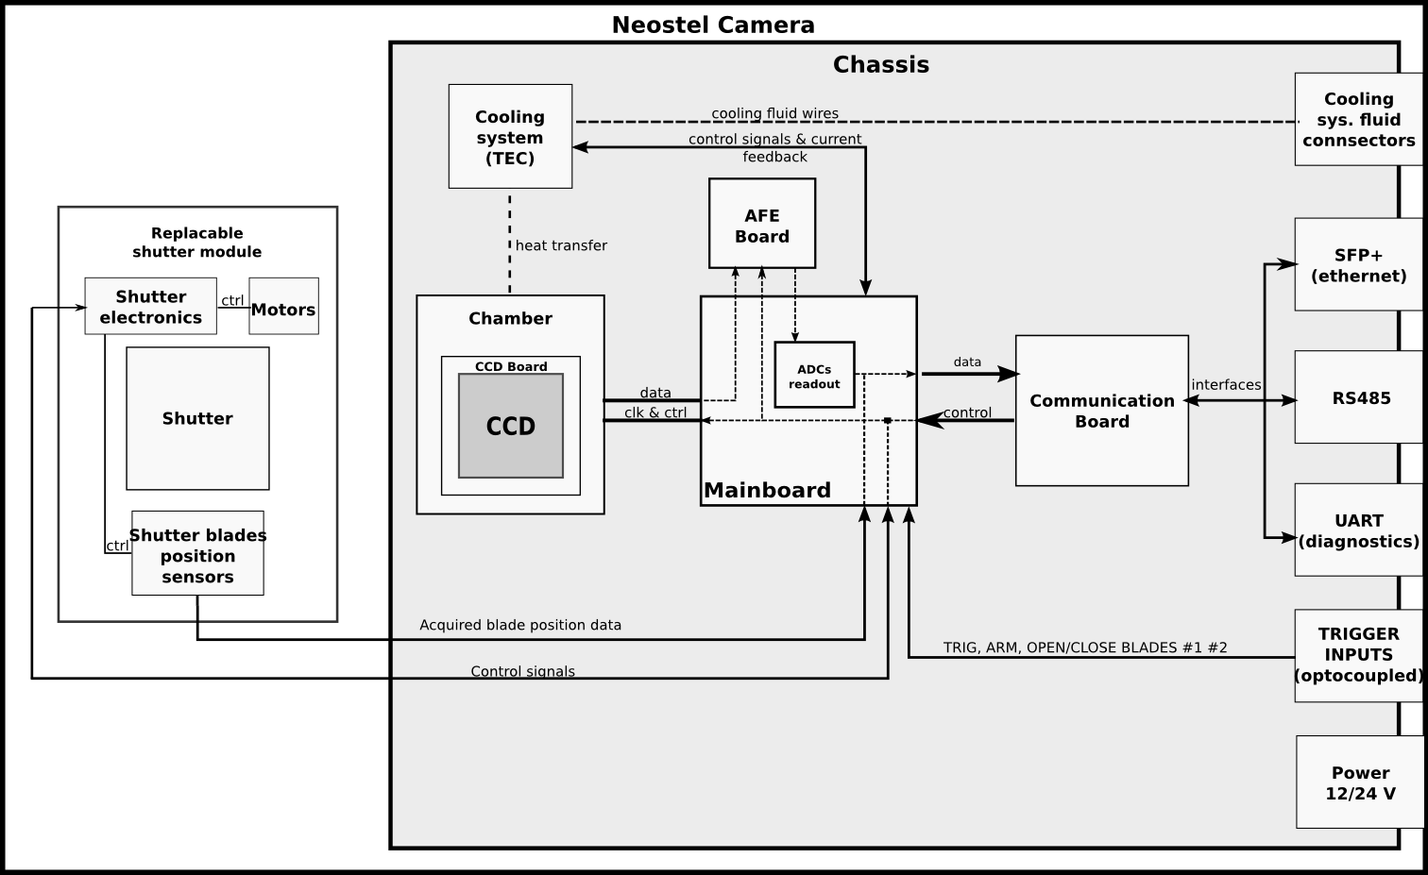

*Figure 4‑1: NEOSTEL camera general block diagram*

*Figure 4‑2: Functional description of NEOSTEL camera*

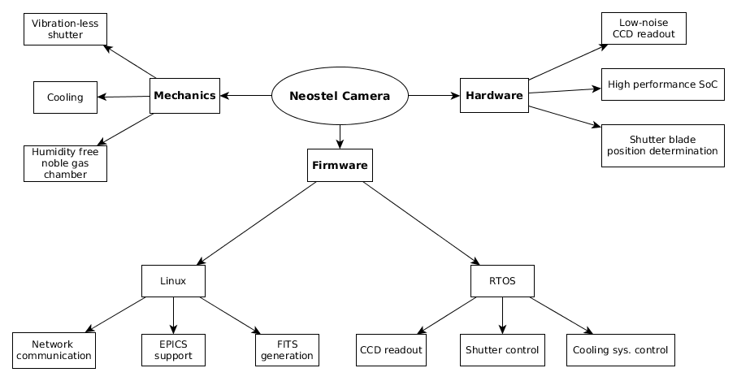

Main functional modules are Mechanics, Hardware and Firmware. Each module has its own functions. The main functions are:

* Frame capture
* Control via EPICS interface using Ethernet
* FITS format file generation
* Microsecond time stamping capability.

Apart from these functions, the camera is equipped with an efficient cooling system based on Peltier heat pump and a vibration free mechanical shutter. The camera is enclosed inside a chassis and is powered by an external power source.

### MECHANICAL CASE

The shape of the chamber is cylindrical. The external envelope of the camera interface diameter is less than 250mm. The camera has got a flange interface to the rest of assembly. Window material is a sapphire glass with broadband AR coating. Liquid cooling is used and a shutter is installed outside of the chamber. Design is compliant with the worst case environment conditions on the site where the camera will be installed.

### COOLING SYSTEM INCLUDING COOLING RACK

The CCD sensor operating temperature is -50°C. To achieve this value the sealed chamber is used. Cylindrical construction of the sensor chamber is filled with a noble gas for insulation purposes as well as to provide moisture free environment. CCD sensor liquid cooling is used (water-glycol). Multiple stage TEC modules are used for direct heat transfer from sensor to the cold plate. Problem of heating CCD sensor (chimney effect) is minimized by sensor power management that reduces dissipated power during exposure time.

The project also includes fluid control rack for camera cooling. Custom-off-the-shelf, rack mount chiller is used. The chiller is equipped with temperature and flow sensors and its operation is managed by the control computer software directly using a serial port. Moreover, independent temperature sensors are implemented in each camera on the coolant inlet and outlet. Both sensors have got hardware alarm outputs that are wired directly to the power management system of the camera to shut down the TEC supply at a given temperature.

The TEC supply is controlled locally by each camera power management block and temperature is stabilised using a PID regulator. A PT-1000 or similar temperature sensor is installed just at the CCD sensor enclosure to minimize the temperature stabilisation loop time response.

Temperature control of the sensor is important for long exposure times. The stability of the temperature is estimated to be below 0,5 degree. The CCD temperature is measured with this accuracy. Sensor temperature is logged and added to each image FITS header.

### SHUTTER MODULE

The shutter can support exposition times from 0,1 to 300 seconds with overall accuracy better of +/-0,5 ms. Shutter lifetime is at least 106 cycles. Shutter time synchronisation accuracy is better than 10us. PTP protocol will be used, UTC time for blades opening and closing is being recorded. PTP time is delivered directly to the Zing SoC and used to time-stamp the shutter operation with microsecond accuracy. Camera is equipped with an internal and external (via RS485 interface) shutter trigger.

The shutter is an independent module that can be easily disconnected mechanically and electronically from the camera. The most reliable solution for the shutter design, based on 2 linear voice-coil actuators supported by the motion controller implemented in the FPGA, is being used in our design.

It works without feedback and relies on a mathematical model derived from measured step response of the shutter mechanism. The shutter position is evaluated using two different sensors: a capacitive and a magnetic one. The information about position of the blades is fed back to the processing system and is added to FITS header. A table of 2000 (TBC) measurements for each blade (open and close cycle) shall be available and included in the optional field of the FITS header

### BI CCD AND ANALOG FRONT END (AFE)

Back Illuminated (BI), Full Frame Transfer (FFT) CCD sensor with 4K×4K active pixels is used for the NEOSTEL camera. The sensor assembly is connected with feed-through using flexible PCB. Rigid-flexible PCB technology ensures optimal weight, relevant thermal characteristics and lack of additional connectors between CCD board and flexible cables. This solution improves reliability. A readout noise of 10 electrons at 2MHz is guaranteed by low noise design, fully differential signal chain and dedicated ADC converters working in CDS mode, also with oversampling. Dynamic range of the signal is equal to 20ke-/e- with a 16bit depth, due to the fact that during long exposures brilliant stars will saturate their corresponding pixels, whereas faint objects with low SNR shall be also detected. A digital CDS based on a high speed pipelined, 16bit ADC is used to fulfil those requirements.

A pixel rate of 2MHz is a boundary where these two acquisition techniques have similar properties. Four readout channels are being used to achieve 2s readout time. An Analog Front End (AFE) will be placed on the main camera board and will be covered by additional shield and connected to the CCD sensor using a differential electrical interface to increase noise immunity.

Due to a number of interconnectivity with the FPGA, an ADC is placed on the mainboard. Within the sealed chamber, temperature and humidity sensors are installed to measure noble gas leakage.

### SENSOR CONTROLLER, TRIGGERING AND COMMUNICATION INTERFACE

The camera design uses the recent SoC from Xilinx, Zynq-7000. Apart from FPGA, it provides 2 fast ARM CPU cores. This enables a compact design, lack of communication bottlenecks and native Linux support for FPGA resources including live reconfiguration mechanisms.

Precise time synchronisation of the readout and shutter operation is ensured by the readout and shutter controllers implemented entirely in hardware, particularly to avoid incorrect operation.

A low jitter is considered as a target in order to guarantee homogeneity. In order to precisely know the position of the shutter blades during opening and closing a high precision encoder is time-stamped using PTP synchronized time reference.

In the proposed solution the shutter is triggered by the camera on the basis of its operational status (exposing, readout). Optionally, an external hardware trigger is implemented and can be used to improve synchronization accuracy. Trigger opto-isolation is provided to avoid ground loops.

Synchronization between cameras is ensured by a central trigger that will coordinate all different cameras functionalities in order to keep them in temporal coincidence.

Communication interface is provided by the SFP+ cage (Small Form-factor Pluggable Transceiver). Several types of optical or copper transceivers can be installed. Gigabit Ethernet protocols is used and media type can be changed without hardware modifications.

To enable cooperation between several cameras, Gigabit Ethernet with the TCP protocol is used. This will provide full autonomy of control and data acquisition of the camera. Since each camera has got an independent operating system, it can store directly the measurement data (FITS files) to the network storage system.

The main power supply converter will be placed up to 25 meters away from the camera . A DC supply of 24V will be used. The camera will accept DC voltage and convert it internally to several lower voltages suitable for the SoC and the CCD sensor. To conform to EMI requirements, power supply block is shielded and placed on the mainboard. The voltage and current consumption of critical supply buses as well as critical electronic component temperatures are monitored and stored in log files.

The CCD sensor supply is based on an already proven, programmable unit that enables precise control of all critical bias voltages and clock levels during the camera operation. This enables the readout noise optimisation, calibration and ageing effects elimination by running autonomous test procedures.

Software part of the design consists of several parts:

* Asymmetric Multiprocessing solution with Linux and RTOS with bootloader enabling early diagnostics
* Linux general purpose operating system providing:
  + System flexibility and ease of interfacing with remote facility subsystems
  + API implementation for camera control and diagnostic procedures
  + FITS implementation for unified data storage
  + PTP daemon for time synchronization
* RTOS providing:
  + Time and reliability critical procedures related to the hardware usage procedures
  + Interconnection to the FPGA logic procedures
* Inter Processor Communication mechanisms
* HDL code implementing:
  + CCD readout state machine
  + AFE state machine
  + Shutter controller
  + Memory controller
  + AXI internal communication bus
  + Cooling module control procedures.

### CAMERA HOUSEKEEPING AND CONTROL WORKSTATION

Dedicated rack mount 24V DC Power Supply Unit (i.e. Maximal 33RZ) is providing power for 4 CCD cameras (4 PS units per telescope). It converts 230VAC 50/60Hz input into eight (8) independently controlled 24VDC fuse protected outputs. Each camera receives two 24V DC power buses – one for TEC and another for internal power supply of the electronics Outputs are activated by an normally open (NO) or normally closed (NC) dry trigger input from the control PC.. Outputs will operate in both Fail-Safe and/or Fail-Secure modes. The control interface enables Emergency Egress, Alarm Monitoring, or may be used to trigger other auxiliary devices. The fire alarm disconnect feature is individually selectable for any or all of the outputs.

Each camera has devoted server with 64 core CPU to handle processing of the data. They are connected together using non-blocking gigabit Ethernet switch which injects PTP time.

The FITS format is very versatile since it allows storage of several non-typical parameters in its header. It is useful for monitoring purposes of the temperature and humidity inside and outside of the chamber, vibration level, critical voltages and currents, TEC current, CCD voltages, an operational status (exposure, readout, idle, failure, etc.). Liquid cooling flow is monitored with two temperature sensors at the input and output pipes of the camera.

# CAMERA DETAILED DESCRIPTION

This section provides information on technical aspects of the NEOSTEL camera design. shows the current camera model using the isometric view. shows the side view of the camera.

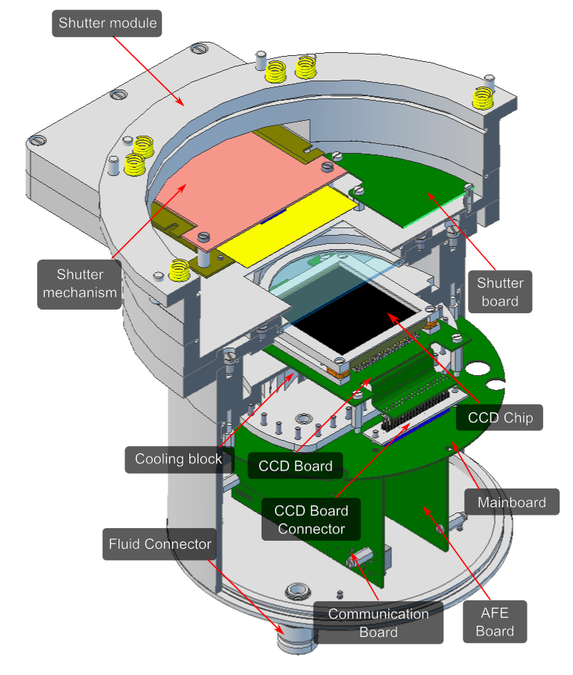

*Figure 5‑1: NEOSTEL camera model - isometric view*

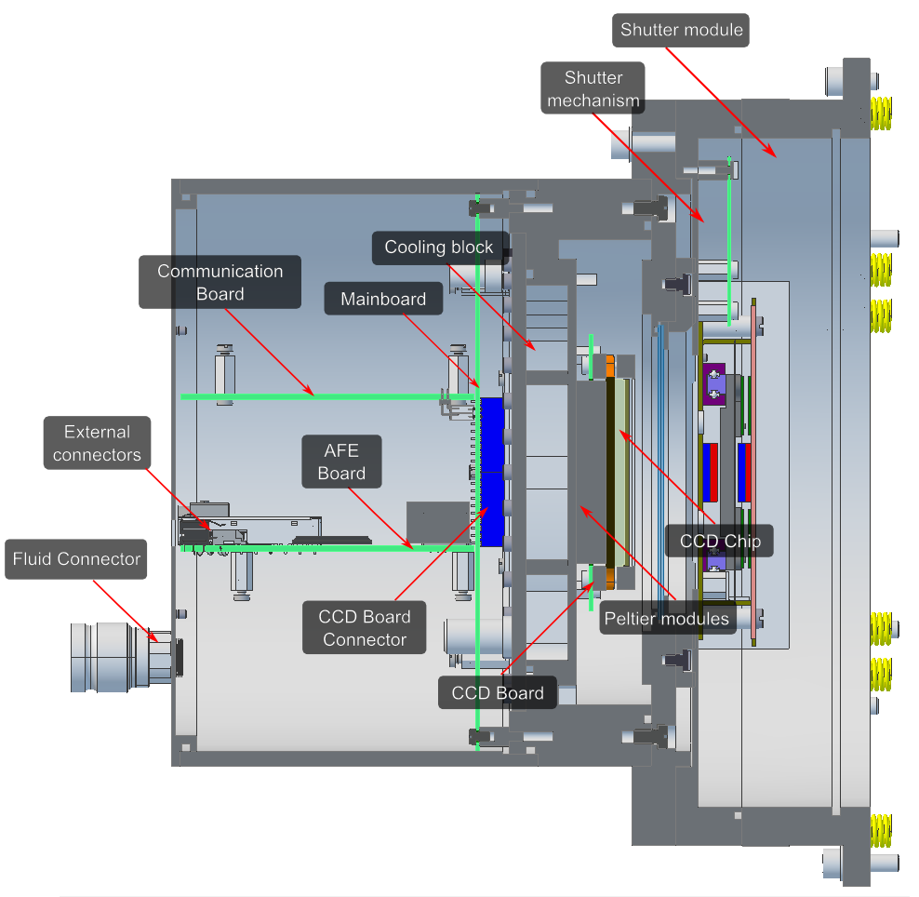

*Figure 5‑2: NEOSTEL camera model - side view*

## MECHANICAL DESIGN

This section describes mechanical aspects of the camera design.

### HARDWARE INTERFACE OF THE NEOSTEL CAMERA (IFC)

The NEOSTEL camera is designed in a modular way.

The Hardware Interface Design () satisfies the following requirements:

* The distance between the CCD and the last lens in the optical tube is fixed. For both, the camera envelope and the allocated space for the shutter, this fixed distance has been considered.

Key distance for dimensioning:

CCD Plane – Adapter Back-Plane: 77,90+/-0.05 mm

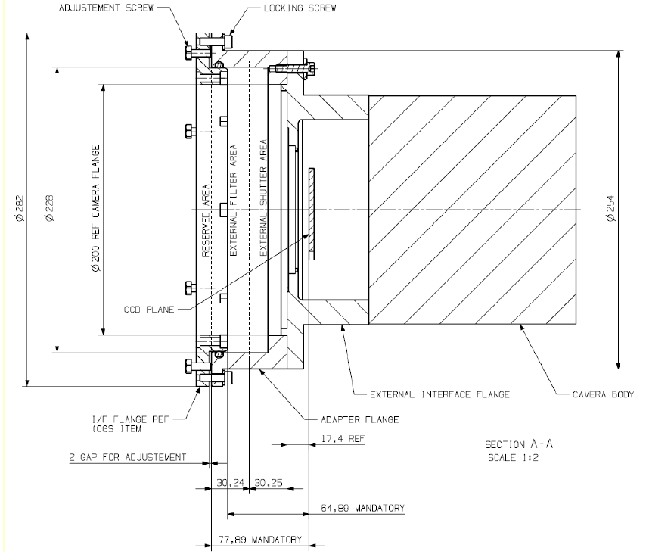

*Figure 5‑3: Camera dimension requirements*

* The shutter is an external (modular) part w.r.t. the Camera Body and rigidly connected to it.
* The shutter is fully disconnectable both mechanically and electrically from the camera without disassembling any part of the camera.
* The shutter support structure is fastened to the external plane of the Camera External I/F Flange ().

Overview of the camera is shown in .

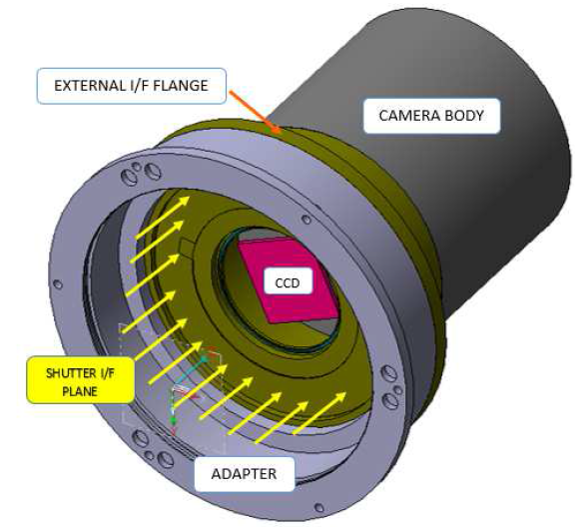

*Figure 5‑4: Camera external I/F flange*

* The available volume for the shutter is included in the adapter flange that connects the camera with the secondary structure ()
* The shutter area main dimensions: diameter: Ø 200 / 328 mm
* Height above optical axis: 30,25 mm

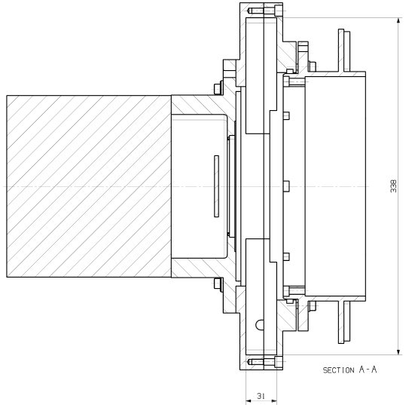

*Figure 5‑5: Camera shutter module dimension requirements*

* The external IF flange is provided with a milling pocket in order to show the CCD PIN 1 orientation.
* The external IF flange allows for the mechanical alignment provided by the System requirements.
* SYSTEM REQUIREMENT: The external mechanical adjustment capability shall be of at least +/- 0.1 mm from the nominal position with a +/-5 microns accuracy in tip-tilt adjustment and within +/ 10 microns in axis. The Camera Design is compatible with this requirement.

The main material for the enclosure consists of aluminum and sheet metal, resulting in a light weighted construction of a reasonably low cost and a high dimensional accuracy.

The whole camera is sealed at the IP68 protection rate. O-rings are used between parts to seal the camera and at the same time allow for its easy maintenance. Electronic connectors of IP68 rate and no-spill fluid connectors are used to ensure safety and proper sealing.

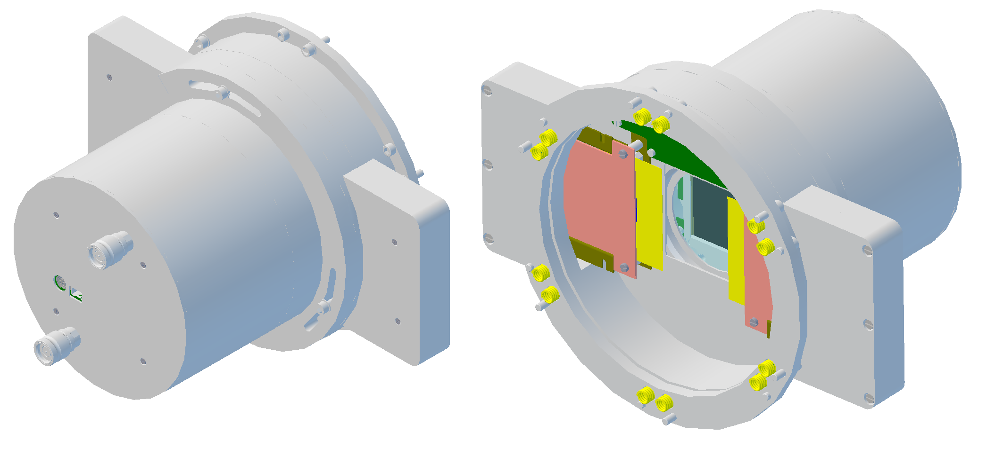

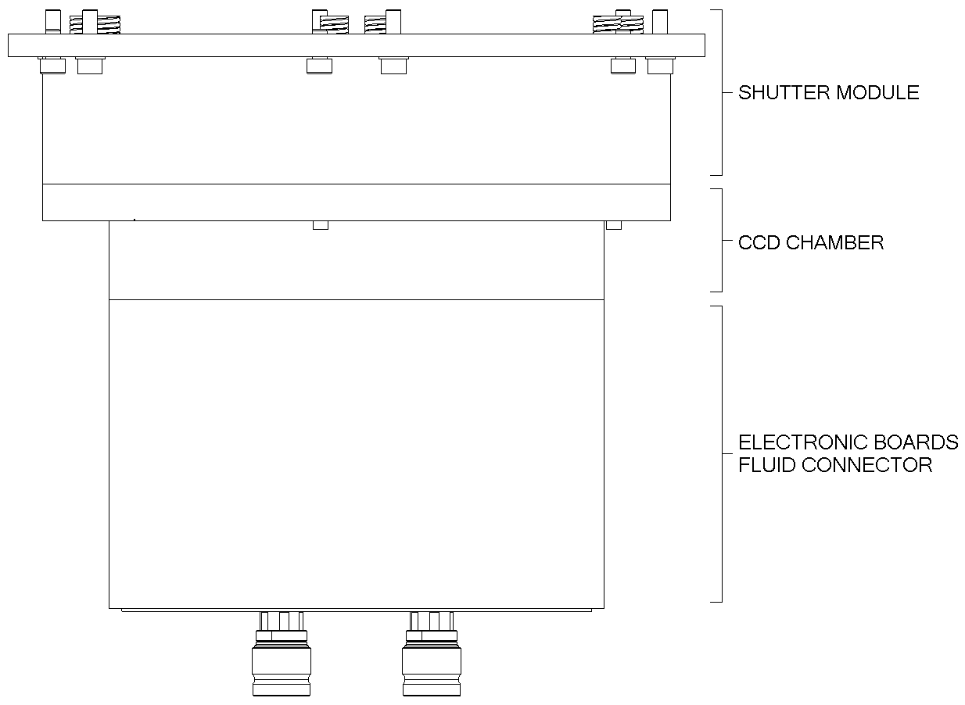

Figure 5‑6: Camera overview

The CCD chamber is discussed in Chapter , Chapter

Back panel of the camera () have power supply, communication and fluid connectors.

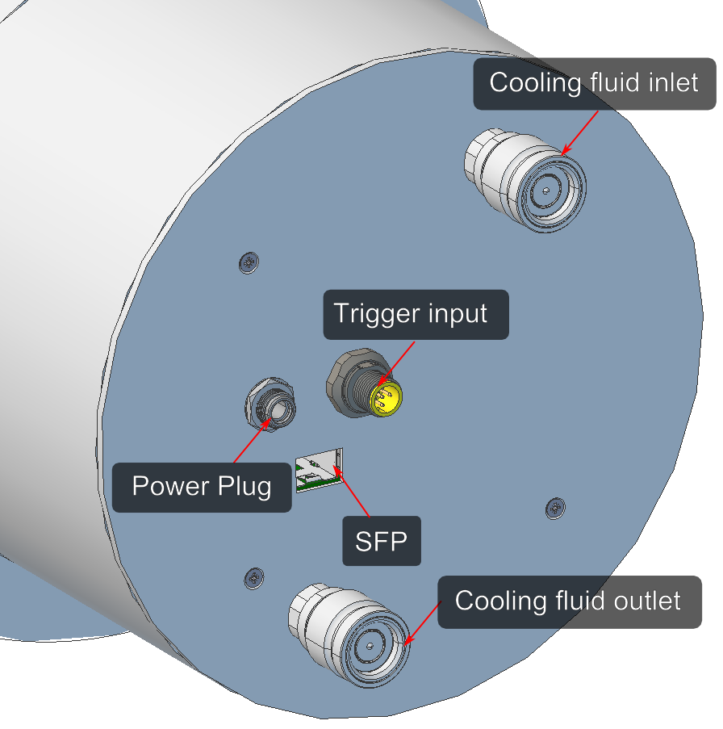

Figure 5‑7: Camera Back panel

At the bottom part of the camera there are electronic boards installed:

* Main board
* Control and communication board
* Analog front end board.

Electronic boards are attached to the sheet metal frame that provides stability and positioning accuracy

*Figure 5‑8*) . This part of the camera is covered with aluminum round profile tube, which provides a solid construction that will be easy to assembly. Between the back panel and the tube there is an O-ring installed for sealing.

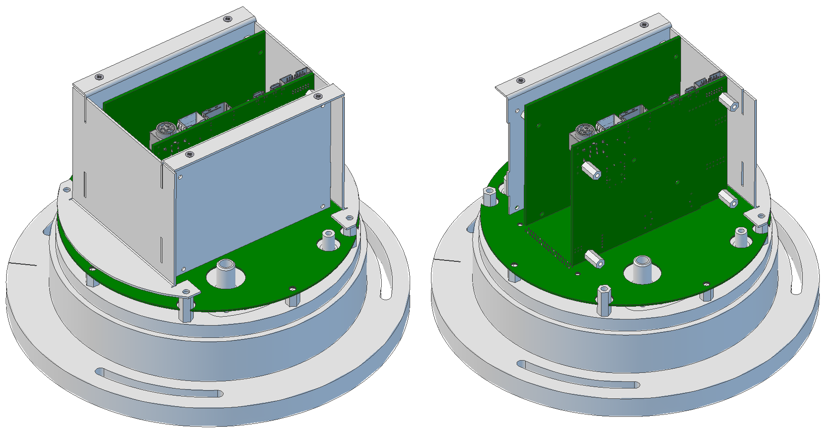

Figure 5‑8: Electronic boards assembly

The design fulfills the requirement for the camera mount to secondary mirror structure as follows:

* The external I/F Flange is provided with dedicated slots that allow the fastening of the camera to the secondary mirror structure (*)*
* The slots allow rotation of the camera around its axis to adjust the CCD orientation.

Wide Angle Slot: 40 deg

Slot Position Diameter: Ø225 mm

Slot Width: 7 mm

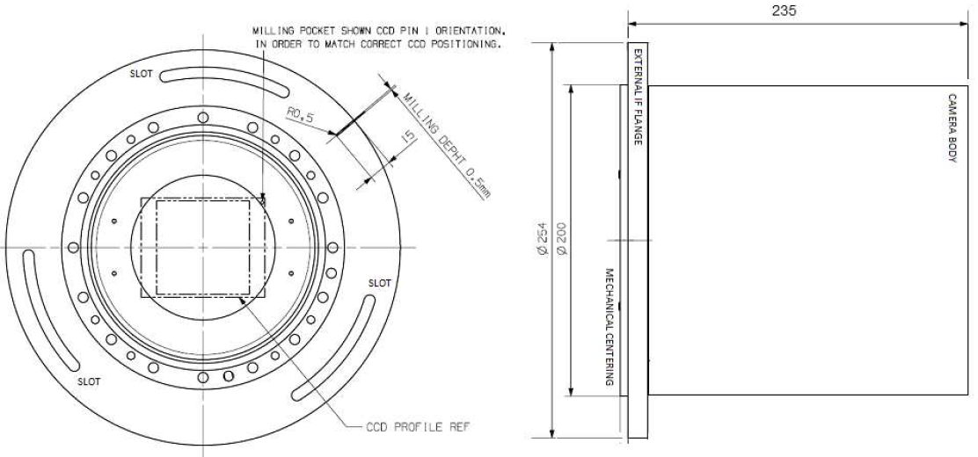

Figure 5‑9: Camera fixing (I)

The shutter is designed as a separate module () which can be detached from the camera both mechanically and electronically. This design makes it easy to mount and maintain the camera. This module also features area for a filter and an additional free space for other components that may be necessary to add later on. This module is attached to the secondary mirror structure and to the camera, so camera is not mounted directly to the secondary mirror structure but via the shutter module. Camera fastening provides the ability of its rotation by multiple of 40 degrees to regulate the position of the CCD sensor.

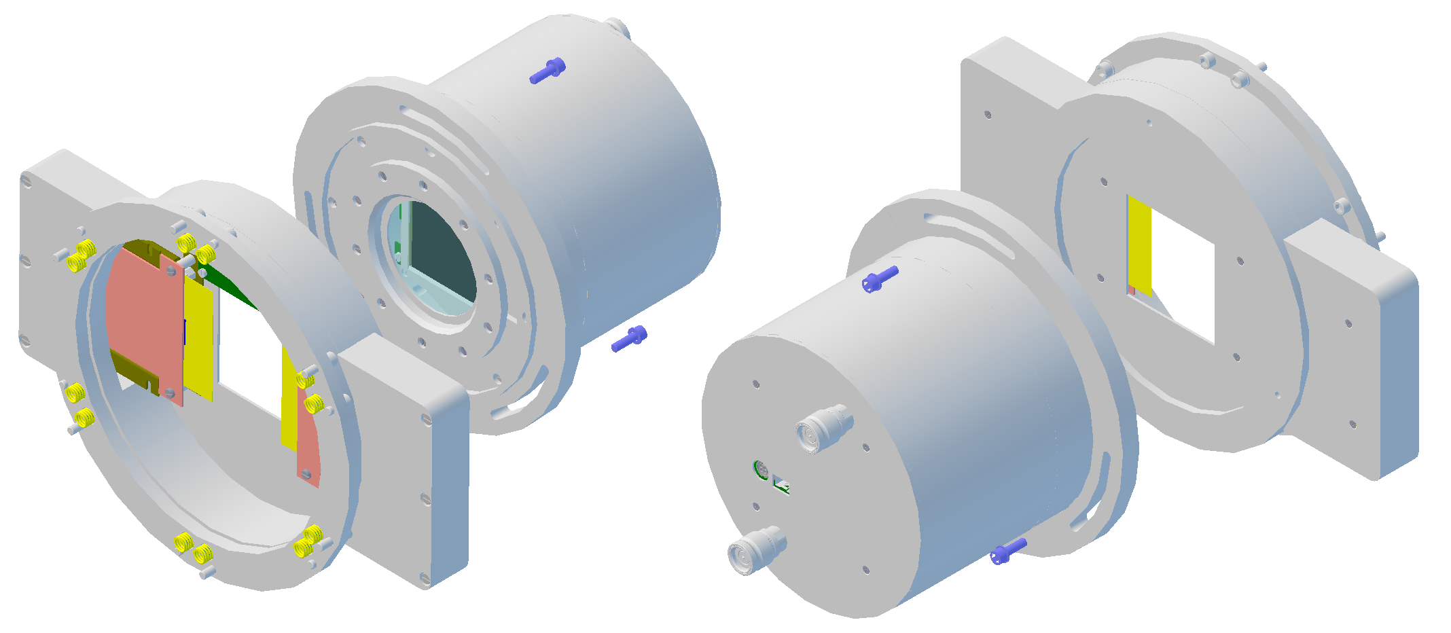

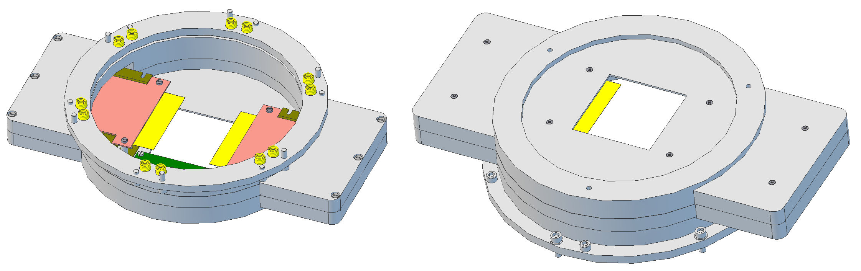

Figure 5‑10: Shutter module

The shutter module provides a camera tip-till adjustment from the secondary mirror structure side of the fastening. The adjustment is made be screwing and unscrewing 6 pull screws (1) (), constant pressure between the shutter module and the secondary mirror structure is provided by springs (3) that are spread around the perimeter of the contact surface. To lock the adjustment there are 6 press screws (2) that will lock the set distance between the shutter module and the secondary mirror structure.

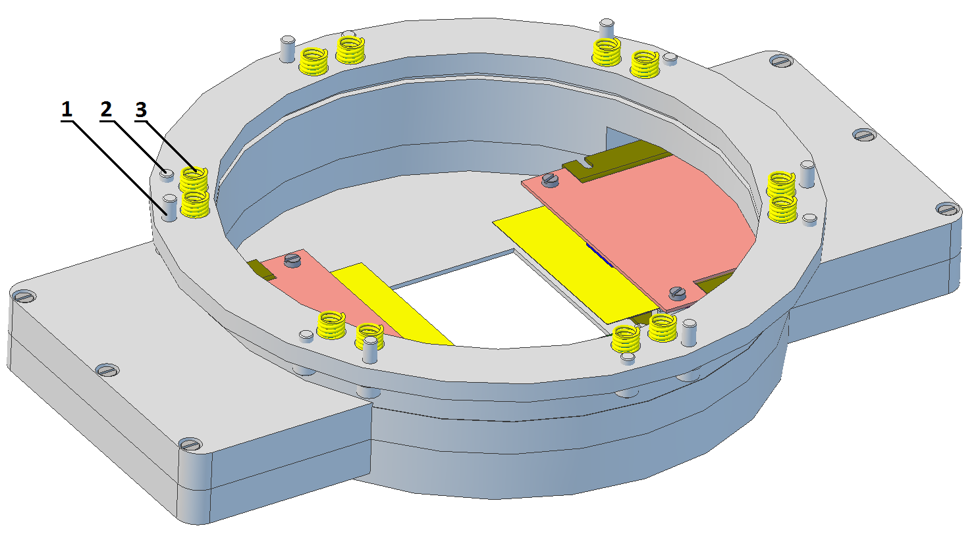

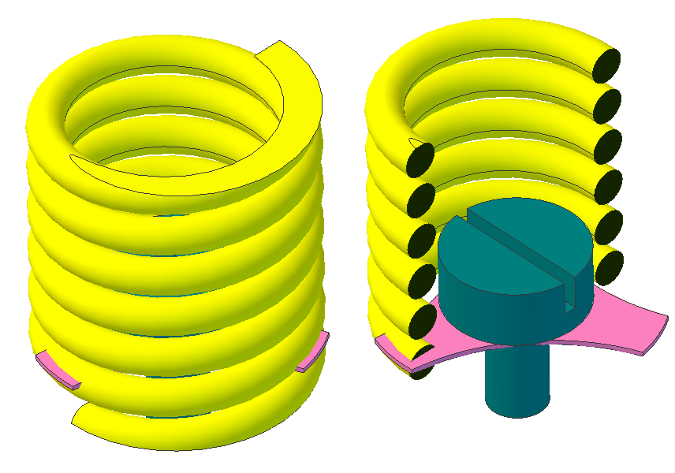

**Legend:**

1. Pull screws
2. Press screws
3. Spring modules

Figure 5‑11: Tip-till adjustment

Current design of the shutter do not satisfy the available volume requirement that is shown in the figure 5-5. Current design need more than 328 mm space in width, the highest dimension (31 mm) is fulfilled. Figure 5-12 showed the actual size that is needed.

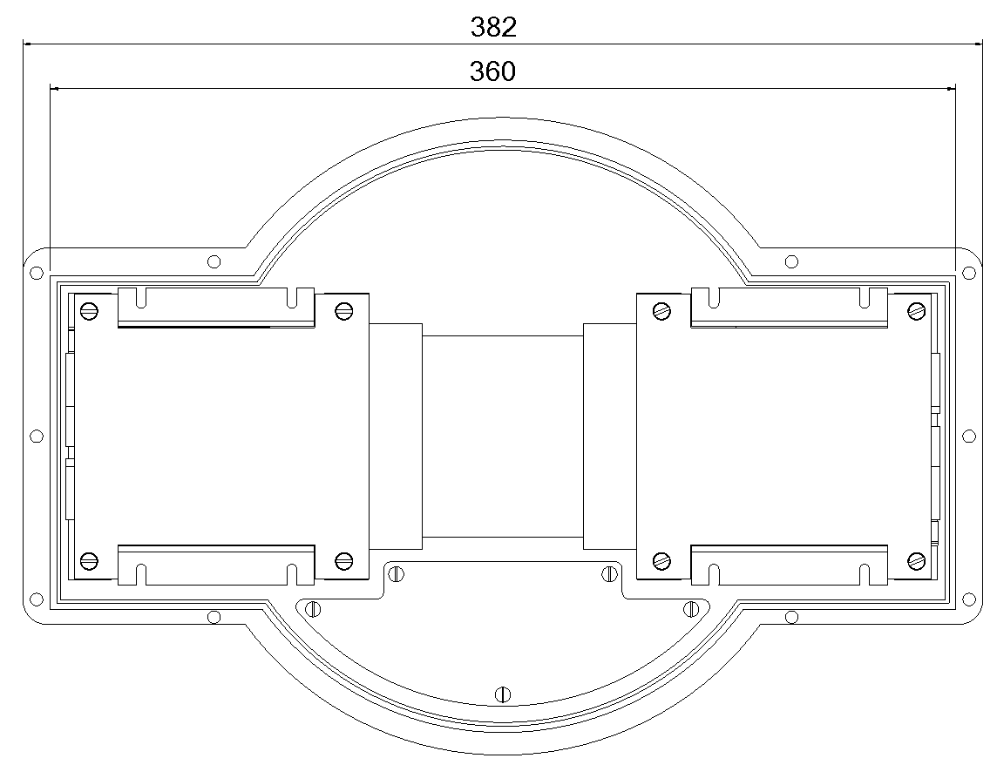

Figure 5‑12: Shutter width

### CCD MECHANICAL MOUNTING AND ALIGNMENT ASPECTS

The CCD mechanical assembly is shown in and .

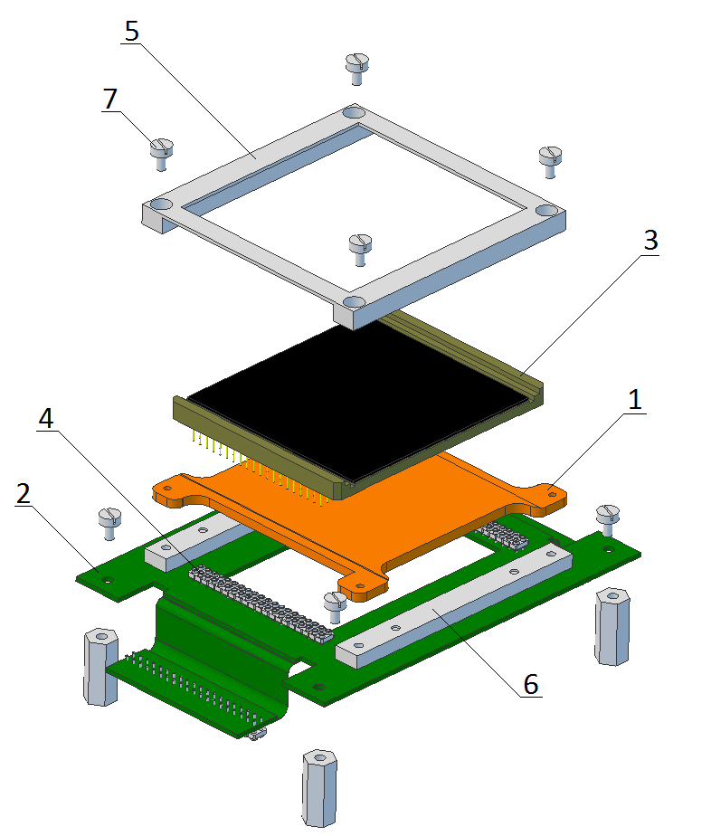

**Legend:**

1. Copper block (coldfinger)
2. CCD board
3. CCD sensor
4. Connectors
5. Tightening element
6. Plastic spacers
7. Polyamide screws

Figure 5‑12: CCD assembly on the cold-finger and PCB

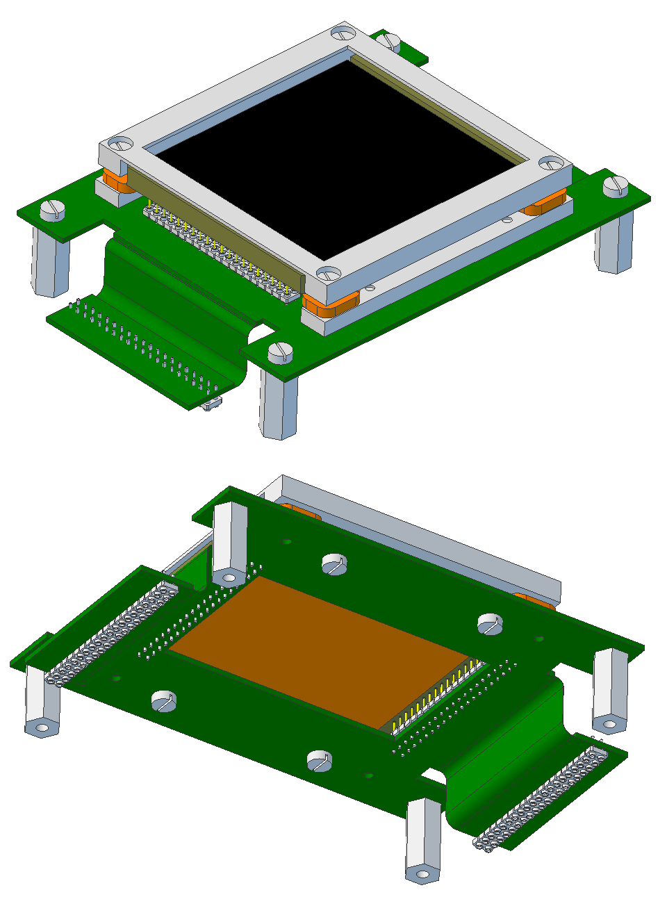

Figure 5‑13:CCD assembly on the cold-finger and PCB

A copper block (1) is screwed to the spacer (6) made of plastic which is screwed to the CCD PCB (2). The CCD chip (3) pins are placed into the connectors (4) on the PCB. To ensure good thermal conductivity between the CCD sensor and the copper block, there is a thermal compound between them. Samtec low-profile socket-strips are used as connectors. Tightening element (5) is screwed to the copper block with polyamine screws (7), therefore tightening CCD to the copper block. The CCD PCB has three rigid parts and two flex parts. The central rigid part is where the CCD pin connectors are located, the two other parts have a connector that goes through the slots on the base plate, as shown in the . These slots will be filled with epoxy resin to keep the chamber sealed. Although the slots are sealed it is still possible to remove the CCD PCB and to put it back without any need for removing the epoxy. The width and length of the flex part are optimized to ensure high thermal resistance.

An alignment of the CCD sensor is discussed in the Chapter

Additional views of CCD Assembly are shown in and *.*

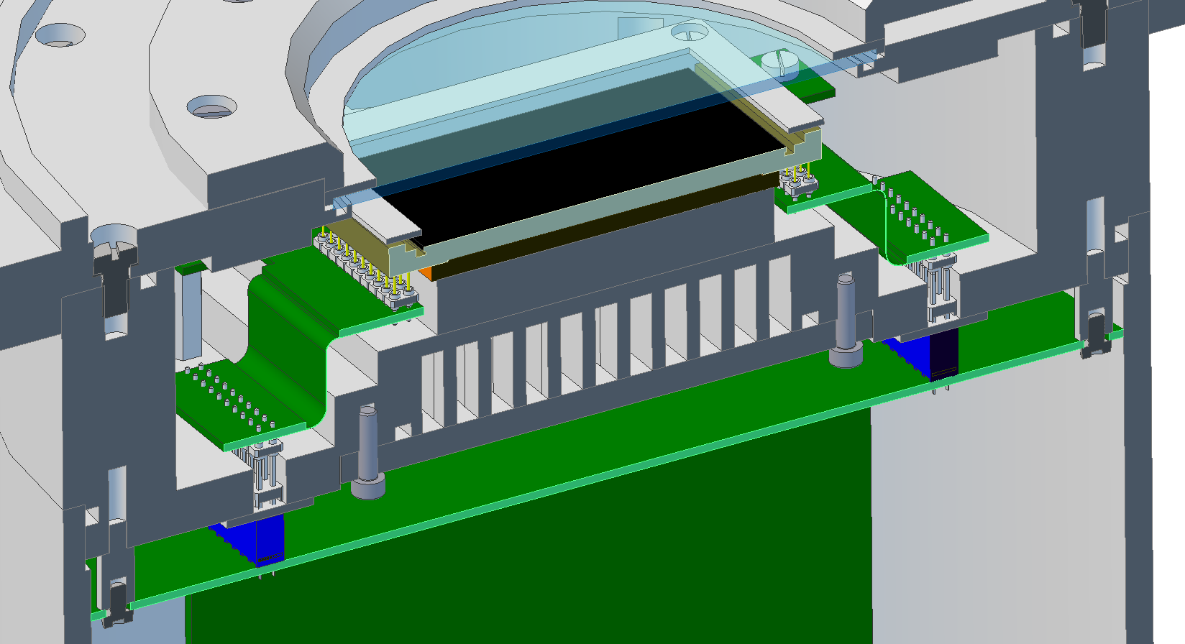

Figure 5‑14: CCD assembly

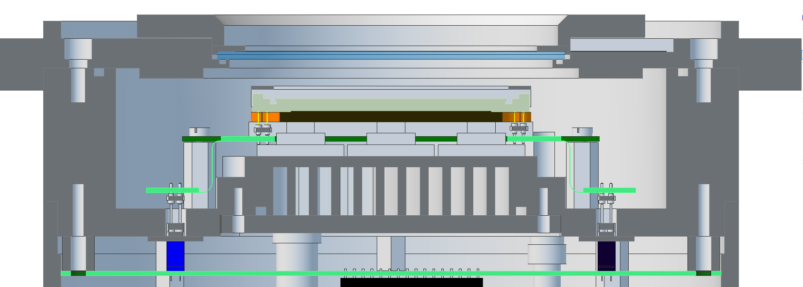

Figure 5‑15: CCD electrical connection

### NOBLE GAS THERMAL INSULATION CIRCUIT

The design of a sealed CCD sensor chamber is shown in *.* Additional views of the concept are presented in and .

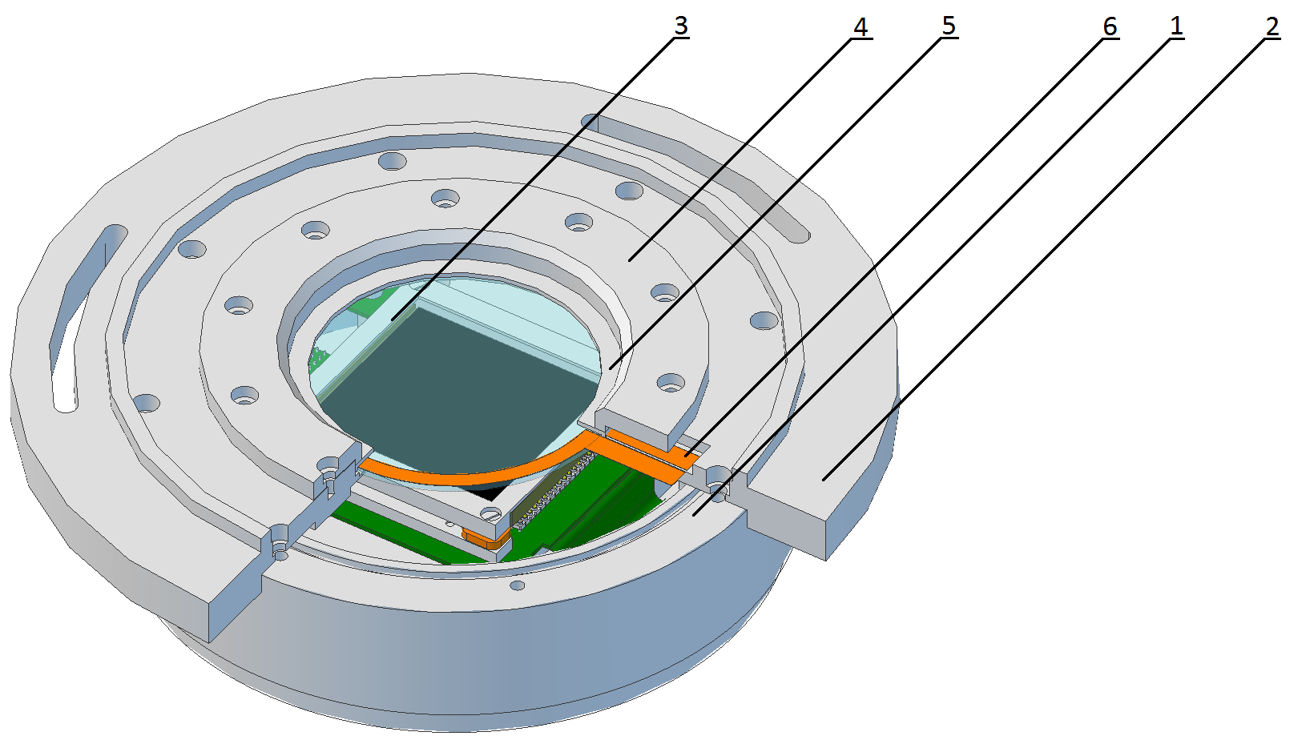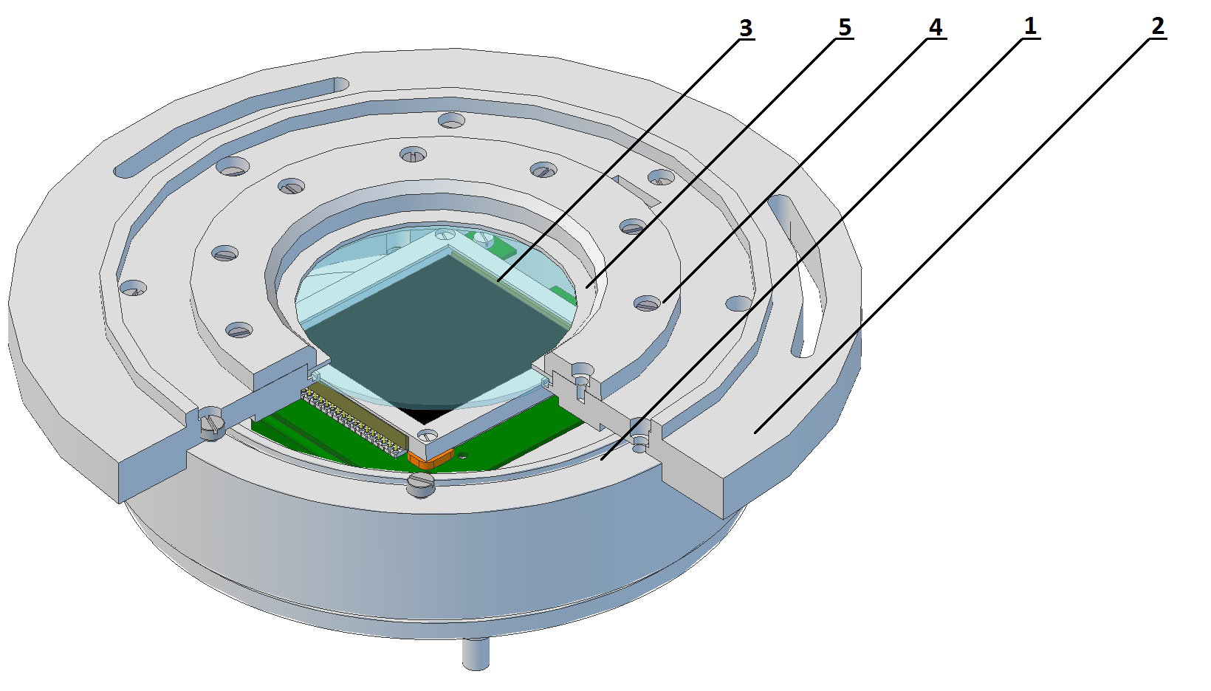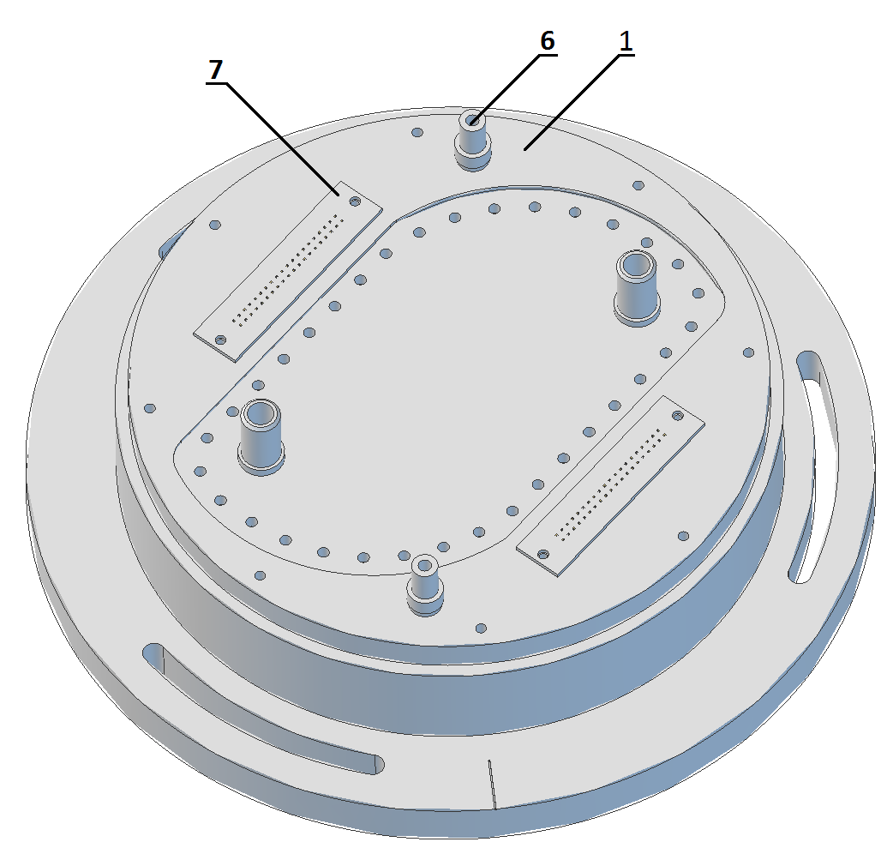

**Legend:**

1. Chamber Base
2. Chamber Cover
3. Sapphire Glass
4. Glass Cover
5. Glass Suppressor
6. Noble gas valves
7. CCD board connectors

Figure 5‑16: Noble gas filled CCD chamber

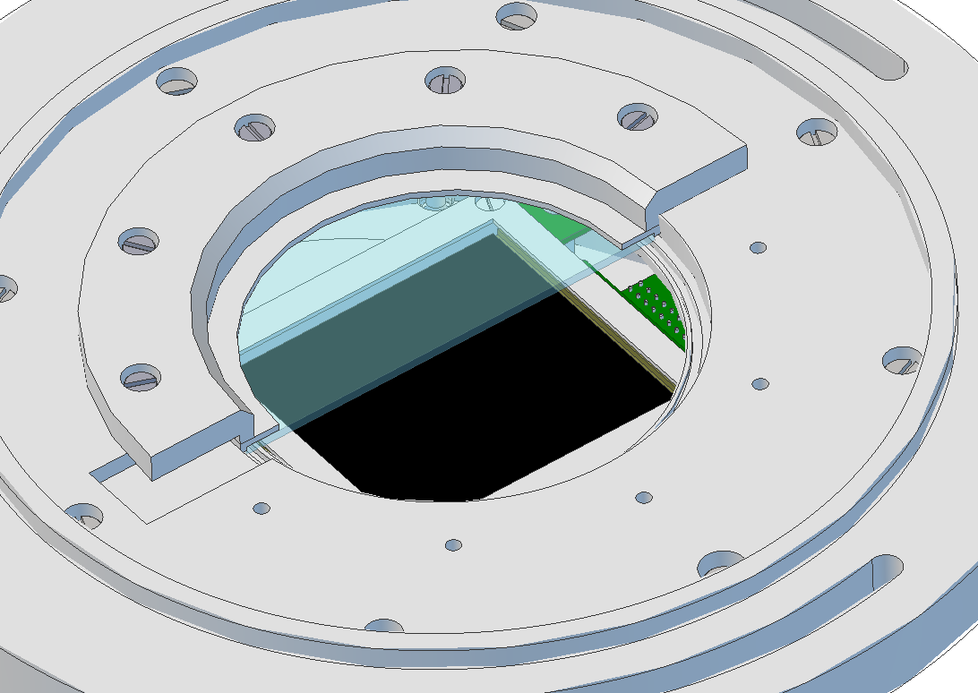

Figure 5‑17: CCD chamber

The base element (1) is fixed with the top cover (2) and the glass suppressor and the cover (4, 5); thus it provides the seal and the sapphire glass fastening. There are O-rings to seal the chamber between the glass (3) and the suppressor (5), and between the base (1) and the cover (2).

There is an elastomeric part between the window and the suppressor that suppresses the window and allows it to resize when temperature changes.

Due to the fact that the distance and parallelism between the CCD sensor surface, sapphire glass and flange are very important, these dimensions will be measured and a report with these parameters will be issued for each camera .

On the other side of the base element (1) there are holes for gas connectors (to fill the chamber with argon) and the slots for 2.54mm pitch connectors (electronic signals and power). The slots are filled with epoxy resin to keep the chamber sealed.

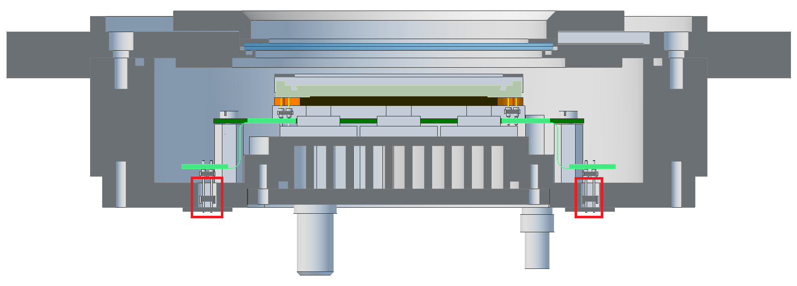

Figure 5‑18: Slots for electronic connectors filled with epoxy resin

To minimize the heat conduction between CCD and the chamber due to radiation, walls will be clad with thermal insulation material of high reflectivity. We are considering plastic with silver coating.

Pressure and temperature sensors are installed inside the chamber to control the CCD temperature and to monitor the seal of the chamber.

#### COOLING SYSTEM, EXTERNAL COOLING AND FLUIDIC SYSTEM DESIGN

The operational temperature of the CCD sensor is -50°C. Water-glycol will be used for the CCD sensor TEC module liquid cooling. Fans must be avoided to minimize the vibration level. A sensor power management minimizes the problem of heating the CCD sensor (chimney effect).

The design also includes a fluid control rack for the camera cooling. A custom-of- the-shelf rack-mount chiller will be used. One chiller will supply four cameras with cooling fluid. An external cooling system overview is presented in .s

Each chiller is equipped with two tubes of 3/8" diameter, one input and one output for the coolant. There is a splitter on each of these tubes close to the cameras, that splits it into four tubes of 3/8" diameter, one input and one output for each camera. Due to the fact that tubes will be at the temperature close to the temperature of the coolant it is necessary to isolate the tube with weather resistant coating. This will eliminate the problem of condensation on the tubes. The pump has a flow rate of 3.8 lpm, so each channel will have a flow rate of around 1 lpm.

There is a possible configuration that one chiller will supply coolant for 2 cameras, then the flow rate will be much higher and safety margin will be more satisfying.

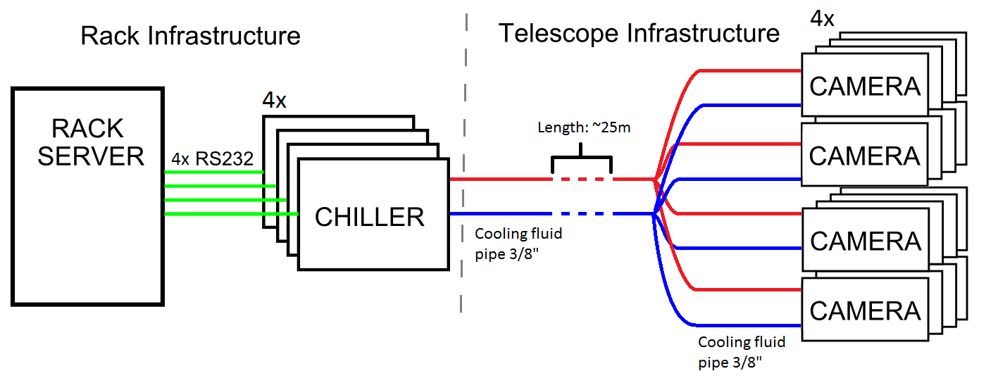

Figure 5‑19: External cooling system

To ensure no leakage, a Koolance QD3 no-spilling connector will be used. These connectors guarantee an easy connection and disconnection of the fluid lines due to shut-off couplings with an internal valve which closes during disconnection.

The chiller is equipped with temperature and flow sensors and the EPICS server software that communicates via a serial port and manages its operation. Moreover, independent temperature sensors are implemented in each camera at the coolant inlet and outlet. Both sensors provide a hardware alarm output that is wired directly to the power management system of the camera to shut down the TEC supply without any need of software intervention. This is the second level of thermal protection. The management software ensures the first level.

The TEC supply is controlled locally by means of each camera power-management block and the temperature is stabilized by means of a PID loop. The PT-1000 temperature sensor is installed just at the CCD sensor enclosure to minimize the time response of the temperature stabilization loop.

The temperature control of the sensor is especially critical in case of long temporal exposures. The sensor temperature is logged and saved into the FITS header of each image. The CCD temperature measurement accuracy is about 0,5 degree.

The liquid cold plate receives the thermal energy from the TEC module that transfers it from the CCD sensor. The CCD sensor output buffers are the main source of thermal energy that can be shut down during exposure time. When active, four buffers generate about 1W of power. When they are shut down this power is reduced to close to zero.

The Table 5-1 below presents the power dissipation of the cooling system for one camera.

Table 5‑1: Cooling system power estimation for one camera

|  |  |  |  |
| --- | --- | --- | --- |
| Name | Voltage [V] | Current [A] | Power [W] |
| CCD Chip | Various | Various | 1.125 |
| Peltier module | 8 | 6.25 | 50 |
| Chiller | 230 AC | 5.9 | 1353 |
|  |  |  |  |
|  |  | Total power [W]: | 1404.125 |

#### CAMERA COOLING

The CCD sensor must be cooled down to -50⁰C to ensure low noise operation of the CCD chip. Therefore a two-stage Peltier module, from which the heat is taken by a liquid cold plate, cools the sensor. The cooling liquid is glycol and water. The drawings below show the thermal path inside the sensor cooling system (, and ).

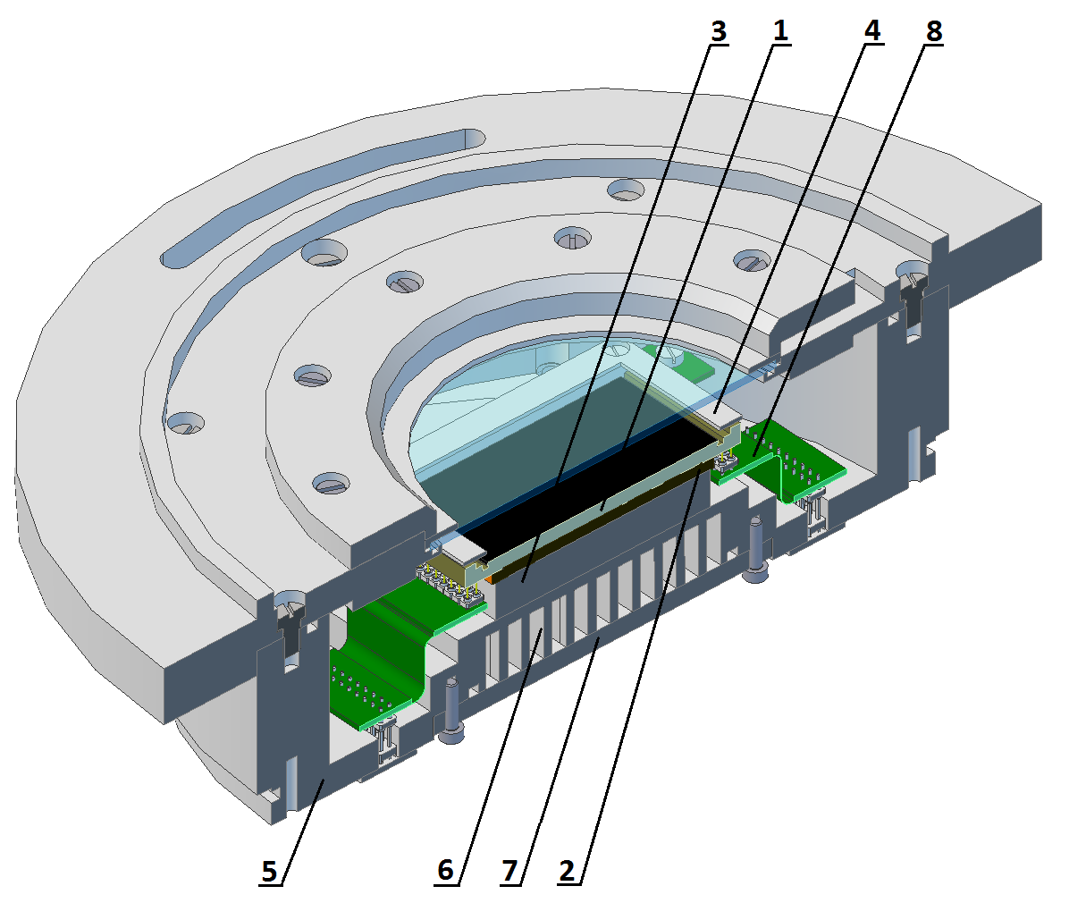

**Legend:**

1. CCD Sensor
2. Copper block
3. Peltier modules
4. CCD tightening element
5. Chamber base
6. Cooling block

(part of the chamber base)

1. Cover of cooling block
2. CCD Board

Figure 5‑20: TEC cooling system

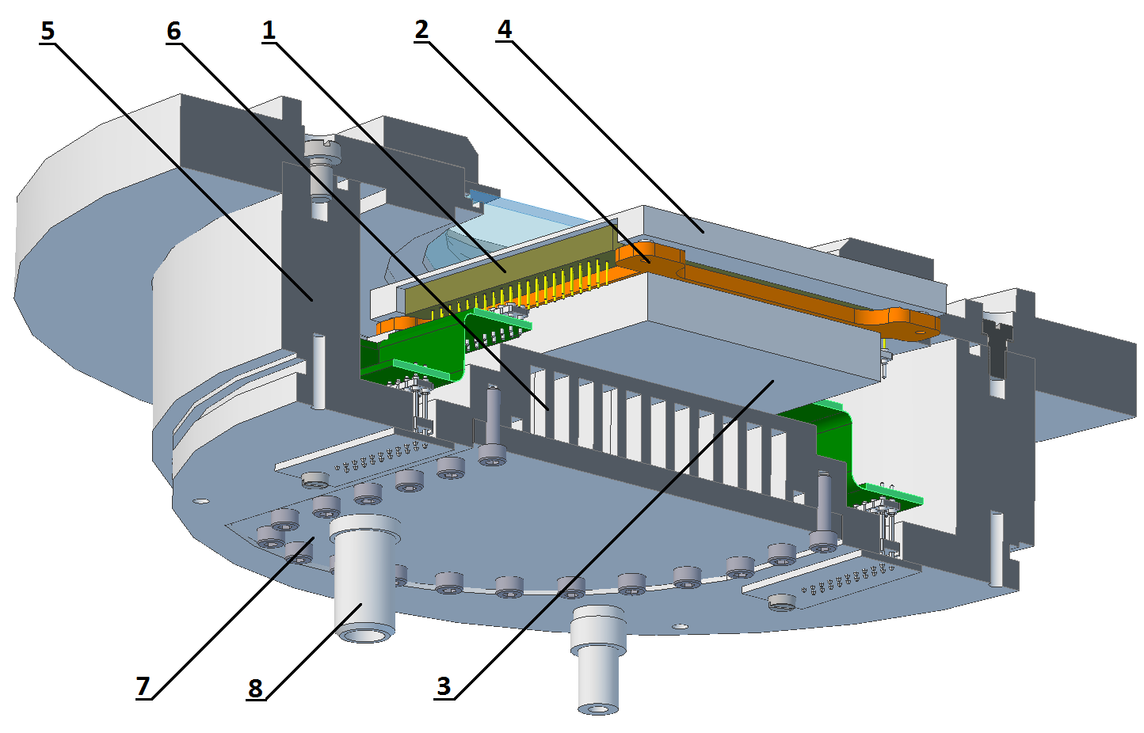

**Legend:**

1- CCD Sensor

2- Copper block

3- Peltier modules

4- CCD tightening element

5- Chamber base

6- Cooling block (part of the chamber base)

7- Cover of cooling block

8- Cooling fluid connector

Figure 5‑21: TEC cooling system overview

The CCD sensor is fixed by a tightening element (4) made of laminate, to improve the adhesion of the sensor surface to the copper block (2). The copper block spreads the heat that is transferred from the entire surface of the CCD sensor to the Peltier module (3). This eliminates temperature gradients on the CCD area. To ensure good thermal conductivity in the thermal path from CCD sensor to cooling block, there is thermal compound between the mating surfaces.

The cooling block (6) is the part of the base element (5), its cover (7) is screwed to the base To guarantee the sealing of the block there is an O-ring installed between cover and chamber base. The cover is provided with connectors (7) to supply and receive the cooling liquid.

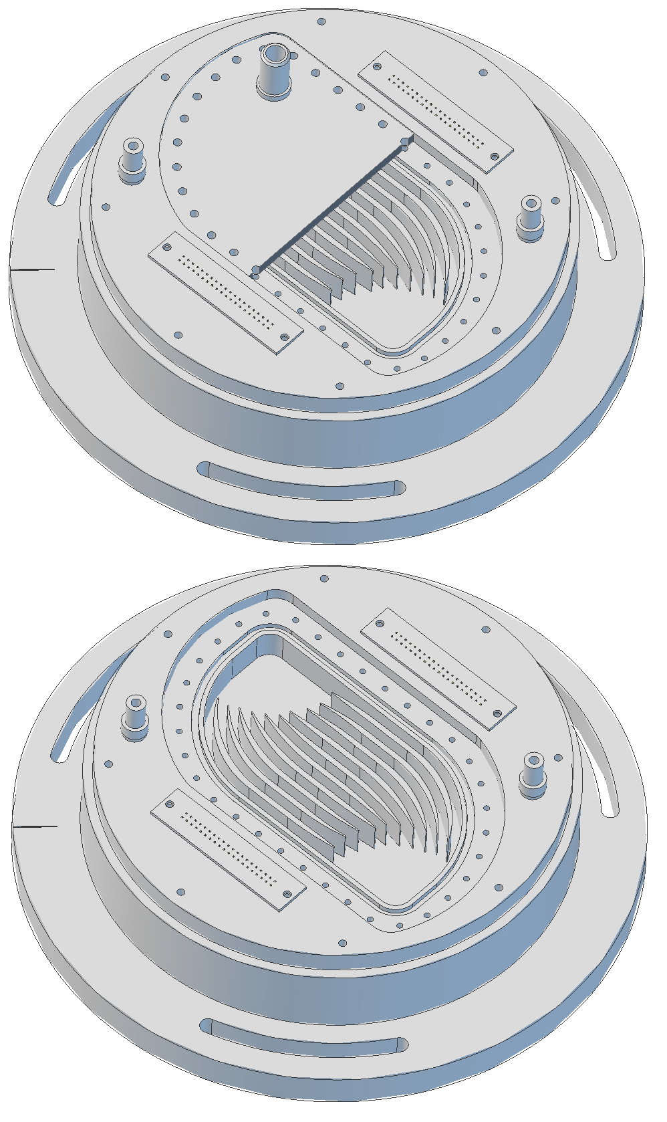

Figure 5‑22: Liquid cold plate

Cold plate has 11 channels that are designed so that the coolant path between the input and output of each of them was the same length which will result in a more laminar flow. This will have direct impact on the vibration which will be minimal with laminar flow. The channels corners are rounded so there will be no turbulence when coolant is entering or leaving the channel.

#### TEC COOLER

presents a simplified schematic of the thermal flow from 4 cameras, the whole telescope will have 4 of those sets.

The Arctic TEC Technologies TECB2-15.5-13.0-75-84 Peltier module is used.

Characteristics of the module are summarized in .

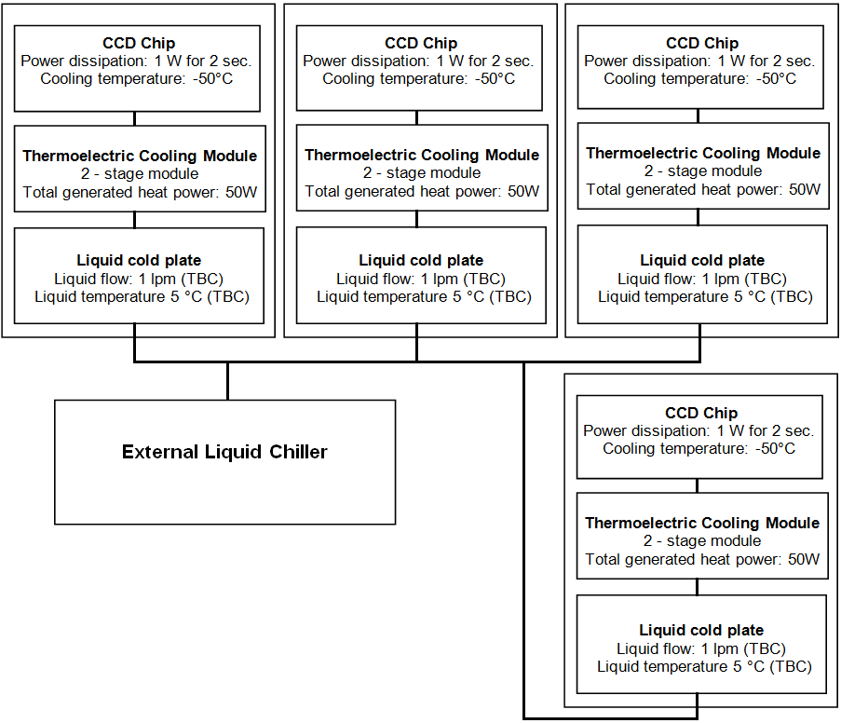

*Figure 5‑23: Thermal flow*

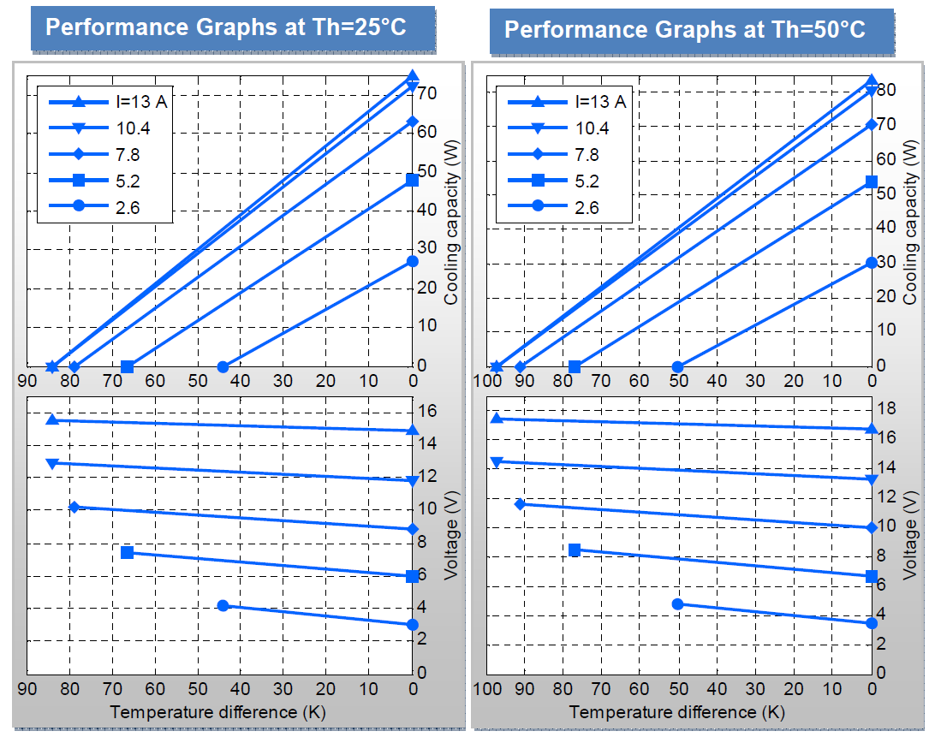

Figure 5‑24: TEC Characteristics

The cooling block (cold plate) has to dissipate 50 W of heat and the inlet fluid temperature will be 5°C. TEC will drain 1W from the CCD, but only for 2 seconds during the read-out operation. Temperature difference of around 85⁰C can be created between the cold and hot side of the cooling block, which provides a satisfying safety margin.

The designed cooling block will have thermal conductivity of around 0.05 (°C)/W, which will result in a 2.5°C temperature difference between the hot side of the Peltier and the cooling fluid, when the cooling block has to dissipate 50W on the hot side of the Peltier module.

Preliminary simulation was made by solving equations of state. The system schematic view is shown in below.

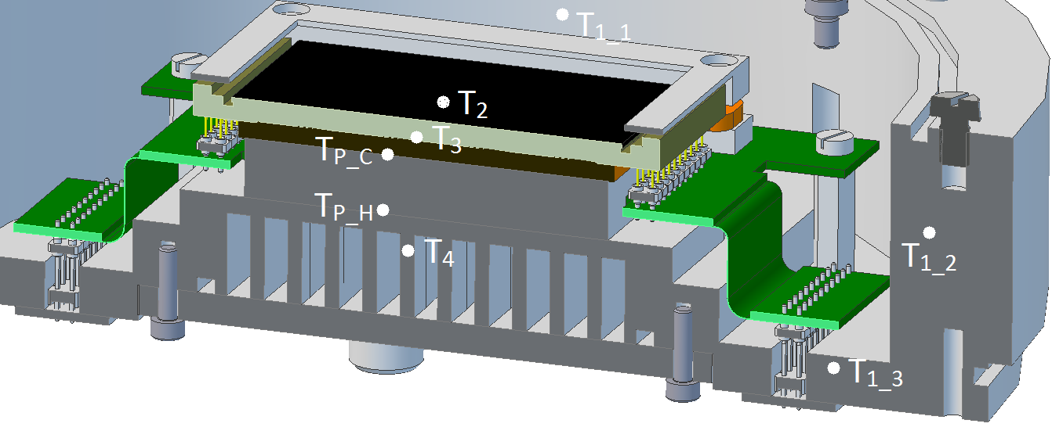

**Legend:**

**T1\_1**- Top cover of the housing

**T1\_2**- Cylindrical walls of the housing

**T1\_3**- The bottom part of the housing

**T2** - CCD camera

**T3** - Copper interface

**T4** - Heat sink temperature

**TP\_C** - Temperature of the cold side of the Peltier sensor

**TP\_H** - Temperature of the hot side of the Peltier sensor

Figure 5‑25: CCD Cooling - System Schematic View

The heat between the components inside the housing is exchanged through the conduction at the contact interfaces and through the convection in argon environment. Therefore the system of heat balance equations for temperature nodes T1\_1, T1\_3, T2, T3, TP\_C and TH\_C respectively can be defined as follows:

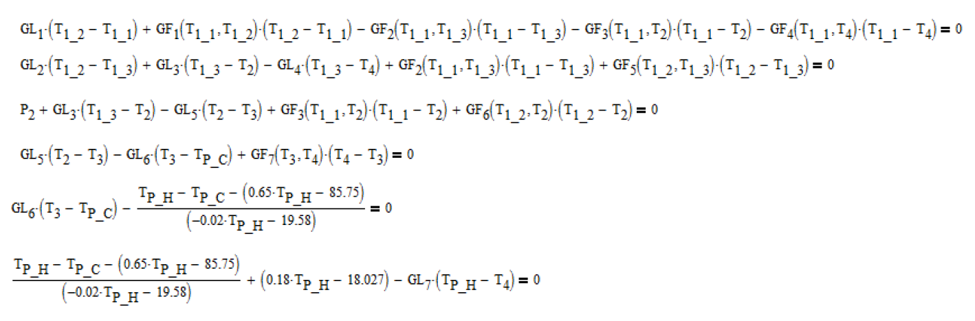

The *GLi* represents the conductive link between two nodes, while *GFi* is the convective link between two nodes. Both GL and GF are defined in W/K. Nodes T1\_2 and T4 are the boundary nodes.

The boundary conditions are given in *.*

*Table 5‑1: Thermal analysis boundary conditions*

|  |  |  |
| --- | --- | --- |
| **Part name** | **Node name** | **Temperature / Power** |
| Cylindrical walls of the housing | T1\_2 | +30 ⁰C |
| Heat sink | T4 | +4 ⁰C |
| CCD camera | T2 | 1 W |

*Table 5‑2* presents the materials definition and their bulk properties which were used in the simulations. The PCB effective conductivity was calculated taking into account the amount of copper and FR4.

*Table 5‑2: Thermal analysis materials definition*

|  |  |  |  |  |
| --- | --- | --- | --- | --- |
| **Part name** | **Material** | **Bulk properties** | | |
| **Density [kg/m3]** | **Conductivity [W/m/K]** | **Specific heat [J/kg/K]** |
| **Camera CCD** | Silicon | 2330 | 148.9 | 712.8 |
| **Housing** | Aluminum PA6 (2017-0) | 2770 | 192.1 | 921.6 |
| **PCB** | FR4 | 1850 | 0.25 | 600 |
| Copper | 8960 | 401 | 390 |
| PCB effective |  | 12.6 |  |
| **PCB mounting screws** | Nylon | 1850 | 0.25 | 600 |

The results of the analysis are presented in .

*Table 5‑3: Thermal analysis results*

|  |  |
| --- | --- |
| **Node name** | **Temperature [⁰C]** |
| T1\_1 | 29.2 |
| T1\_3 | 22.7 |
| T2 | -52.2 |
| T3 | -52.2 |
| TP\_C | -52.3 |
| TP\_H | 22.4 |

The results of the performed analysis shows that the current design should fulfill the requirement of the temperature of the CCD camera below -50⁰C.

#### CAMERA COOLING ARCHITECTURE: PELTIER MODELS AND DRIVING CIRCUITS

A two stage thermoelectric cooler is used to provide sufficient temperature difference between the CCD sensor and the rest of the electronic equipment. The thermoelectric cooler controller is presented in the .



Figure 5‑26: TEC control circuit

A Pulse Width Modulation (PWM) controls the IRS2004 driver, which is connected to the MOSFET transistor half bridge that consists of two STL60N32N3LL. The bridge output is connected to the thermoelectric cooler through an EMI filter to eliminate ripples. The return current and the output voltage are buffered with an AD8031 and sampled by a ADS7945 SPI SAR 14-bit ADC and feed back to the CPU1 which runs the control algorithm in real-time. The PWM drive is synchronized to the pixel-clock and generated by an IP core implemented in the FPGA to eliminate current transients that could affect the CCD signal acquisition.

#### CHILLER

The foreseen chiller is the RC7BD model of ThermoTek Inc (). It can dissipate 220W of heat power from the cooling block while keeping the cooling liquid at -25⁰C below ambient temperature (*,* ). If the ambient temperature e.g. is already between 0 and -20 degrees, then the chiller will be switched off.

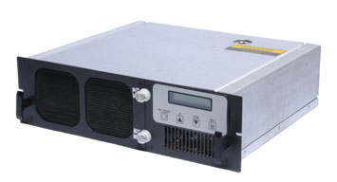

Figure 5‑27: Rack mount chiller

It has a temperature stability of ±0.1 ⁰C and can be controlled via RS232. It is rack mounted. One unit can dissipate the heat from two cameras. Below one finds the characteristics of the chiller work.

No spill Koolance locking connectors are used. They would allow a live insertion and replacement without spilling the cooling fluid.

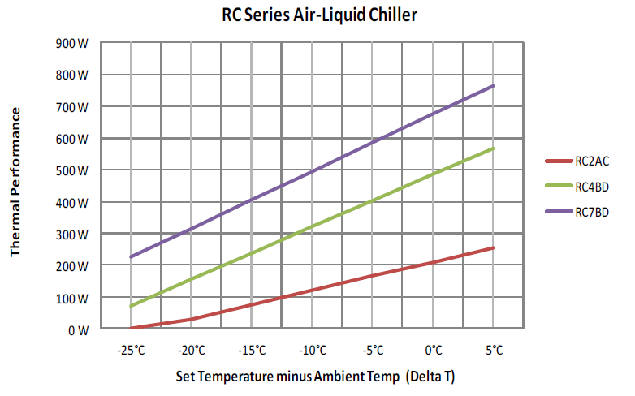

Figure 5‑28: Chiller characteristics

Chiller will be places inside the control room with the temperature +15/+20°C so, when the coolant temperature is fixed to +5°C is can dissipate around 400W which give us satisfying safety margin in this area. Water-glycol mixture will be used for a coolant to have a freezing point below 0°C (but rather near -10°C) so that there will not be a problem with being near freezing point when ambient temperature will be -20°C. Also there may be a need to set coolant temperature lower than +5C so it is necessary to lower the freezing point of the coolant.

#### FLUIDIC SYSTEM ANALYSIS

Fluid System Data are presented in . The Reynolds number and of the increase of temperature between the chiller and the camera, considering a 25m cable line and a 12m length difference. The calculations are performed for both -20⁰C and +30⁰C ambient temperature and for a 1/4'' and 3/8'' liquid tube diameter. The liquid flow rate is 3.8 liter per minute. Calculations were made for water with glycol C2H4(OH) 2,34% volume in mixture. The part of the tube from splitter to the camera will be relatively short and the flow rate will be half the normal value compare to the whole system, so it is neglected in the calculation.

*Table 5‑4: Fluid System Data*

|  |  |  |  |
| --- | --- | --- | --- |
| **Ambient temperature [°C]** | **Liquid line diameter [**'**']** | **Reynolds number** | **Glycol temp. Change from chiller to camera [°C]** |
| 30 | 1/4'' | 2903,27 | 1,07 |
| -20 | 1/4'' | 1,09 |
| 30 | 3/8'' | 1981,6 | 1,57 |
| -20 | 3/8'' | 1,60 |

A 3/8'' liquid tube will be used due to the fact that the Reynolds number is lower than 2000, thus in this connection the flow is laminar. This will have direct impact on the vibration which will be minimal with the laminar flow.

### SHUTTER MECHANICAL DESIGN

The shutter module (*)* is an independent unit, that can be fully mechanically and electronically disconnected from camera. Therefore it is easy to maintain and heat generation does not interfere with the cooling of the sensor. Mechanical interface with the camera is described in Chapter .

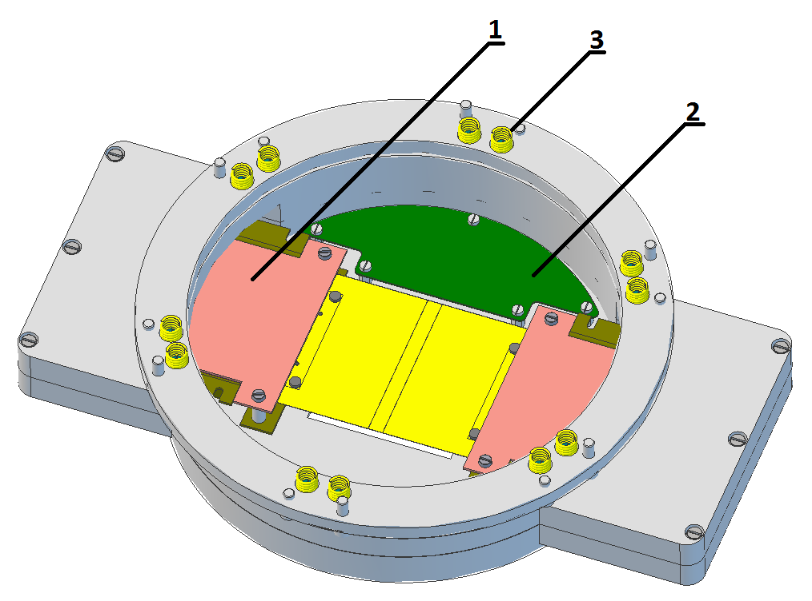

**Legend:**

1- Shutter mechanism

2- Shutter electronic

3- Module case

Figure 5‑29: Shutter overview

The shutter contains two identical mechanism modules based on a voice coil actuator () and the electronic module with actuator drivers and data acquisition from position sensors. One module contains: one blade (5), four magnets (4), coil (2), arm (3), two linear ball slides (6), a position sensor (8,9) and closing of the magnetic circuit (7).

Electronic control signals and power for mechanism modules are transmitted through the flex PCB to the shutter controller. The coil is glued to the arm, the wire from the coil is sold into the flex PCB. There is a part made of steel (7) on the top, used to carry the magnetic flux. The concept of opening/closing of the shutter is presented in .

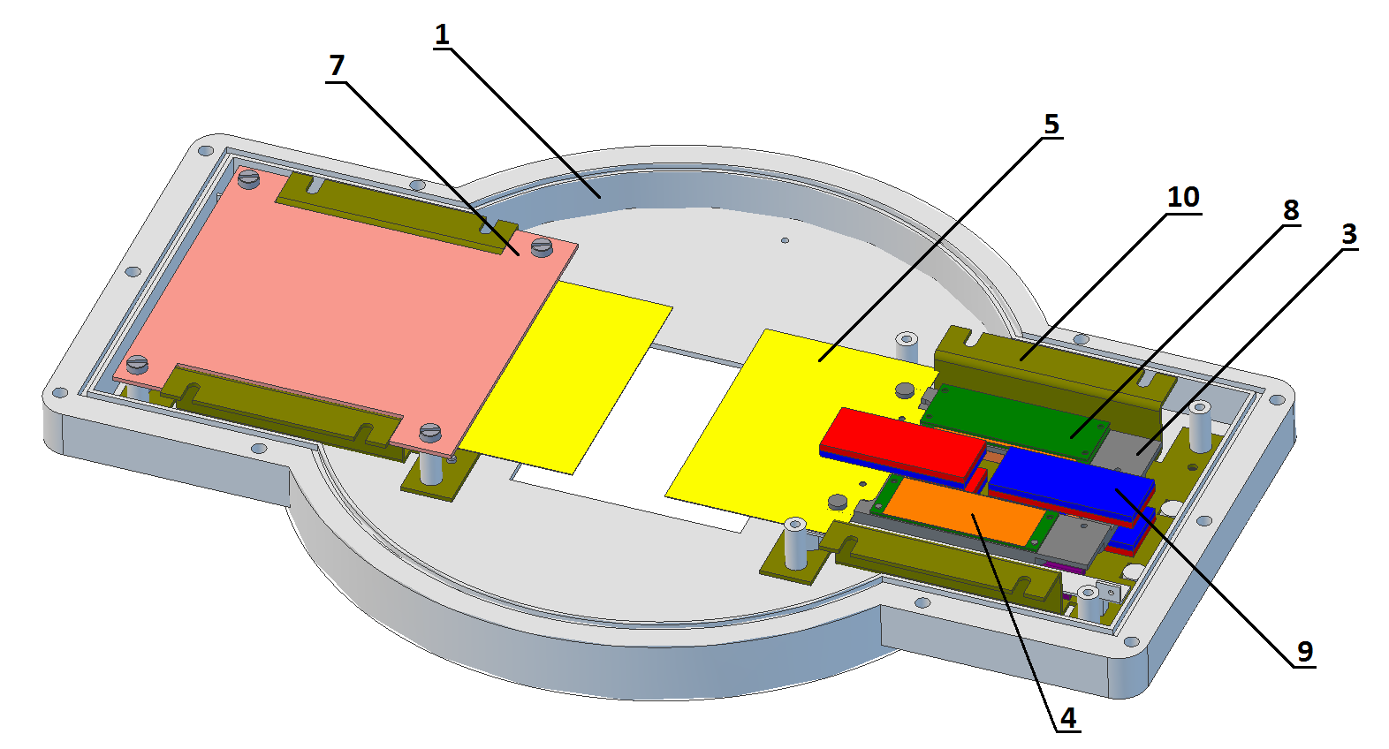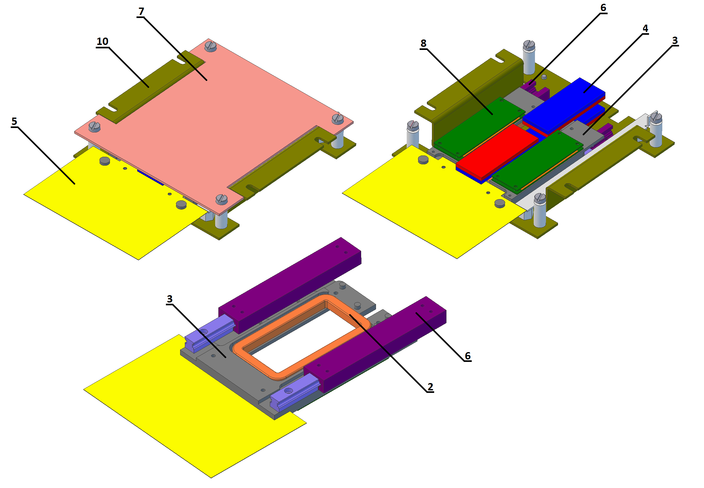

**Legend:**

1- Base

2- Coil

3- Arm

4- Magnets

5- Blade

6- Linear ball slides

7- Mechanism cover

8- Position sensor fixed part

9- Position sensor moving part

10 - Chassis

Figure 5‑30: Shutter mechanism construction

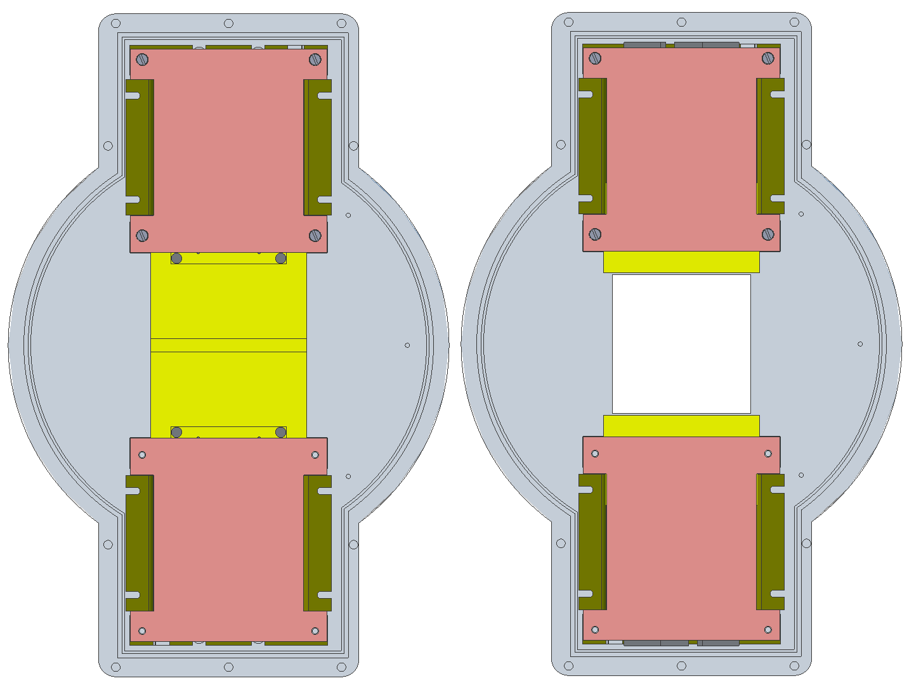

Figure 5‑31: Shutter mechanism opened and closed

The shutter performs a linear movement under the influence of the Lorentz force when the current flows through the coil. The picture below demonstrates how the magnets and the coil are arranged within this design ().

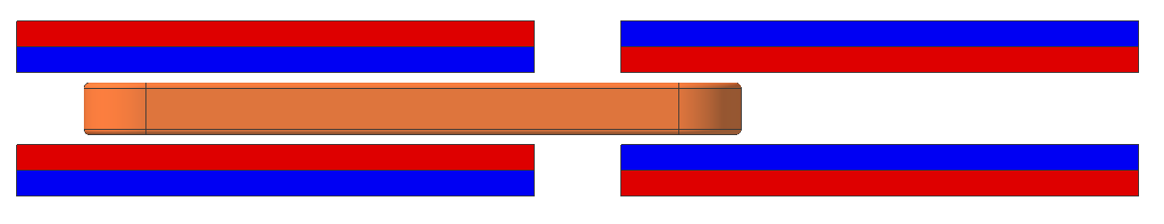

Figure 5‑32: Coil-magnet arrangement

The actuator is designed for linear movement with 44mm stroke. The range of motion is larger than is necessary to cover CCD pixel matrix, because it is favored to use only the linear part of the blade movement characteristic, when it is above the sensor. The portion of this additional space for movement is designed for a controlled attenuation and braking of the shutter to minimize vibrations as much as possible. This type of actuator is characterized by high dynamics and a smoothness in movement. Neodymium magnets made of N35H and with a remanence of 1.21 T are used to obtain highest power at low currents. The magnet size is of 50mm x 20mm x 5mm, magnetized in 5 mm direction. Linear ball slides are characterized by small friction and high durability. Del-Tron Precision, DA-3 slider is used ().

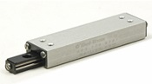

Figure 5‑33: Linear bearing

A differential capacitive sensor is used as a position feedback for the shutter blades (*).*

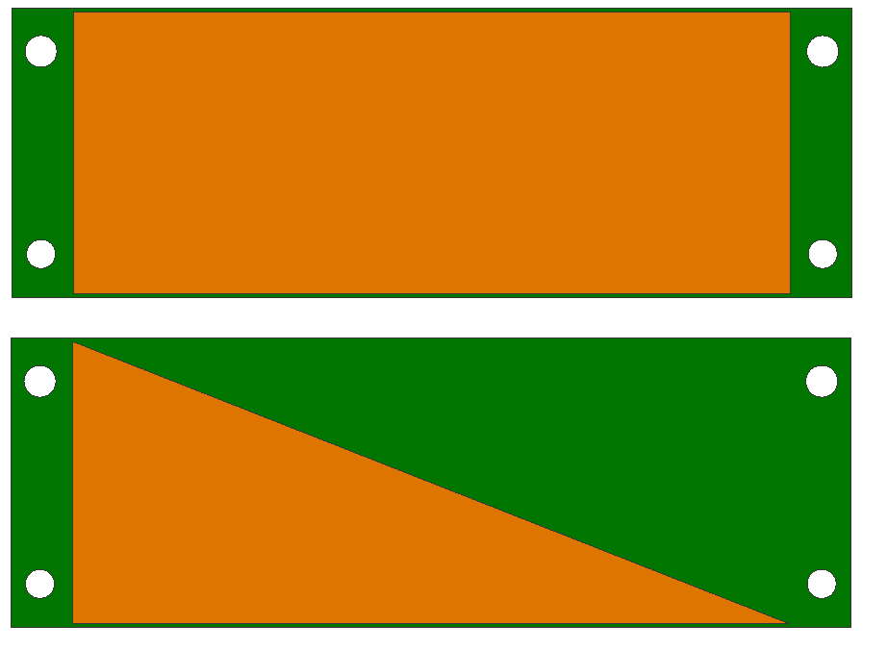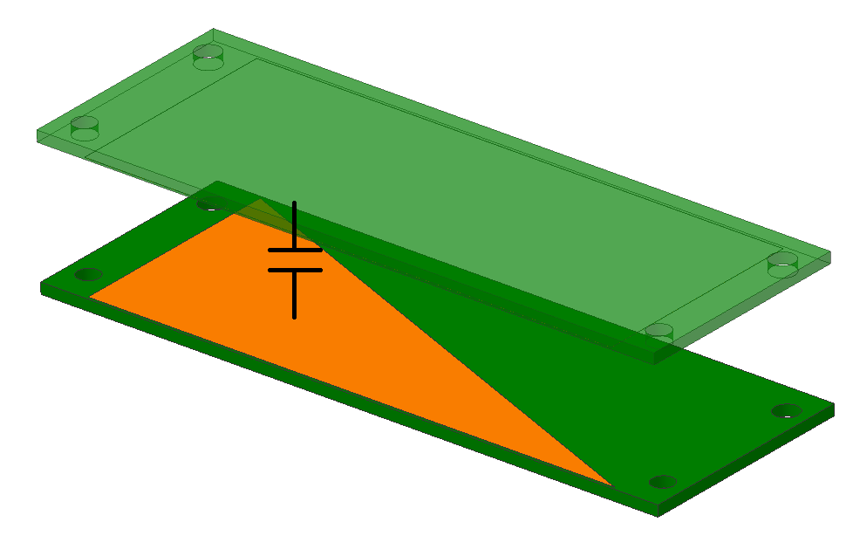

Figure 5‑34: Capacity sensor

The principle of its operation is based on measurement of the change in capacitance formed between fields of copper on two PCBs that are facing each other, where one is moving along with the shutter blade and another one is fixed. Each mechanism has got two pairs of PCBs, one pair create one capacitor that changes its capacity during the blade movement. The capacity depends on how much copper fields, that are facing each other, are covering each other. When they are fully covered, the capacity reach the maximum value. Copper fields are designed in such a way that while shutter is moving, one of the capacitors increases and another decreases its value. Therefore a differential measurement can be used. The differential measurement eliminates the inaccuracies associated with the movement of the blade and the position of the PCB. To know the exact location of the blade, the sensor has to be calibrated first to establish the relationship between the output signal and the position of blade.

## CAMERA ELECTRONICS - ARCHITECTURAL OVERVIEW AND SUBSYSTEM DECOMPOSITION

The electronics of the Camera Assembly consist of two main parts: The Control and Communication Board and the Mainboard with Analog Front-End (AFE), Detector, Power Supply and Driver Modules.

Principal parts and functions of the boards and modules are presented within the block diagram of .



Figure 5‑35: NEOSTEL camera block schematic

The processing platform of the Control and Communication Board is based on a Xilinx Zynq System-on-Chip (SoC) solution that includes two core Cortex A9+ application processors and one Field-Programmable Gate Array (FPGA). It also contains a number of integrated peripheral interfaces like Ethernet, SPI, I2C, CAN, USB etc. as well as two DDR3 memory controllers.

The system runs both Linux and RTOS operating systems in an AMP scenario, with Linux being responsible for the high level control and maintenance and with RTOS being in charge of time critical tasks. All the communication is based on the Ethernet interface. A PTP synchronization protocol provides a microsecond synchronization capability. A serial port is used as a standard console output for diagnostic purposes.

The Mainboard integrates the controllers for the analogue front-end, for the CCD sensor (detector) TEC module, diagnostics and sensors.

The system is controlled via EPICS and provides server functionality. Image data will be double buffered and sent to a remote facility server in the FITS format.

**Electronic System Features**

* Low noise 16MP CCD sensor readout – images are handled in a self-describing FITS format with additional diagnostic information
* Shutter control with accurate start/stop position feedback implemented in the FPGA in the external shutter module
* Environment measurements (humidity, temperature, position)
* EPICS SCADA support with EPICS server implementation for system diagnostics and control
* High speed interface: 1 Gbps Full Duplex Ethernet through SFP transceivers with full hardware PTP support including time-stamping
* Internal and external trigger
* Time synchronization via PTP
* Heterogeneous system with both RTOS (for time-critical procedures) and Linux (for interfacing flexibility and easy data processing with low latency control and a diagnostics path)
* Universal CCD data readout with flexible FPGA logic and modular AFE
* Innovative Xilinx Zynq design with dual core Cortex A9+ and FPGA on one silicon die with shared subsystems.

### CONTROL AND COMMUNICATION BOARD

The Communication Board is shown in the block diagram ().

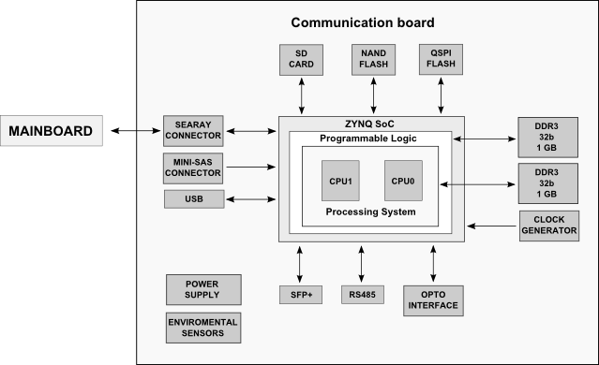

*Figure 5‑36: Communication board block diagram*

The Communication Board is inserted into the connector of the Mainboard. It is intended to be an interface between the camera electronics and an external server. The role of this board is:

* The generation of timing signals for the CCD sensor
* The generation of timing signals for the Analog Front-End module
* The data collection from analog-to-digital converters and sensors
* The communication via Ethernet
* The time synchronization using a PTP protocol.

The main processing unit is Zynq SoC containing two ARM Cortex A9+ processors and an FPGA logic. This part supervises all onboard peripherals and CCD sensor operations. It also sets the proper voltage to supply and bias the CCD, drives CCD signals, receives data from A/D converters and sends data over the Ethernet. The Zynq processor has been chosen because of its ability to support 1 or 10 Gbit Ethernet. Zynq SoC uses two types of the memory. The first one is volatile (RAM) memory; the second is non-volatile (FLASH) memory. The RAM memory keeps the data and is required for image processing purposes, whereas FLASH contains the Linux file system. There is an additional storage device on the module - a Micro SD card is used to store system logs. The Ethernet connection is established by a SFP/SFP+ transceiver. Thus copper or optical Ethernet connection can be implemented. The internal power supply consists of two quad channels high efficiency DC/DC converters that supplies all devices on the module. A detailed electrical schematic is presented in the mainboard file.

#### ZYNQ SOC

The ZYNQ SoC manufactured by Xilinx is the most important part placed on the communication module. The XC7Z030-2FFG676I chip was chosen because of the four high speed transceivers implemented in the 676-ball BGA package.

It has two so-called high-range (HR) banks, three high-performance (HP) banks, processing system (PS) banks and a single high-speed GTX transceiver bank. HR, HP and GTX banks belong to the FPGA of the SoC. The PS banks belong to the processor part of the SoC.

Pins from HR banks drive UART, SPI, IIC, LVDS and MLVDS interfaces. There are also general-purpose pins to drive LEDs and to check the state of push-button switches.

HP banks are used as an interface to the SDRAM DDR3 memory and as the LVDS interface.

PS banks are the ARM processor external interface. They are connected to the SDRAM DDR3, NAND Flash, NOR Flash and SD card. Some of the pins are general-purpose pins and drive LEDs and interfaces like IIC, SPI, CAN and UART. The ARM processor can boot from all non-volatile memories mentioned above.

#### CLOCK GENERATORS

There are five oscillators on the Communication Board () Two of them are ARM system clocks; the others drive GTX interfaces.

*Table 5‑5: Clock generators*

|  |  |  |  |
| --- | --- | --- | --- |
| Oscillator part number | Frequency | Connected to | Role |
| SiT8103AC-32-18E-33.33300X | 33,33 MHZ | ARM | System clock |
| 570BBC000121DG | 10-280 MHz | ARM | RAM clock |
| ASFLMPLV-156.250MHZ-LR-T | 156,25 MHZ | FPGA | 10 Gbit Ethernet clock |
| LF VCXO026156 | 20 MHz | FPGA | White Rabbit clock |
| VM53S3-25.000-2.5/-30+75 with CDCM61004RHBT | 125 MHz | FPGA | White Rabbit clock |

156,25 MHz, 20 MHZ and 125 MHz oscillators are controlled by onboard DACs. Thus a frequency stabilization and phase synchronization can be achieved which is implemented in PTP and related protocols.

#### VOLATILE MEMORY

The Communication Board contains two banks of SDRAM DDR3 memory. Each bank contains two 16-bit 128Mx16 chips. The first memory group is controlled by the FPGA, the second by the ARM processor. The single memory chip has a capacity of 2Gb (512 MB).

#### NON-VOLATILE MEMORY

There are three types of non-volatile memory on the Communication Board. The first one is a NAND Flash, ONFI compatible. The MT29F8G08ABBCAH4 memory was chosen. It is single chip, 8Gbit (1GB), 8-bit NAND memory, for the intention to store Linux file system.

The operating system data can be also stored in NOR Flash. Two S25FL128SAGMFIR01 chips are used. A single one is a 128Mbit (16MB) Flash memory chip with a fast quad-SPI interface.

The third memory is a micro SD card (user defined capacity). The TXS02612RTWR level translator is placed between the SoC and the SD card.

The ZynqSoc can boot from all of these memories. Jumpers can select the boot-mode.

#### SEARAY CONNECTOR

This part (SEAF-20-01-X-10-X-RA) connects with the Mainboard. It delivers supplies, MLVDS and LVCMOS interfaces to the rest of the electronic circuitry.

#### MINI-SAS CONNECTOR

A Mini-SAS connector is optional and can be used in the future. It is electrically connected to the Zynq GTX transceivers. Thus PCIe x4 or 40Gbit Ethernet can be implemented.

#### USB

A user-friendly debugging interface is implemented. There are two CP2102-GM USB-to-UART bridges connected to the FPGA part of SoC.

Detailed electrical schematic is presented in USB.SchDoc-file.

#### SFP+

One GTX transmitter and receiver of the SoC are connected to the SFP+ module. This part was chosen due to its ability to transceiver fast 1 and 10 Gbit signals used in Ethernet connections. The resistor tree provides backward compatibility with SFP module.

The detailed electrical schematic is presented in the SFP+.SCHDoc-file.

#### RS485 AND OPTO-INTERFACE

These interfaces are used for the triggers and shutter control. The RS485 is bi-directional; the opto-interface has four inputs.

#### POWER SUPPLY

The power supply chain of the Communication Board is presented in the block diagram ().

View of the Communication Board is shown in .

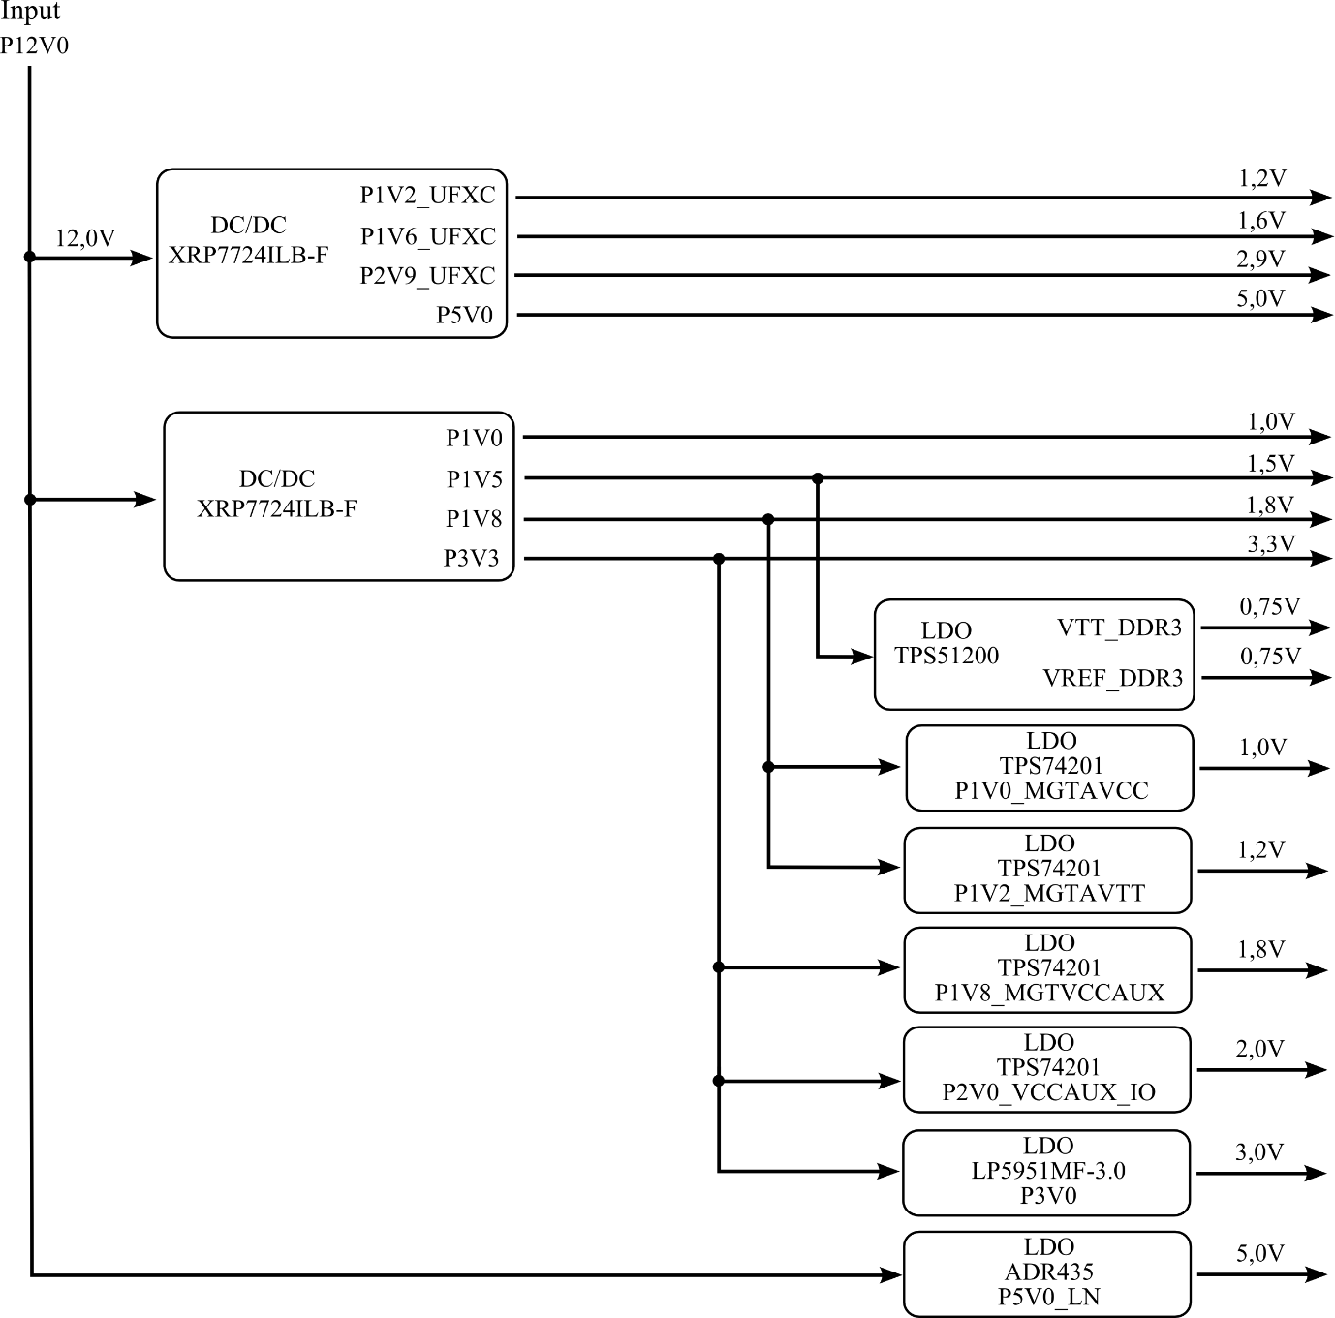

Figure 5‑37: Power supply chain of the Communication Board

P12V0 is the main power supply from the external power adaptor. There are two quad synchronous buck converters that convert the main supply into several voltages. Each converter channel consists of a common controller/driver (XRP7724) and external, high power transistors (STL60N32N3LL). P1V2, P1V6, P2V9 and P5V0 rails supply the mainboard through a Searay Connector. Other voltages from a second DC/DC converter, P1V0, P1V5, P1V8 and P3V3 supply the SoC, some peripherals and LDOs. LDOs are used to supply noise-sensitive parts e.g. the SoC GTX transceivers or the DDR3 reference voltage.

Detailed electrical schematics are presented in the Power.SchDoc-, Power supply linear.SchDoc- and Power supply switching.SchDoc-files. The view of the Communication Board is shown in .

Supply, , shutter interface and trigger signals will be delivered using standard Amphenol, M12 ruggedized connectors.

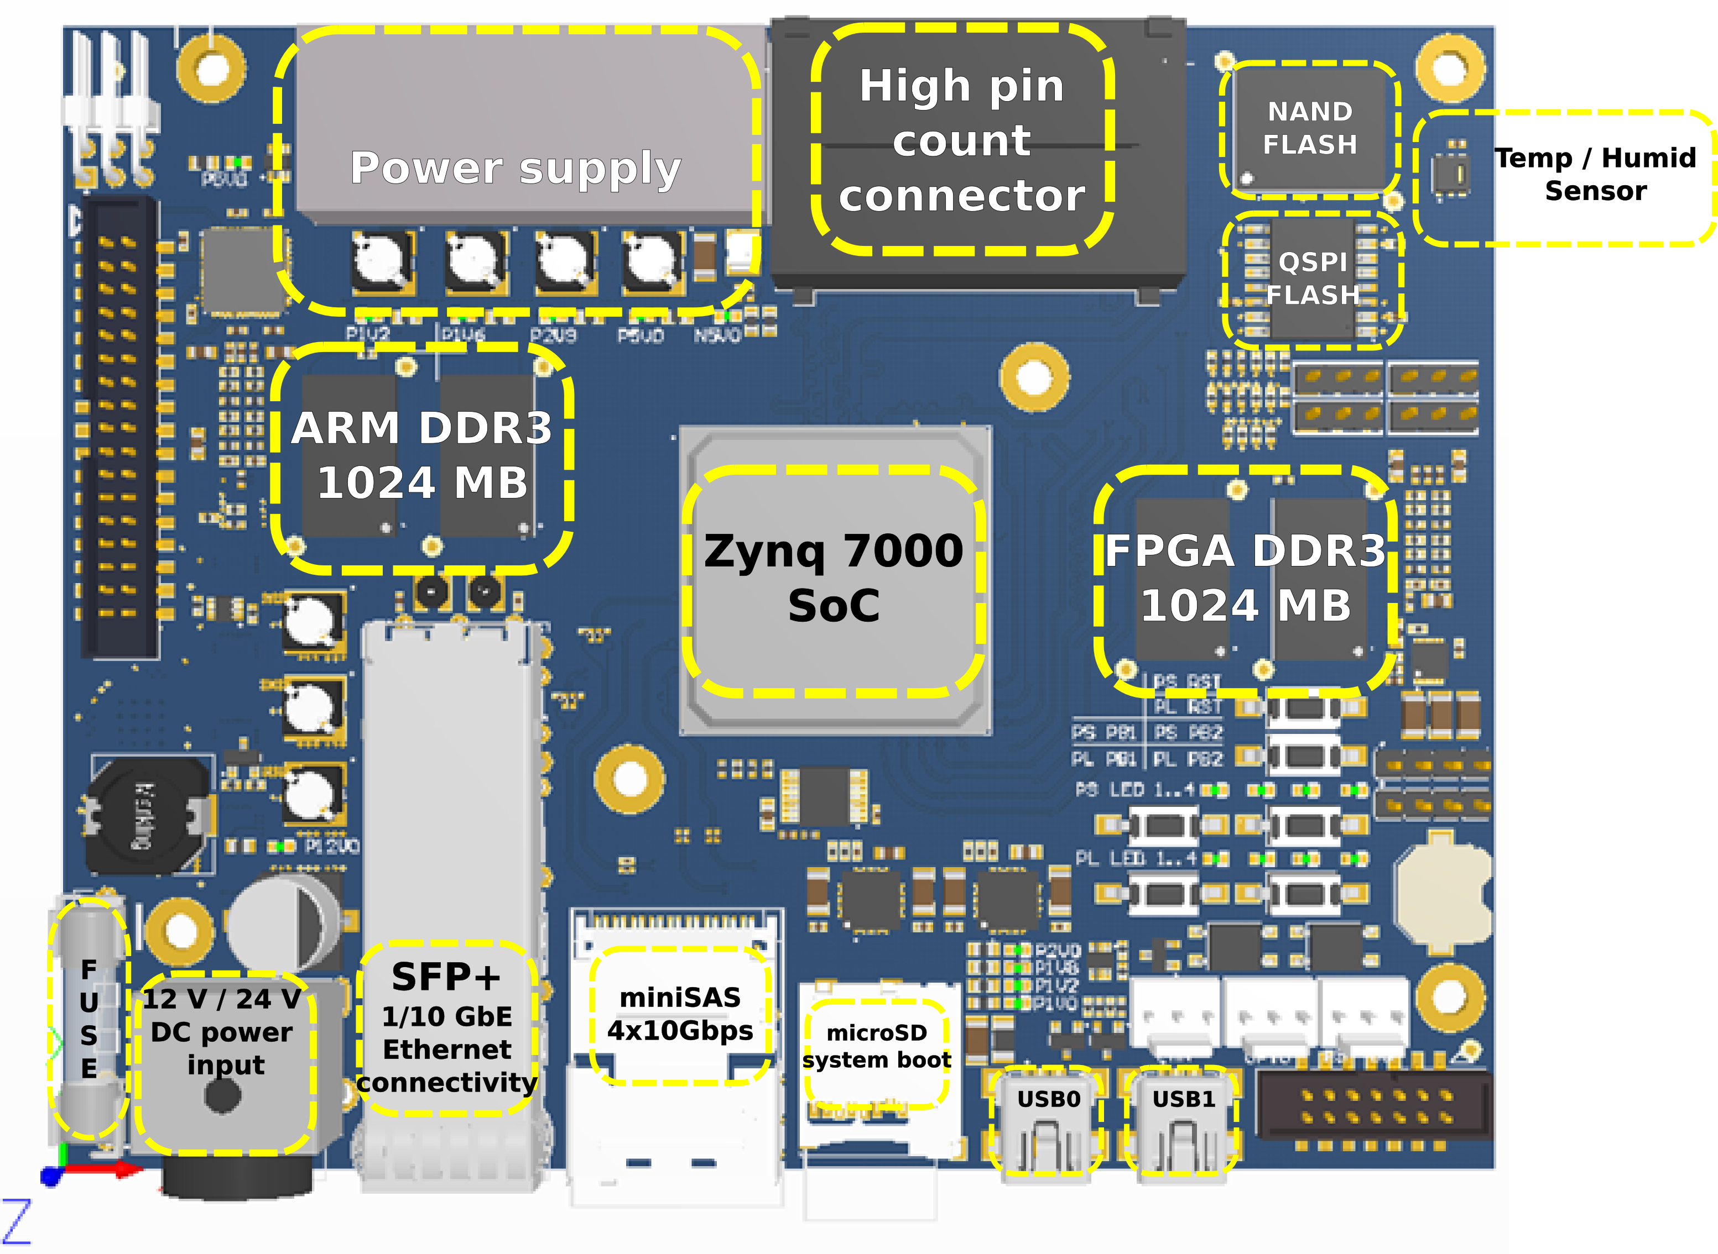

Figure 5‑38: View of the communication board

#### LAN INTERFACE AND DATA LINK TRANSFER ASPECTS

The communication interface of the camera is provided by a SFP+ cage (Small Form-factor Pluggable Transceiver). Several types of optical or copper transceivers will be installed. Gigabit Ethernet or even PCI Express Gen II protocols can be used without hardware modifications.

To enable the communication between several cameras, Gigabit Ethernet and TCP protocol are implemented. This provides an option for each camera for its full autonomy control and data acquisition. Since each camera has an independent operating system, the measurement data (FITS files) can be stored directly using NFS or FTP protocols on suitable servers.

The main system architecture data path starts at the CCD sensor readout (16 ADCs) and end at the FPGA fabric in Zynq SoC. The Data can be read from the sensor and sent to the processing system in real time. The latter packages the data into FITS format and sends the according FITS files to the control system (PC server) via a Gigabit Ethernet interface (). Gigabit Ethernet is implemented by means of a GTX transceiver and PCS/PMA logics. It cooperates with a hardcoded MAC block that is directly connected to the ZynQ CPU subsection.

The AFE produces 16 serial streams of 100Mbit/s each. These streams are de-serialized by the IP Core and transferred by the AXI stream to the ZynQ memory.

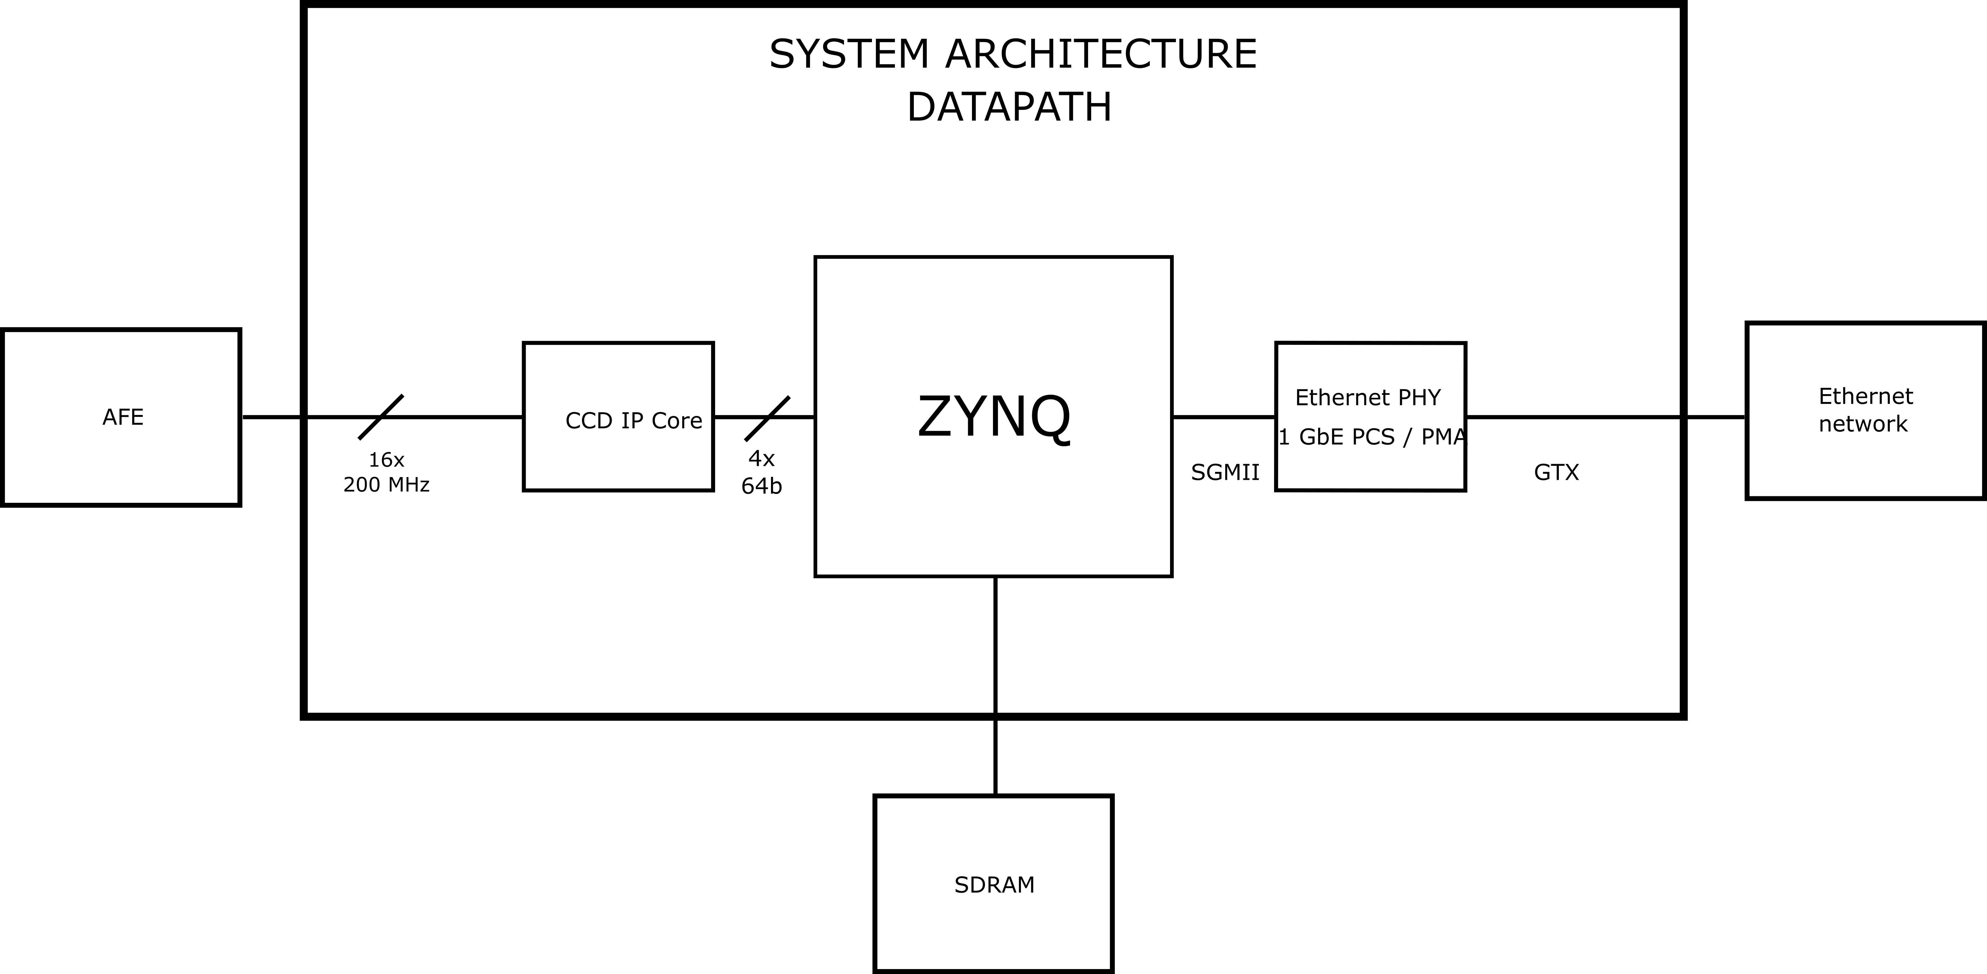

Figure 5‑39: Data path

#### TIME AND SYNCHRONIZATION INTERFACE (NTP,PTP ETC)

Precise time synchronization of the readout and the shutter operation is ensured by the readout and shutter controllers that are implemented entirely in the hardware, in particular to avoid an image smearing, e.g. by starting the read-out before a complete closing of the shutter.

A low jitter of the order of 10us shall guarantee homogeneity. For the precise knowledge about the exact position of the shutter blade(s) during opening and closing, a high precision encoder signal is recorded and stamped using the PTP timing. PTP synchronization is shown in

*Figure 5‑40*.

The shutter can be triggered by the camera in the proposed solution depending on its operational status (exposing, readout). Synchronization between individual cameras will be ensured by the central trigger that will coordinate the functionalities of the different cameras in order to keep them in temporal coincidence. The trigger can be generated using an opto-coupled input or LAN at a specified time.

The ZynQ SoC Media Access Controller block already has a PTP protocol implemented. A microsecond accuracy is achievable with a dedicated Linux driver. Other protocols like NTP are also implemented, using the standard Linux daemon service.

The following actions of the camera are time-stamped:

* trigger event
* start of shutter opening
* end of shutter closing
* start of CCD readout
* end of CCD readout
* shutter profile.

Time-stamping is partially implemented in the hardware, partially also in the software. Each event triggers a Core 1 CPU interrupt that reads the time-stamp value from the PTP Ethernet register in MAC and assigns it to the specific event. Such a solution is a compromise between complexity and accuracy, because ZynQ does not give direct hardware access to the time-stamp register in PTP MAC.

The figure below presents schematic of PTP synchronization subsystem. Each camera as well as processing server PC is connected to common Gigabit Ethernet Switch with PTP capability. PTP time master is used to distribute time to whole NEOSTEL installation ().

D:\Users\Greg\Documents\Creotech\ESA\NEOSTEL\RPD-new\obrazy\ptp.emf

*Figure 5‑40: PTP Synchronization*

#### TRIGGER

Multiple NEOSTEL cameras image capture can be triggered in two scenarios: by hardware and by software. An external hardware trigger is applied through optocoupled logic level inputs (there will be no ground loop problem). Firstly an external electronics module can control analog trigger signals for all cameras. Secondly cameras itself can control image capture (via EPICS or continuously within a certain period). Each signal assertion is time-stamped. Trigger signals are: Open/Close blade #1, Open/Close blade #2, Arm camera and Trigger CCD readout. Shutter blades are controlled separately and cannot be opened when the camera is not armed. Triggering scheme is shown in

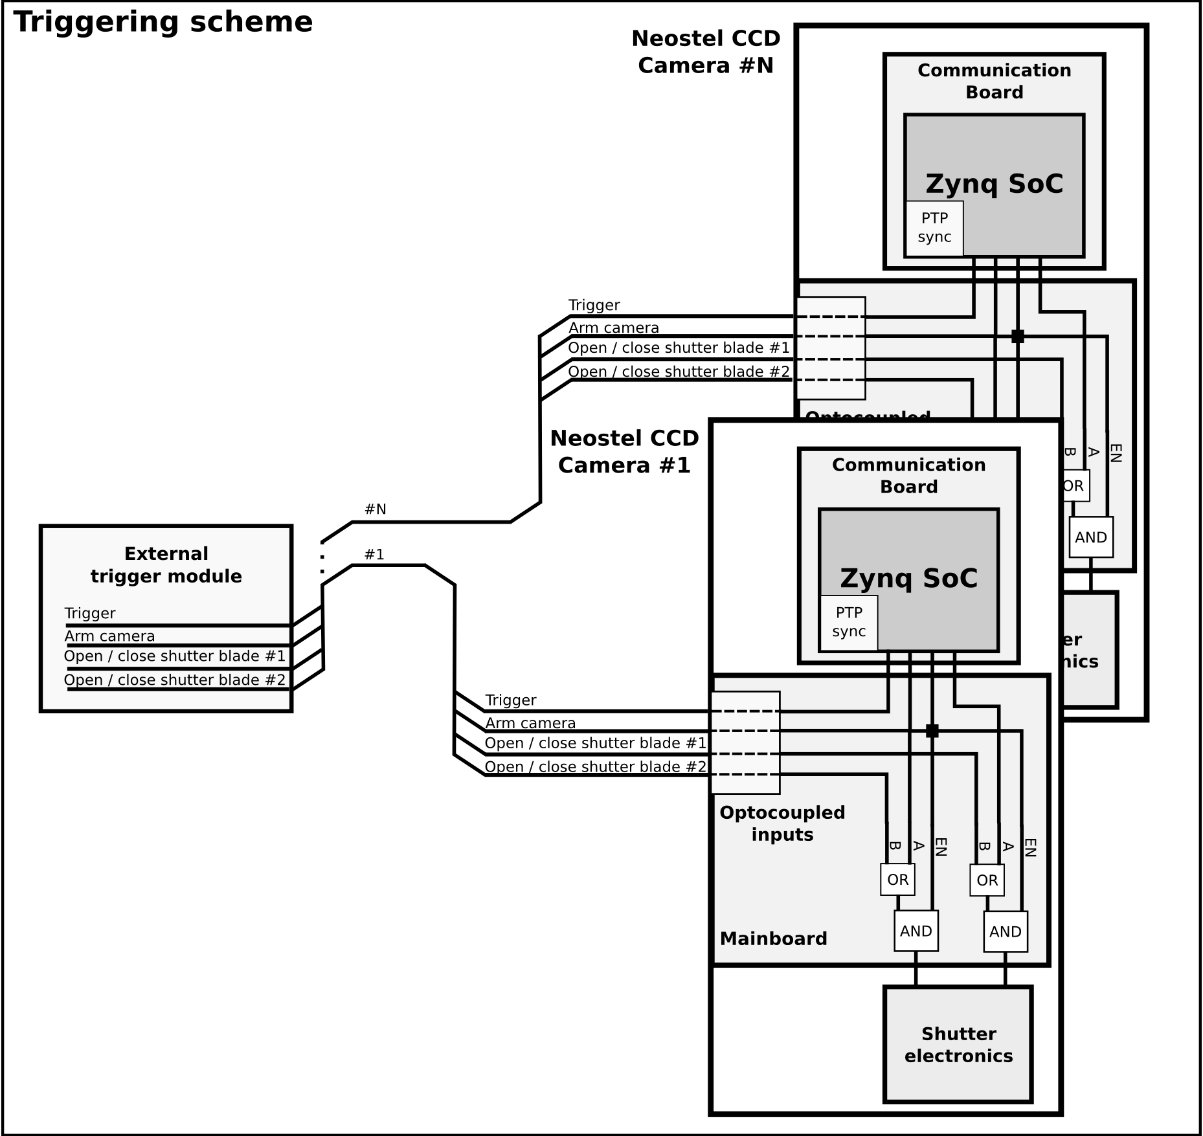

*Figure 5‑41: Triggering Scheme*

### MAINBOARD

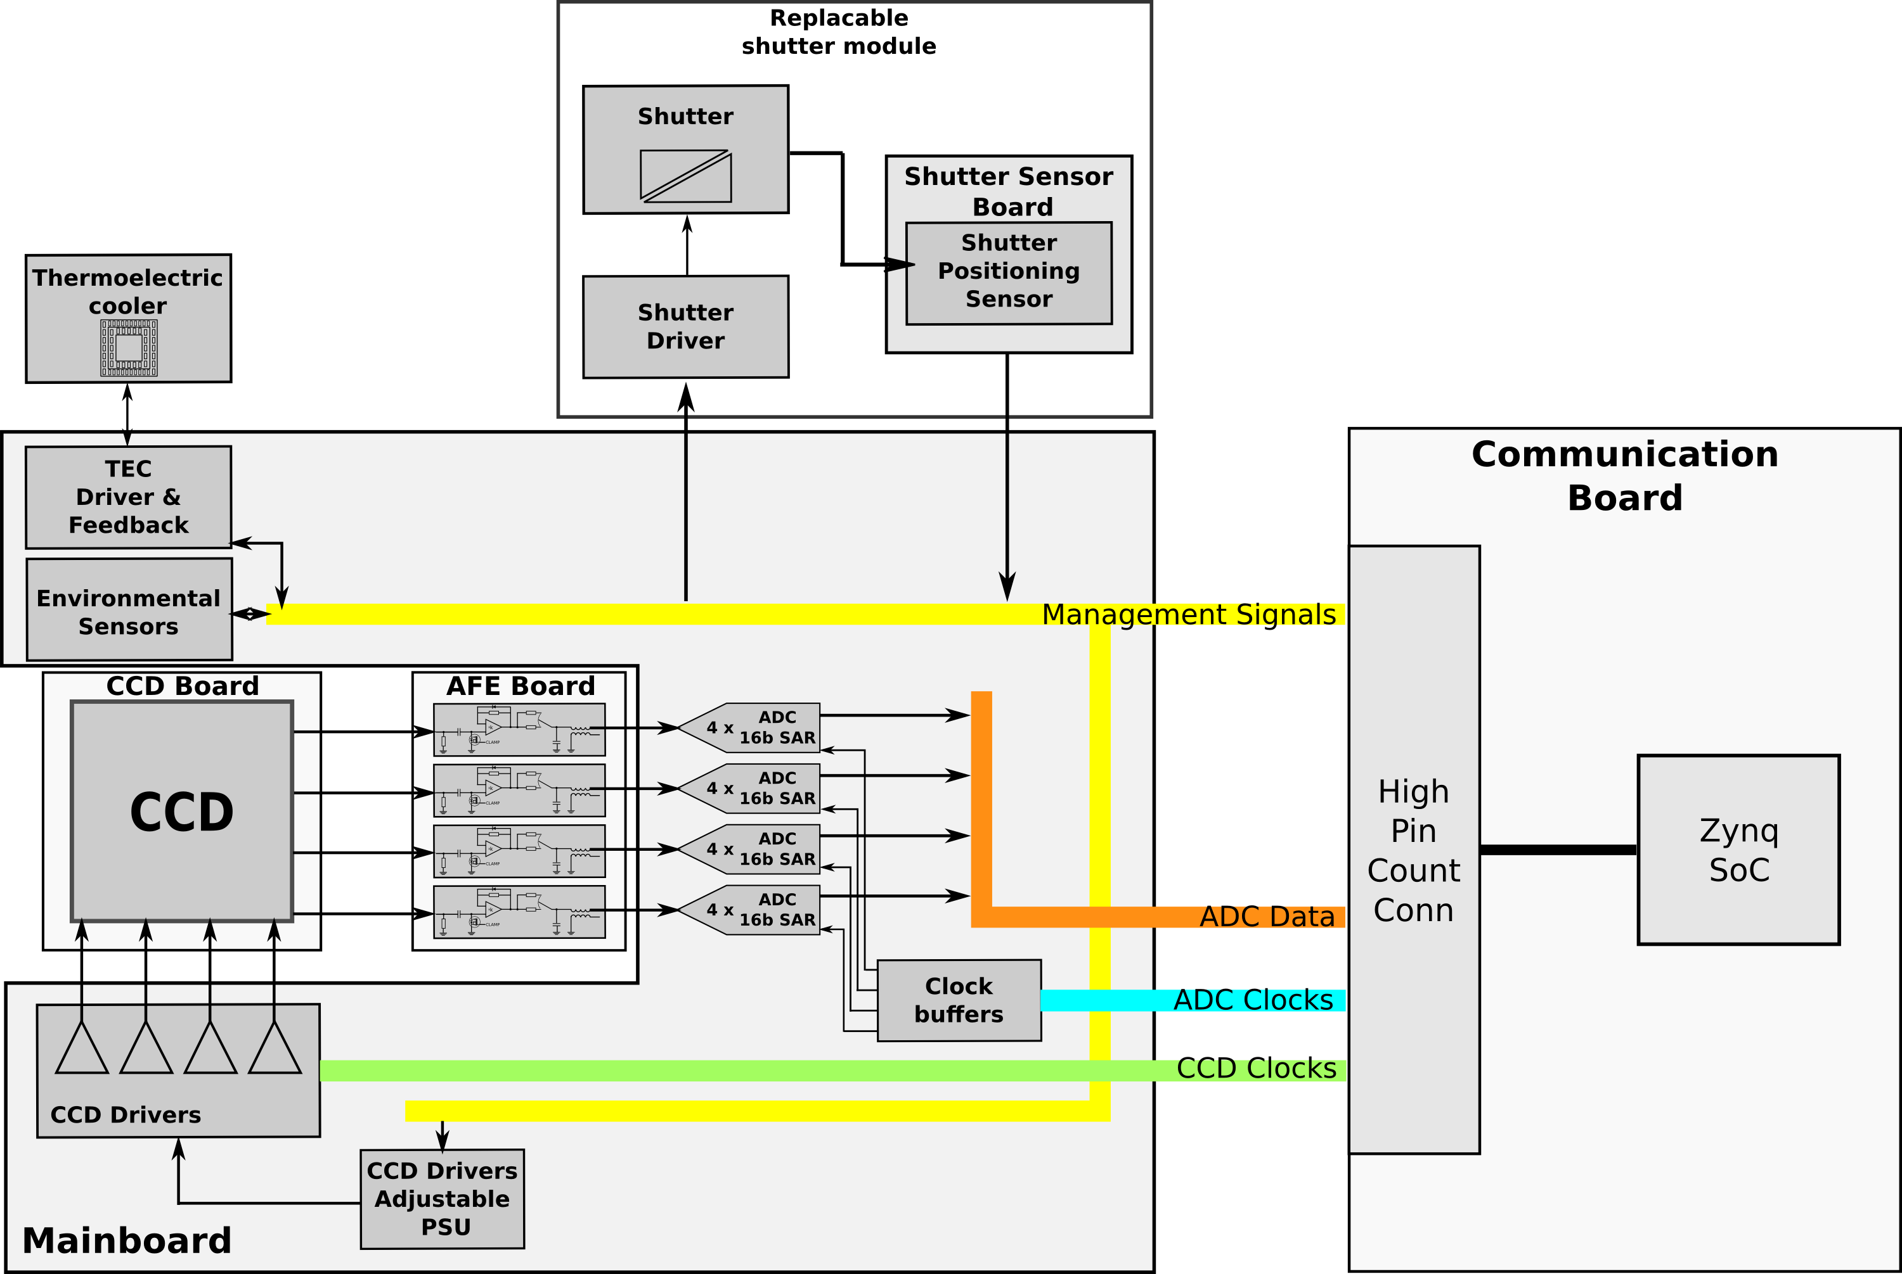

Figure 5‑42: Mainboard, CCD and shutter block diagram



*Figure 5‑42* shows the block diagram of the systems connected to Mainboard.

The Analog Devices ADC (AD7960) 18bit SAR converters have been selected due to their low noise abilities, a high SNR and the relative high sampling rate. Four ADCs will be implemented to sample each CCD channel – the goal is to oversample the signal and to utilize a digital signal processing to filter white and correlated noise. To lower the jitter of sampling clocks, an additional buffer will be used that distributes the signal point-to-point.

The Analog-Front-End (AFE) board contains a circuitry designed to process raw analogue data from the CCD matrix. Depending on its implementation it can be CDS, adaptive filtering and buffering of the input signal. Several implementations are considered and the one with best noise characteristics will be used in the final version of the camera.

The Shutter driver is enclosed in the shutter case and implemented as a linear amplifier with a current limiter (through feedback), working in a half bridge configuration. The position detection of the shutter position is based on differential capacitive sensor. It is connected with the Mainboard using dedicated sealed connector where RS485, I2C and logic control signals are distributed.

The Mainboard also contains the Peltier Thermoelectric Cooler (TEC) with a half bridge driver set trough a PWM controller. An additional feedback circuit is used on the board to measure the current of the Peltier module. The PWM operation is synchronized with the CCD operation to prevent a noise interference propagation to the AFE chain.

The board also has a dedicated ADC for reading the PT1000 temperature sensors that measure the temperature in different parts of the camera.

#### CCD AND CCD DRIVING SIGNAL

The main task of the camera Mainboard is to provide power to all other modules of the camera - generated from one single standard 24V power entry and CCD control. All voltages needed by the detector module - power, bias, reset and clocking upper and lower levels - are adjustable by Digital-to-Analog Converters (DACs). The programmable range fits within the safety region defined by the sensor manufacturer.

The sensor is the most critical part of the design. Therefore, the NEOSTEL camera was designed to support at least two different CCD vendors – E2V and Andanta, given the possibility that one CCD prototype could not be available at the time of deployment. A third vendor, Fairchild Imaging does not produce suitable sensors anymore. The summarizes the parameters of the two foreseen sensors.

The E2V sensor is described by the manufacturer in a substrate biased configuration at positive level (instead of ground) to enable positive voltage biasing and clocking. However, a bipolar operation was selected, with the substrate connected to the ground to preserve similar supply and driving circuits for both sensors. All driving and biasing voltages specified by the manufacturer were corrected by the resulting bias voltages. Thanks to this approach, both sensors can be driven by similar voltage levels and differences can just be compensated by means of resistive dividers at the LDO regulators. The E2V CCD230-84 is considered as the preferred sensor while Andanta CCD4150A is the backup one.

Table 5‑6: CCD Sensors Comparison

|  |  |  |  |
| --- | --- | --- | --- |
| CCD sensors comparison | | | |
| Parameter | Sensor 1 | Sensor 2 (preferred) | Unit |
| Summary specification | | | |
| Sensor name | CCD4150A | CCD230-84 |  |
| Manufacturer | Andanta | E2V |  |
| Resolution | 4096 x 4096 | 4096 x 4096 | pix |
| Pixel size | 15 x 15 | 15 x 15 | μm |
| Image Area | 61.44 x 61.44 | 61.44 x 61.44 | mm |
| Clocking sequence | three-phase | four-phase |  |
| Illumination | backside | backside |  |
| Outputs | 4 | 4 |  |
| Fill factor | near 100 | near 100 | % |
| Maximum rate of heating or cooling | N/A | 5 | K/min |
| Performance specification | | | |
| Full well capacity (Image) | 300 k | 150 k | e- |
| Output amplifier sensitivity | 5 | 2.5 | μV/e- |
| Charge transfer efficiency | >99.999 | 99.995 | % |
| Spectral range | 300 -1060 | 300 -1060 | nm |
| Maximum readout frequency | 3 | 5 | MHz |
| DC Operating voltages | | | |
| Substrate | 0 | 0 | V |
| Output Drain | 24 | 20 | V |
| Reset Drain | 15 | 8 | V |
| Output Transfer Gate | -1 | -7 | V |
| Output DC Level | 16 | 15 | V |
| Clock voltages | | | |
| Reset Gate low | -2 | -9 | V |
| Reset Gate high | 8 | 1 | V |
| Summing Well gate low | -5 | -9 | V |
| Summing Well gate high | 5 | 1 | V |
| Horizontal clocks low | -5 | -9 | V |
| Horizontal clocks high | 5 | 1 | V |
| Vertical clocks low | -9 | -9 | V |
| Vertical clocks high | 3 | 1 | V |

The CCD sensor requires several bias voltages that are generated by low noise – Low Drop Out (LDO) regulators that are trimmed by DACs.

The CCD drivers require a low ripple and stable power supply. Therefore, all needed power voltages are provided by LM1117/LM337 LDO and linear regulators that are trimmed by DACs. The industrial temperature range for all semiconductors was chosen.

For the horizontal and vertical transfer electrodes, EL7457 drivers are used. At the output of these drivers, resistors are installed that limit dv/dt. A too high dv/dt would cause charge efficiency degradations.

CCD drivers are controlled together with AFE control signals by a micro-programmed state-machine (automata) with stack, capable of generating set-up signal patterns and interpreting simple conditional commands. The CCD drivers are implemented by means of RAM memory and can be programmed via an AXI Lite bus directly by software on PS. Optional binning and advanced readout modes can be easily implemented by dedicated sub-routines.

Control and readout for the CCD sensor are performed entirely on Communication Board. 16 ADCs are controlled for the reading of the CCD data. The IP core has status, control and configuration registers which are available via the system bus. Two different trigger signals can trigger the sensor frame acquisition: an external trigger or internal trigger. The internal trigger is controlled by software and can be synchronized via PTP (by a software running daemon). As mentioned within the system diagram, certain actions are time-stamped and an exposition-time timer counts the frame exposition.

The Readout frequency is programmable and can be adjusted by means of two timers as part of the CCD control Finite State Machine (FSM). Any multiple of the clock frequency can be programmed including 2MHz and 500kHz.

The requirement for the usage of different sensors is another key-aspect. The CCD Control FSM consists of a programmable pattern generator which controls outputs that further controls the analogue front end of the sensor and generates the necessary clock and reset signals. The internal program of the pattern generator can be changed, as it is implemented in the system as Block RAM memory. The difference in clocking sequence between E2V and Andanta is part of the actual dual CCD source solution.

When it comes to the CCD sensor decision E2V is regarded as a better solution, due to the fact that it has better dark current noise parameter which is one of the key parameters for the designed camera. Additional advantage over the alternative sensor is that it has got additional inputs which allows for faster binning and cleanup process.

#### SENSORS AND MONITORING HARDWARE

The Mainboard will have an ADC to connect with the PT100 temperature sensors which will measure the temperature at the different parts of the camera. An additional integrated 3-axis accelerometer and temperature sensor will be placed on the PCB. The function of the accelerometer is detection of vibrations caused by e.g. the shutter.

In addition, several temperature sensors will be installed at the cooling inlet and outputs, close to the CPU and other critical camera components. The temperature sensors will be equipped with hardware monitors that can shut down the TEC operation by wire.

### ANALOG FRONT END

The main task of the Analogue Front End (AFE) is to digitalize analogue CCD output signals with Analogue Digital Converters (ADCs) and to feed them into the FPGA. The separation of the AFE from the rest of the digital modules and high current sinking components provides additional noise and jitter immunity. The sampling clock is generated locally by means of a low phase noise generator for the reduction of additional jitter. Digitalized data are passed serially to the Communication Board with a minimum of noise induced by the sampling process. This requires low voltage output (differential) interfaces and some additional digital buffering near the ADC components.

This approach (given a proper Printed Circuit Board (PCB) routing) enables a conversion of the CCD readout without compromising the S/N ratio over a wide band of frequencies and allows a 4x oversampling ratio and the application of digital filtering techniques implemented in the FPGA.

Sixteen AD7960 ADCs are used. Each of them is a high precision18 bit SAR running at max. 5MSPS i.e. resulting in a minimum of 200 ns between consecutive samples. In order to enable oversampling, 4 ADCs per channel are used. As it is well known, few last LSB represents noise and INL differences between channels. In order to account for that we discard the last two bits (LSBs).

The ADC interface is responsible for reading sampled data from the ADC, grouping these data into pixels and sending the data along with synchronization signals (data valid, frame valid) to the Direct Memory Access (DMA) engine. Because the CCD sensor has 4 read channels, the ADCs are aggregated into four groups of four ADCs each. Each group of ADCs samples both black and video levels of the CCD signal for a single channel as shown in the following figure. Each ADC group needs 4 phase-shifted CNV signals to trigger the ADC sampling at the appropriate moment.

Due to the maximum speed of each ADC being 5MSPS, the maximum achievable pixel-readout speed is 2.5MPix per second in the proposed configuration. The minimum data readout clock at 5MSPS is 125MHz.

A general block chart of the ADC interface (ADCI) is presented in . The ADC Interface consists of a general control state machine, of sync-signal generating state-machines and 16 ADC readout cores. The general-control state-machine is responsible for overall core synchronization of the control signals that are generated by the CCD driver Finite State Machine (FSM). Sync signal generating state machines along with appropriate counters generate the video control signals needed by the Video Direct Memory Access (VDMA). 16 ADC readout cores are responsible for generating the readout clock for the ADC, the readout of serial data, the deserialization and the grouping of the samples of the CCD signal into pixels. Each pixel consists of 4 samples of black level and 4 samples of video level. Pixel data and video control signals are connected to the DMA engine, as described in the next section.

All signals sourced in the FPGA (clocks and data signals) are characterized by a certain amount of jitter (even 1ns pp). For some signals, the jitter is noncritical, provided that adequate timing margins are ensured. For the ADC conversion trigger, jitter is a critical parameter for achieving the expected SNR. CNV signals coming from the CCD Driver will be resynchronized by internal Input Output Blocks in the FPGA.

The entire readout electronics has a common clock source. All clocks responsible for the CCD readout, sampling and charge shift are derived from a common clock source. There are different frequencies but they remain in constant phase relationship. The AFE is placed on a dedicated, shielded module. Common mode chokes and Signal Integrity control methods are used to minimize cross-talks.

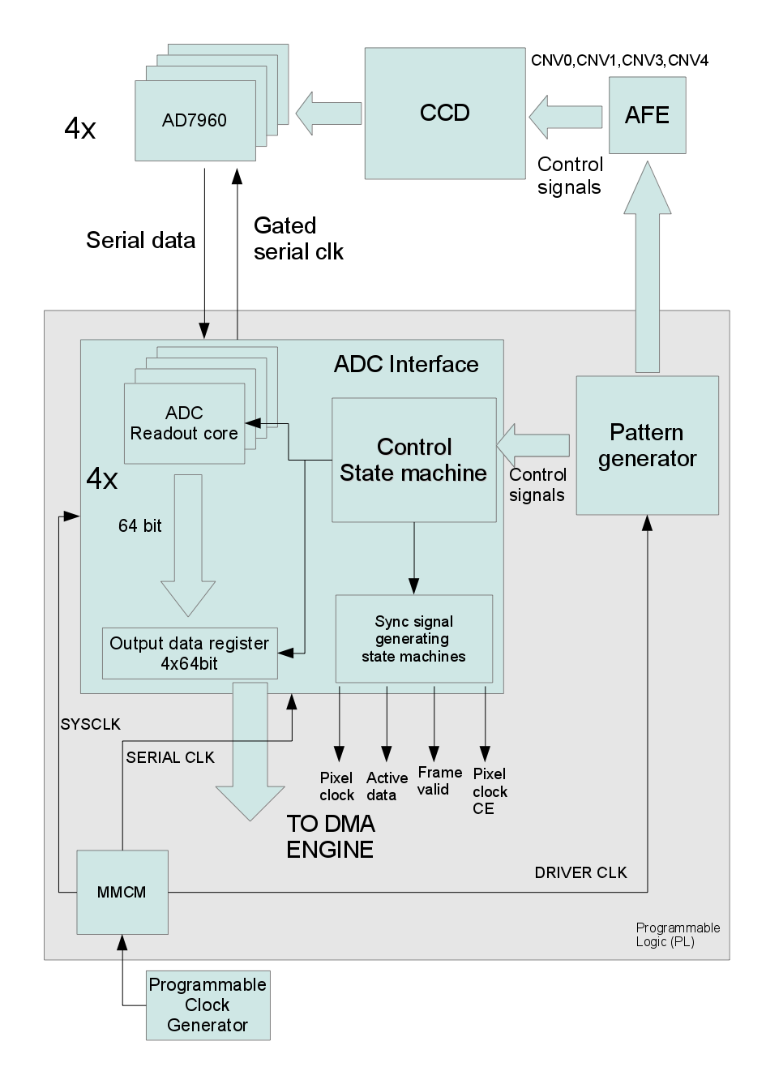

Figure 5‑43: AFE block schematic

#### NOISE MITIGATION

Readout noise is one of the limiting factors that affect camera sensitivity and SNR. There are several noise sources in the design that need to be carefully investigated.

Each acquisition channel is sampled by four Analog Device AD7960 5Msps 18bit SAR ADCs. All of the ADCs' sampling clocks inputs are driven by the signals equal in frequency but with different phase. This allows to oversample reference and pixel levels of the output signal and use DSP techniques to enhance signal to noise ratio. ().

SAR ADCs show best resolution and accuracy versus sampling rate ratio. In contrary, Sigma-Delta ADCs would offer up to 24 bits but have limited bandwidth and lower accuracy. Flash ADCs would reach Gsps but with an Effective Number Of Bits (ENOB) around 8-12bits. The AD7960 has best fitted parameters for the application – 5Msps are close to the pixel clock and 18bit resolution necessary to reach a sufficient SNR.

#### OVERSAMPLING

The timing diagram below shows the sampling scheme used for a single channel of the CCD acquisition system when highest readout frequency of 2MHz is used. Under this condition duration of pixel and reference levels is about 250ns, minus signal edges and reset pulse. Usage of four 5 Msps ADCs allows to gather 4 samples per each signal level. Considering that the video information itself is the arithmetic difference between voltages of the levels, oversampling allows to gather 8 samples per pixel. Oversampling allows to reduce the thermal noise level which will be shown later on. In Sxy denotes Sample y from ADX x.



Figure 5‑44: CCD signal oversampling (Reset pulse not shown)

Without oversampling, SNR for a single ADC is equal to:

SNR(dB) = 6.02\*ENOB + 1.76

Oversampling with k samples improves SNR by 10log10(k).

In the ideal case, a 18bit ADC and 4 samples per pixel would result in a SNR of:

SNR(dB) = 18\*6,02 + 1.76 + 10log10(4) = 117dB

After the consideration of noise, INL, and DNL between four ADCs, 2 Least Significant Bits (LSBs) have to be dropped:

SNR(dB) = 16\*6,02 + 1.76 + 10log10(4) = 104dB

The oversampled signal has to be averaged and subtracted for obtaining the actual pixel value. This operation in digital signal processing corresponds to a Correlated Double Sampling in analogue processing. It lowers the white noise in magnitude – the effective oversampling amounts to a factor of eight, not four:

SNR(dB) = 16\*6,02 + 1.76 + 10log10(8) = 107dB

Oversampling and Correlated Double Sampling (CDS) do not remove the correlated noise – unless they are in phase with the sampling clock. To remove the correlated noise, an estimator for both levels has to be calculated and subtracted from the signal before an averaging and the CDS. A X^2 estimator is used, because it does not consider any specific noise distribution. This estimation allows the removal of the reset noise and power line hum. However, it is difficult to predict how much this will improve the SNR.

Readout noise is proportional to the bandwidth. In the NEOSTEL camera case, the bandwidth is shaped in the digital domain by a digital filtering. The readout noise then depends on the readout frequency – the higher the frequency, the higher the noise.

The oversampling will not impact on the final data transfer rate.

#### ANALOGUE SIGNAL PATH NOISE

The block diagram below () shows the signal path between one CCD output and one group of ADCs.



Figure 5‑45: Analog signal path

The output of the CCD is a transistor with an open drain output. To be operational, it needs additional resistor load, which is installed on the AFE board. A capacitor is placed to cut off the DC level from the CCD which tends to depend on temperature and additional factors. A MOSFET transistor driven by a CLAMP signal is used to shift the reference level to zero volt. This solution ensures that pixel level voltage will be negative and referenced to the ground. Reset pulse will be therefore positive, and has to be cut out to protect signal amplifier input from overvoltage. The protection is implemented by a diode in operational amplifier's feedback loop.

A noise reduction section is implemented as a RC low-pass filter with an adjustable bandwidth. Pass frequency is change by switching serial resistance of the filter. A small resistor is used to provide wide bandwidth which is required to transfer sharp signal edges. When reference or pixel level is reached, DC value of the signal is measured. To minimize noise, filter is switched to higher resistance which narrows the bandwidth. The noise added by the filter depends only on the capacitor value.

After the noise reduction, the signal is transformed from a single ended to a differential signal with a high common mode rejection of RF noise. The signal is adjusted on the Mainboard to fit ADC's accepted input levels.

For the initial simulation in a Tina-TI simulator (), an equivalent circuit has been designed. The signal amplification was implemented with an OPA355 OPAMP whereas the buffering was realized with a THS4531 OPAMP. The results of this filtering are presented below. The noise reduction module moves the corner frequency of 1/f noise from the original position of few megahertz to 300Hz. This improves the noise in the band from zero to 5MHz (sampling rate of the ADC) by more than a factor of 10.



Figure 5‑46: Filtering Results

### SHUTTER ELECTRICAL DESIGN

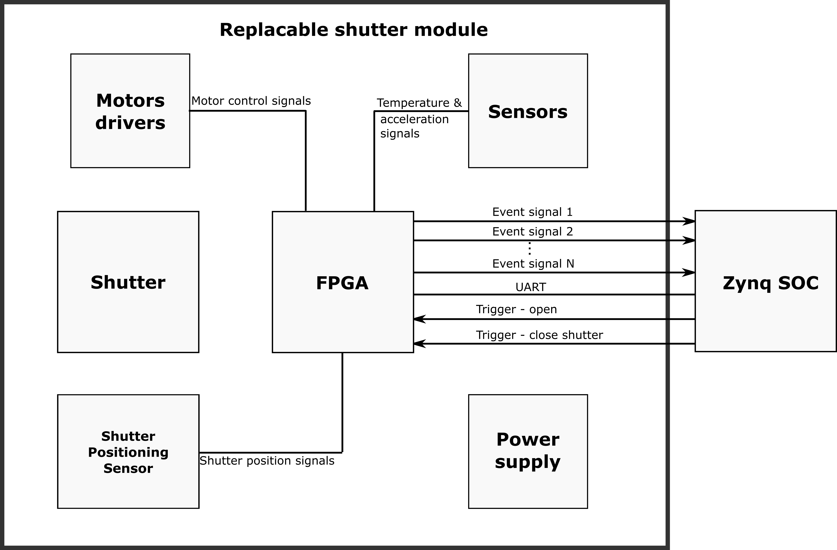

Figure 5‑47: Shutter's module block diagram

Electronics of the shutter is placed inside the shutter’s replaceable module. It consists of an FPGA which controls the shutter mechanism and receives the information about shutter position from the shutter sensor. The shutter module is configurable via UART interface. The shutter can also be controlled via UART or analog trigger signals. Output event signals are asserted when certain actions take place like correct shutter opening and closure. presents the block diagram of the shutter’s module internals.

#### SHUTTER POSITION SENSOR

The shutter positioning system is based on a capacitance measurement. A Small PCB copper plane is placed under each shutter leaf, creating a capacitor whose capacitance dependents upon the position of the leaf. A high frequency generator is connected to the shutter and the plane – leading to a current flow which depends on the shutter-plane capacitance. The current is directed to a known resistance. This allows to measure the voltage drop-out and to calculate the shutter-plane capacitance ().



Figure 5‑48: Position sensor schematic (describe how it works)

#### SHUTTER DRIVER

Each shutter motor has an independent driver channel, allowing to control the movement of each leaf. The separation of the individual channels allows a synchronization of the speed of both leafs despite the differences in the direction of the gravitational force. The diagram below shows one single shutter driver channel.

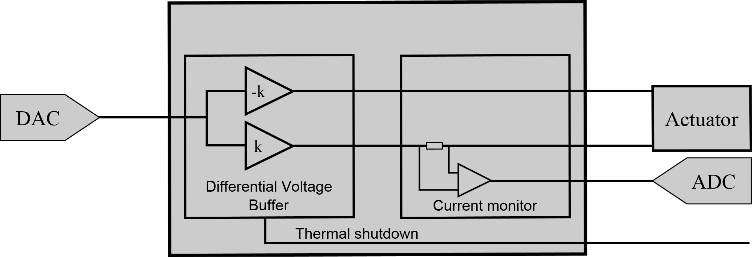

Figure 5‑49: Shutter driver channel (shutter actuator)

The shutter driver channels () are controlled by a single SPI Digital to Analogue Converter (DAC) with two independent analogue outputs – DAC7612. To provide the motors with sufficient current, an additional differential buffer is used. Thus buffer is implemented on OPA548 operational amplifiers with an output current up to 5A. The buffers have an implemented thermal shut-down to protect the shutter driver from overheating. Buffers are connected to output headers by LC PI-type filters to minimize the EMI.

The positive output of the differential buffer is connected to a current monitor, which is implemented as a 10mOhm resistor with an AD8031 operational amplifier, set to a gain of 20. The output of the current monitor is connected to an ADS7945 SPI SAR 14-bit ADC and creates a feedback path. This solution allows to implement control algorithms that can modulate the DAC output to accomplish a constant current drive instead of a constant voltage.

Two modes of shutter driver operation are being considered – an operation with feedback from the shutter positioning subsystem or an operation based on lookup tables. In the first solution, a digital controller e.g. PID is feed with the shutter position and the motor drive current. This allows the adjustment of the speed of the leaf. In the second solution, a table of drive values is created, based on calculation and adjusted by experiments. The table will contain a set of analogue values for the DACs that will be applied within a specific time interval to obtain a repeatable shutter movement.

## FIRMWARE (ARM SOFTWARE + FPGA DESIGN)

### SOFTWARE

#### OPERATING SYSTEM ARCHITECTURE

The Camera operating system architecture is shown in the diagram below ().

**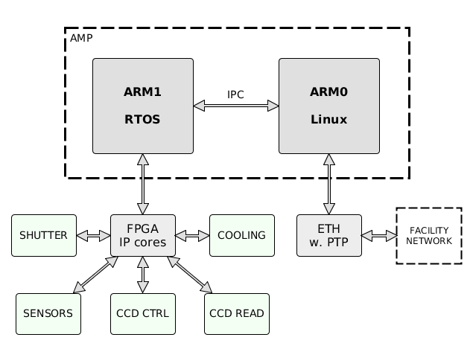**

Figure 5‑50: Operating System Architecture

The camera is running two operating systems: an embedded Linux system and RTOS. Linux is used for the communication and the control of the entire system. RTOS is used for time critical tasks.

The SoC that is used in this design is a two core unit which supports the AMP operation. This way one core is used for Linux and the other is reserved for RTOS. It was verified that FITS meets specification regarding the header size required for time-stamping.

#### RTOS

The purpose of using the Real Time OS is to provide uninterruptable procedure of handling the hardware related events and processes. The RTOS core is connected through AXI bus to the FPGA logic containing IP cores providing:

* CCD IP Core (FSM)
* Shutter interface control IP Core
* Sensor read IP Core
* Cooling subsystem IP Core
* Slow control (actuators etc.) IP Core
* Minor peripheral control IP Cores.

All IP cores have control, configuration and status registers that provide full control over them.

Due to security reasons there is no direct access to the RTOS functions. All of the remote interactions are handled by the Linux OS, to which RTOS is connected with IPC solution.

IPC is based on built-in OCM inside Zynq SoC providing memory access with access arbitration through Snoop Control Unit and Cache Coherency Bus. The caching of shared memory is disabled in MMU unit of the SoC. There are implemented basic mechanisms in OCM such as semaphores, mutexes and message queues. This solution solves the problems with IPC communication such as locks and synchronization problems in case of interconnecting two processors working in asymmetric scheme.

#### LINUX OS

To provide the remote control and data acquisition from the camera, Linux OS is used. It provides flexible, convenient method to achieve:

* Facility level integration with other equipment using EPICS SCADA server
* Data encapsulation in self-describing, interchangeable format using FITS file format
* API for camera functions described in this document
* Data storage on external machines using transports based on TCP/IP, for example NFS or FTP
* Easy camera access with Linux tools, such as SSH etc.
* Internal diagnostics processes checking for software and hardware faults (including external hardware watchdog for system hung).

Linux OS is based on PetaLinux provided by Xilinx for Zynq SoC family. The Linux is compiled from BSP and customized to fulfill requirements of the camera. There are several processes running continuously.

#### EPICS SERVER

EPICS soft IOC is used for providing handlers for API procedures based on IOC database.

EPICS enables the facility control software to easily access the functionalities implemented in the camera including:

* Triggering actions performed by firmware and/or hardware
* Reading values from the system
* Implementing alarms and alarm monitoring of values of diagnostic procedures implemented in the camera
* Periodic scanning of values provided by system components

The EPICS server is based on Channel Access protocol implemented over the TCP/IP protocol and the gigabit Ethernet connection.

#### FITS FORMAT

The FITS format is very versatile since it allows the storage of several non-typical parameters in its header. It is useful for the foreseen monitoring of e.g. temperature and humidity inside and outside the chamber, vibration level, critical digital voltages and currents, TEC current, CCD voltages, and operational status (exposure, readout, idle, failure, vacuum, etc.). The liquid cooling flow is monitored by means of two temperature sensors at the input and output pipes of the camera.

The file format will be implemented according to FITS 3.0 standard defined in “Definition of the Flexible Image Transport System (FITS)” document from the FITS Working Group published 18 November 2010.

Output of the camera with diagnostic data will be fitted in Single Image FITS (SIF) since the additional diagnostics and time-stamping information can be stored as the header keyword values as standard printable ASCII (positions 32-126 in ASCII table) strings which limitation far exceeds the need of representation diagnostic values and timestamps. Minor data can be stored as comments if needed.

The FITS standard allows to store image data as two dimension matrix with integer values. The integer size can be defined up to 64 bit representation, thus it exceeds the 16bit readout of the ADC data. Since there is no limitation for file length additional data can be added if needed.

Calibration activities: the flat fielding, dark current, bias subtraction and pointing model update will be handled by software, but can be also implemented directly into the camera firmware, if necessary.

The storage of the FITS file will be performed by a CFITSIO/CCFITS library. The FITS headers and HDUs will be filled following the NEO-CAM-DR-0150 requirement. Test images (with filled headers and stub raw data) will be supplied with camera.

#### BOOT SEQUENCE

When the input power is applied to the camera, the system starts booting. The Initial boot sequence works as depicted in the diagram below ().

The boot sequence incorporates an initial system test. Basic peripherals needed for the operation are checked. Due to the fact that the system is a multi-camera design, the operational system image is stored remotely. (e.g. on a server available via NFS).

Initially a test version is booted from the QSPI Flash memory. If the initial test has passed, the remotely available image is loaded and the system is restarted. In the second scenario a fail-safe system version is booted.

The initial testing will be performed using uboot procedures. The entire diagnostic output during the boot is logged on a SD card that is attached to the designed board to enable future problem tracing and debug possibilities.

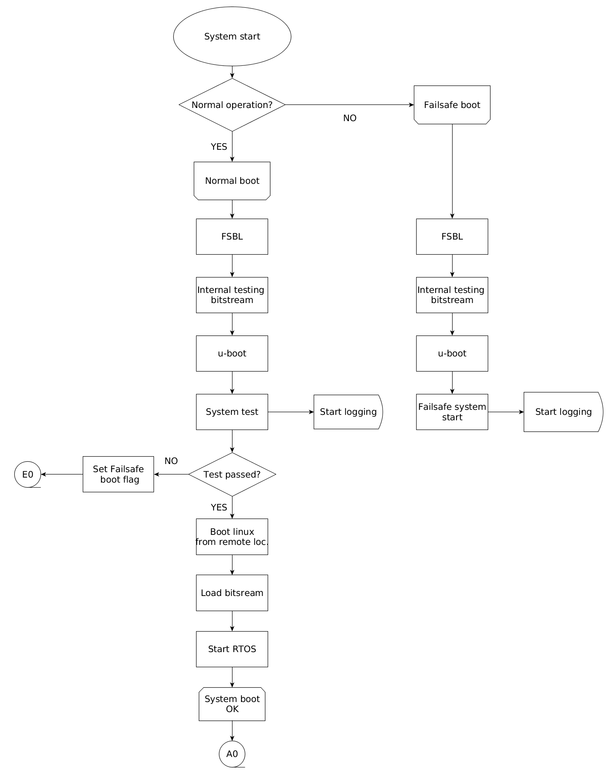

Figure 5‑51: Boot sequence

#### LINUX START

The Linux start sequence is shown below ().

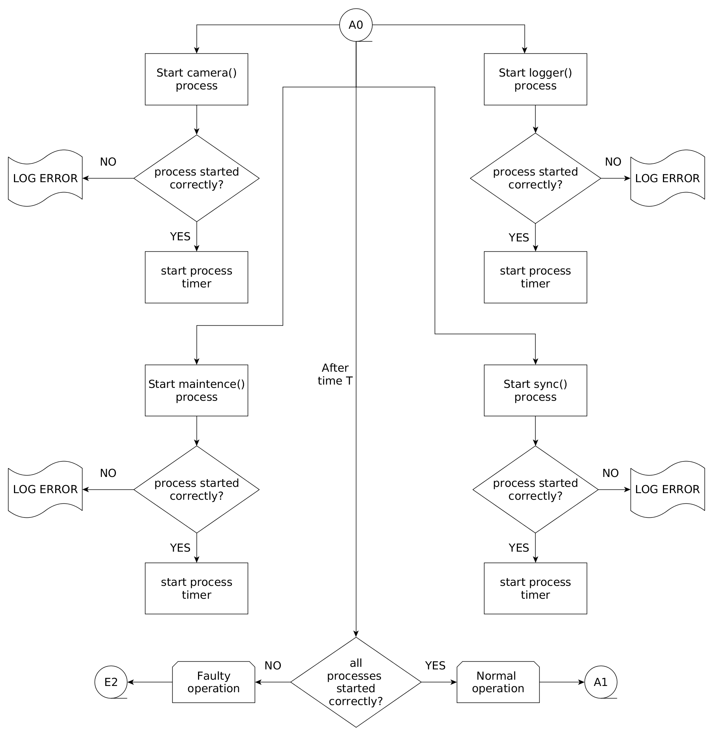

Figure 5‑52: Linux start sequence

After a correct boot procedure, Linux OS starts all processes needed for the proper operation. These processes are responsible for controlling all peripherals and the CCD data acquisition. At this moment normal embedded Linux OS is running and all typical applications and access methods such as SSH are available. Logs are stored internally on a SD Card and can be send additionally via EPICS to the control system or viewed on a serial console. If all processes started correctly the system is moving to the A1 state, which is the normal operation. In the second scenario the system goes to E2 state which means that some subsystems are not fully operational.

#### NORMAL SYSTEM OPERATION

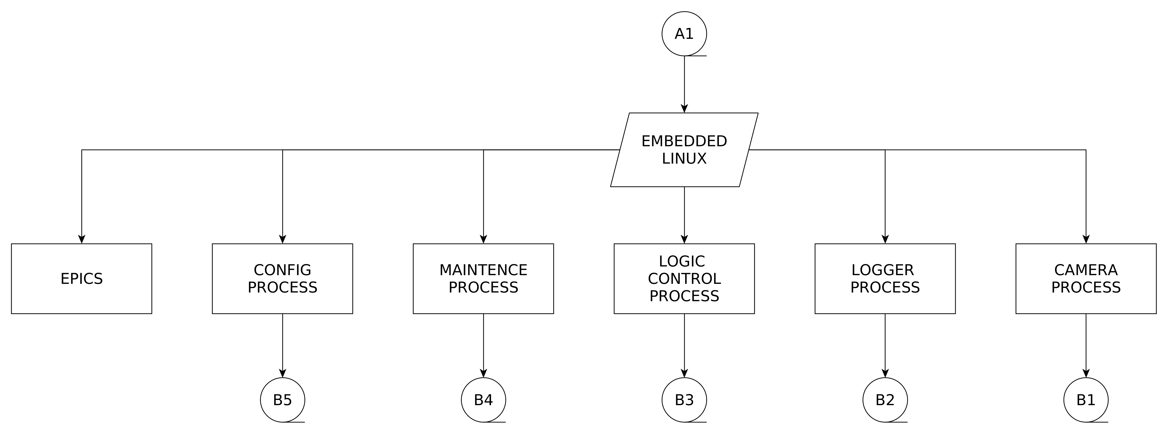

Figure 5‑53: OS processes

The scheme above () shows the normal system operation. An embedded Linux is running along with all processes. EPICS control is using processes and programs that control all of the peripherals.

The system can be controlled via EPICS or manually by logging directly to the system.

The initial setup script, running at the beginning of the boot sequence, provides the default configuration of the device.

Processes running on the camera are responsible for:

* Maintenance – checking all peripherals and the runtime behaviour
* Configuration – set-up of the camera configuration
* Logic control – IP Cores control and set-up
* Logging – storing the entire system behaviour
* Camera control – image acquisition, shutter and readout control.

#### CAMERA PROCESS

The scheme below () shows the system behavior when the image trigger is started. A first basic testing consists in a check if all systems are operational. Then the shutter opening is started.

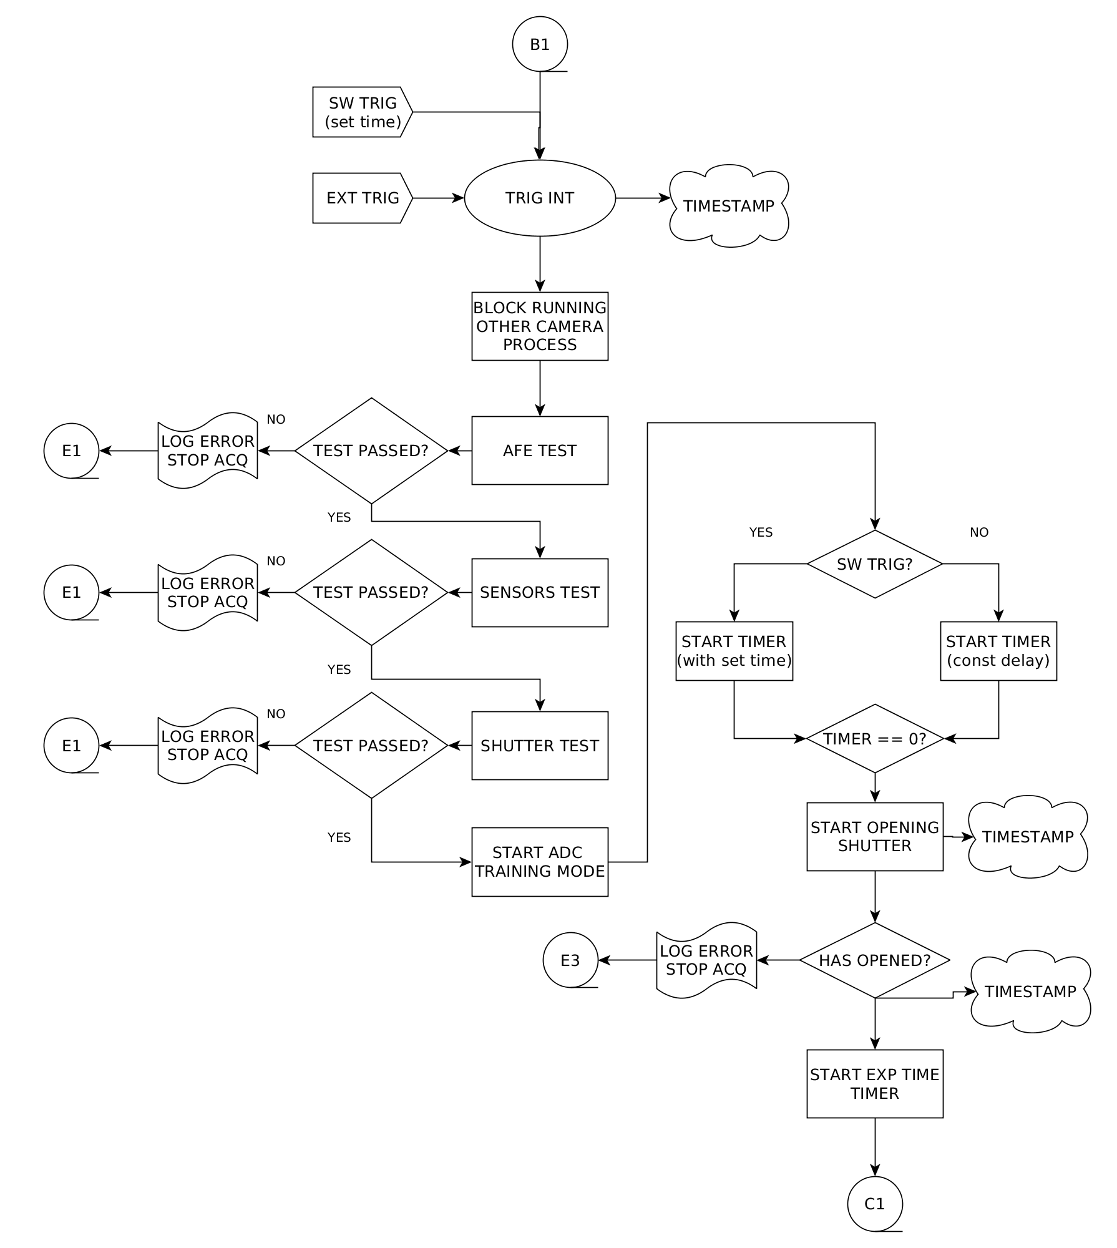

Figure 5‑54: Camera process

The camera process behavior after the opening of the shutter is shown below (). Shutter opening and CCD readout are time stamped. Along with time, the sensor data are stored for each timestamp. Time stamping itself is done within the processing system. The precision of this approach is equal to approx. 3 µs. After the shutter opening, the exposure time is measured and after finishing, the shutter closure procedure is started. Both opening and closing of the shutter can fail, in this scenario the camera process is terminated and disabled.

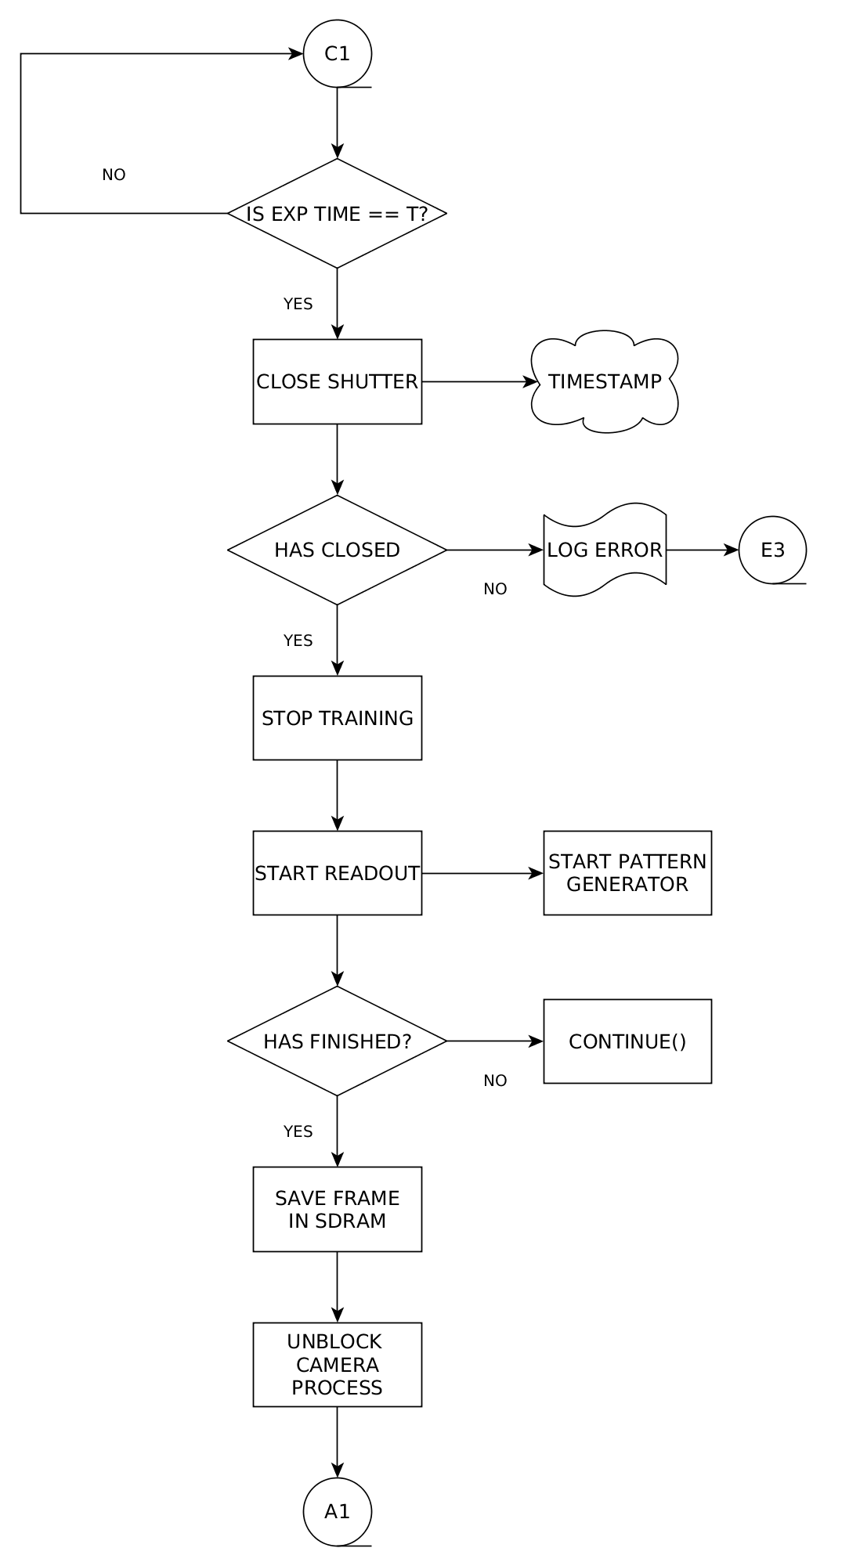

Figure 5‑55: CCD acquisition process

The operations of other background processes are shown below ().

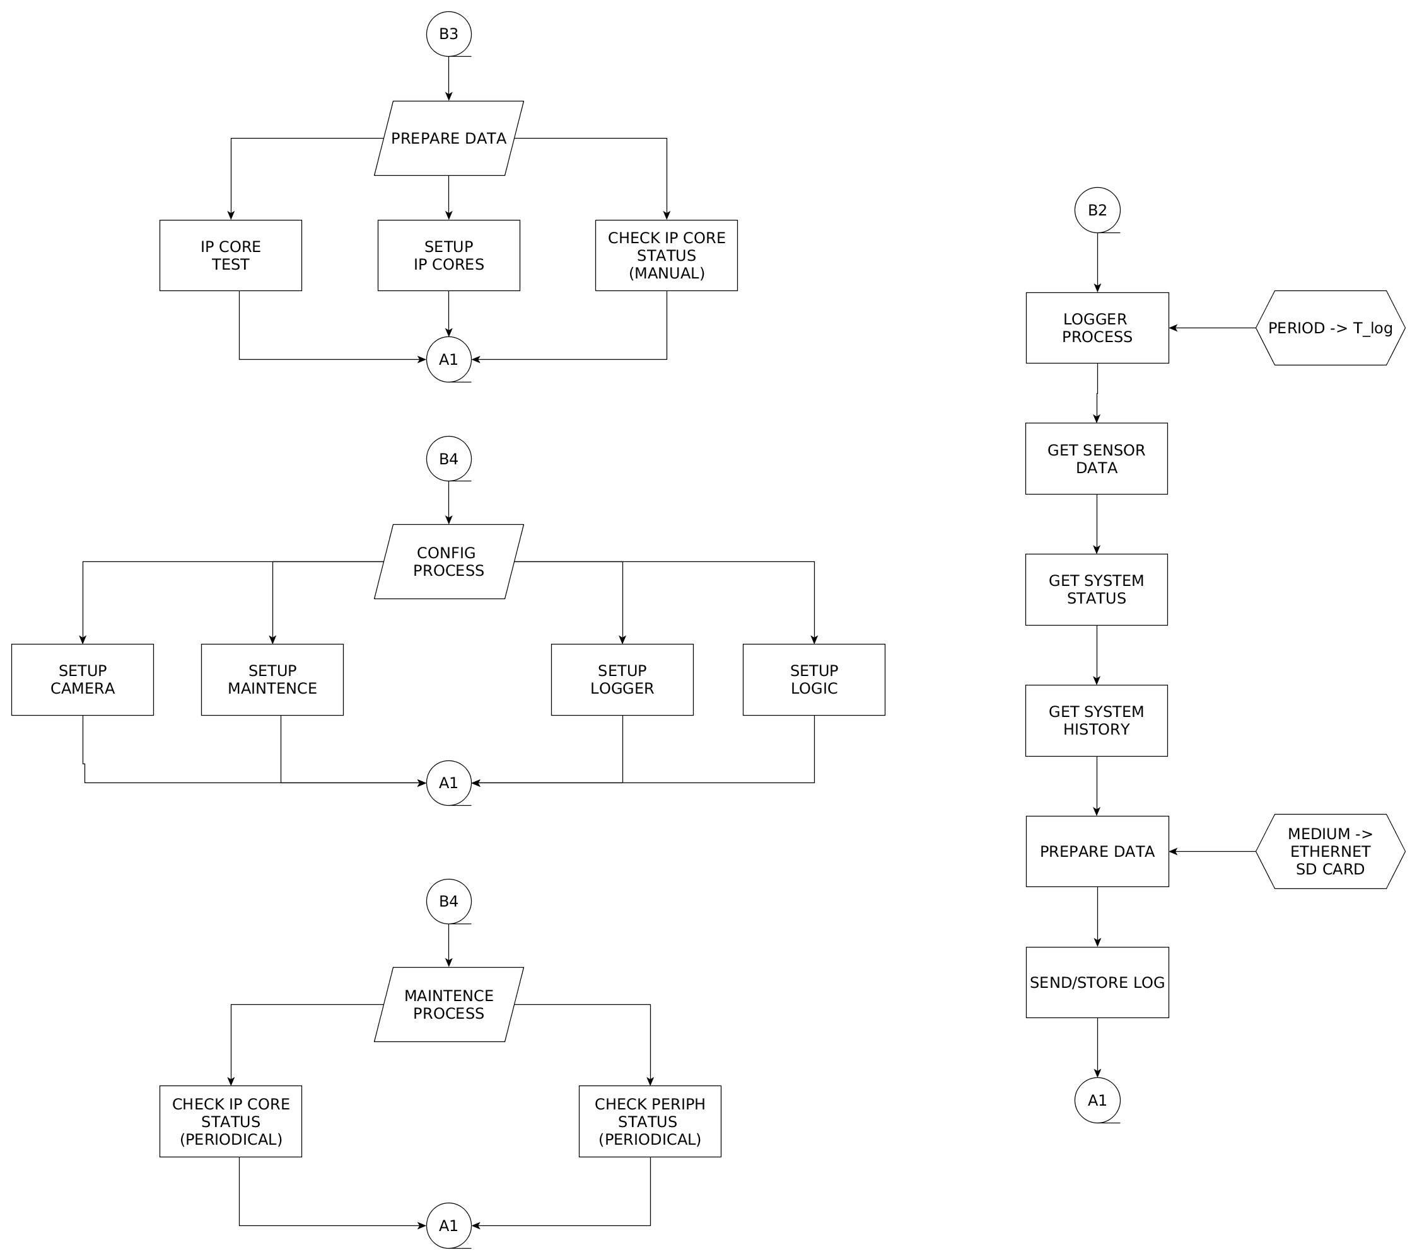

Figure 5‑56: Other processes running in background

The diagram below () presents different error handling processes.

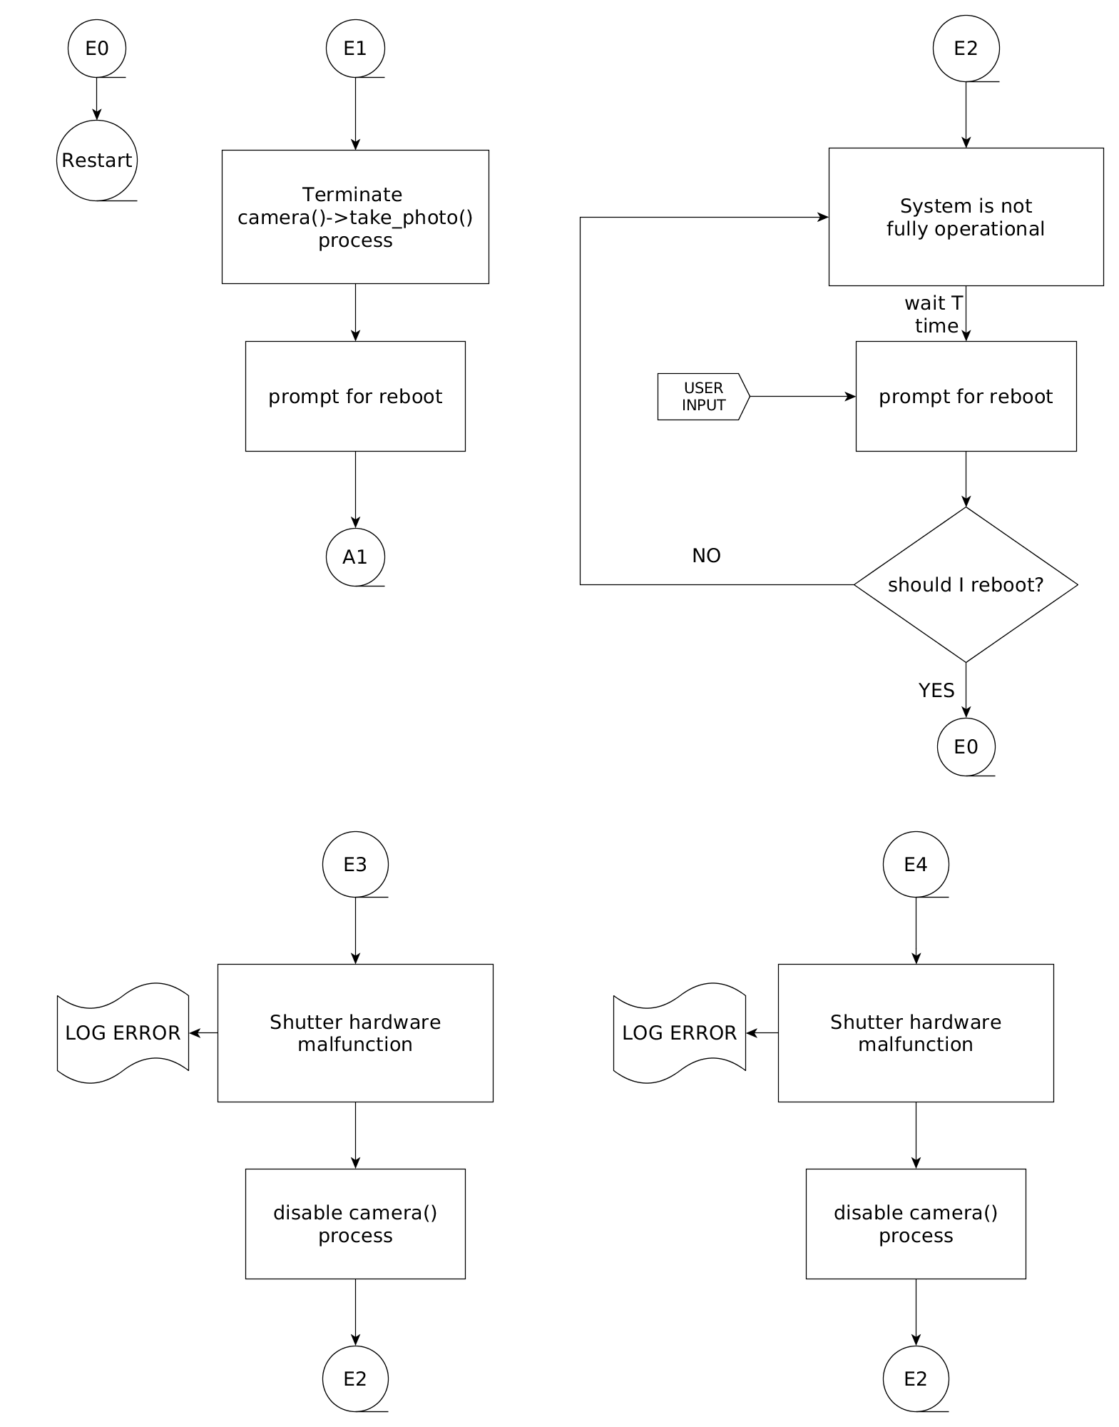

Figure 5‑57: Errors handling processes

#### TASKS ON FREERTOS



Figure 5‑58: RTOS tasks

The RTOS task controls the image acquisition (). The image acquisition is triggered by an external (e.g. via RS485) or internal trigger. In parallel task, the RTOS measures the temperature and adjusts the power of the cooling system. It is essential to consider that the power adjustment of the cooling system during readout depends on the number of lines being read. The cooling system control is done in such a way that it won't be run when data are being read, so that it won't add any additional noise to the acquired sensordata.

#### SOFTWARE

The System design is developed entirely using Xilinx tools:

* Vivado Design Suite – HDL development and simulation
* Xilinx SDK – C development for RTOS
* Petalinux – Linux development, kernel customisation etc.

#### CODING STANDARDS AND TESTING

HDL and C are being developed using internal standard. Each HDL IP core is tested with a test bench.

RTOS and Linux C programs are checked for compliance with the internal standard. In the future the code will be compliant with the MISRA C standard. The testing is done on all levels, each part of the system is tested separately and also subsystem and system integrity tests are performed.

#### MONITORING AND CONTROL SW INTERFACE AND EPICS COMPATIBILITY

The camera system can be used in multiple operation modes. In each mode a different capability is available for the user and for the operator. This is an essential feature which allows also for an easy maintenance of the system.

The following operation modes will be provided:

* DIAGNOSTIC MODE: In this mode an error has occurred previously somewhere in the system. This simple application is booted on the device that collects all data from of all sensors. All data as well as the failure log of the test mode are written onto a SD CARD for debug purposes.
* TEST MODE (during boot): Every time the system boots an internal test is performed. The test is performed via a uboot-script. This process runs with the assumption that no Ethernet-connection is available. If the test fails, the system boots into diagnostic mode.
* SERVICE MODE (on runtime with Linux): The Camera can be set into service mode at any time during runtime. This allows for service and maintenance of the camera. In this mode all processes at highest verbosity level, all operations are logged and specific functions are available for the operator.
* NORMAL MODE: In this mode, the camera system is seen as an EPICS controlled device which allows frame data acquisition.

### DIGITAL SYSTEM DESIGN

#### CCD IP CORE

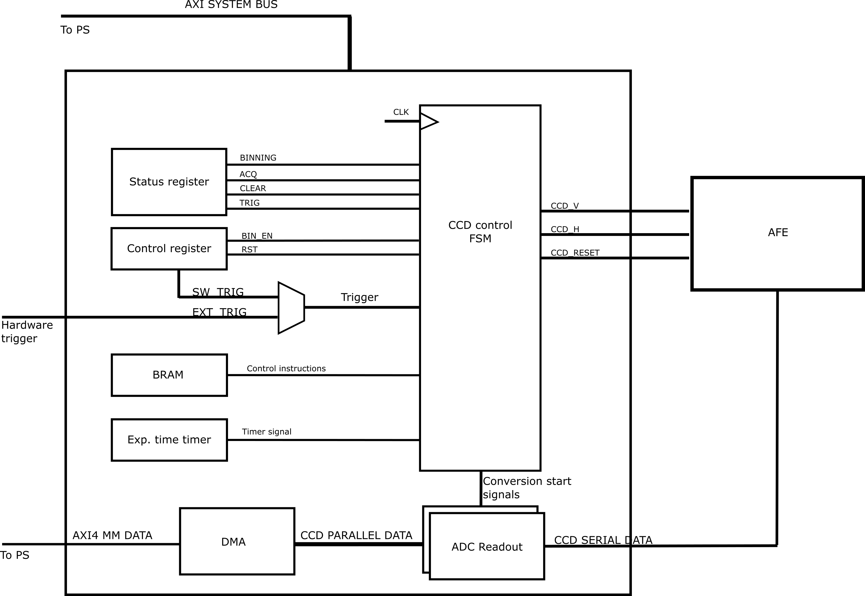

Figure 5‑59: CCD and AFE control state machine

presents the general IP core structure: input and output signals. The CCD FSM is configured to use several signals: BIN\_EN – chooses optional binning mode, RST – FSM reset, SW\_TRIG – software trigger, EXT\_TRIG – hardware trigger, Config register – settings of horizontal and vertical readout frequency, Exp. Time timer – counter that measures the exposition time.

CLK – FSM Clock - Status register reflects state of the FSM using several signals: BINNING – confirmation of binning mode, ACQ - FSM in data acquisition mode, CLEAR – FSM in sensor clearing mode, TRIG – trigger received. Core control registers, status registers and BRAM are programmed by PS using AXI Lite bus. ADC data after deserialization is transferred by DMA to PS RAM by AXI4 Memory Mapped bus.

##### ADC READOUT

To leverage the ZynQ SoC design philosophy, the ADC data acquisition module is based on existing Intellectual Property (IP) cores (provided by Xilinx) with a proper ZynQ design toolset (Vivado). Xilinx provides IP modules compatible with AXI bus specifications, designed to fulfill common tasks such as handling a DRAM memory transfers.

Camera DMA engine utilizes following Xilinx IP cores ():

* The AXI VDMA v 6.2 is a DMA controller especially to handle video data. It is programmable and supports various DMA schemes. The VDMA core is fully duplex – supports both read and write channels to the memory – in our specific case only write channels are used. VDMA transfers video data over the AXI Stream Bus (address-less data packets) and outputs data using AXI Memory Mapped Bus (data packets with addresses).
* The VidIn (Video In To) AXI 4.0 Stream v 3.0. 2 AXIS core provides the interface between clocked, parallel video data and the AXI Stream bus. Internally it is built around dual ported FIFO which acts as a bridge between two asynchronous clock domains – video data pixel clock and AXI Stream bus clock. FIFO acts also as a data buffer and its depth is programmable.
* AXI Interconnect v 2.1 acts as a bridge between AXI MM cores and hardware memory interconnect. It is capable of translating the AXI protocol version (IP cores use version 4, while interconnect hardware uses version 3) and the arbitration between connected AXI MM buses.

The ADC Interface outputs 4 groups of ADC data signals, each group with 4 ADCs sampling each of the 4 read channels from the CCD. This gives in total 16x16bits of data. Due to noise and ADC non-linearity, two LSBs of each ADC are discarded thus yielding in a total of 16x16bits of data. The data is split into four 64 bit groups and fed to the VidIn AXI Stream core along with generated synchronization signals: ACTIVE DATA and VSYNC. The Synchronization signals ensure that data from each CCD read channel are treated as video frame and are directed via DMA into the desired memory segment. Pixel values are read from the CCD and written to memory simultaneously via four channels, which causes the data to be out-of-order. To obtain the final picture, an additional software pixel reordering is required. The single raw data frame has a size of: 4096x4096x2x4x2 bytes i.e. 256MB.

##### ADC DATA POST-PROCESSING

To enable additional methods for the DSP noise removal to the already considered simple CDS, the registered CCD signal must be oversampled. Due to a relatively low maximum frame rate noise removing DSP routines have been implemented at first place within the software (PS). This approach provides access to all samples acquired by the FPGA and enables advanced image processing possibilities, by using e.g. Matlab.

The FPGA is equipped with two memory banks – the first bank, dedicated to image processing; the second bank to the operation system.

Oversampling is optional and can be disabled by software.



Figure 5‑60: Video data path

## OTHER PROJECT ASPECTS

### OVERALL BUDGET ANALYSIS (POWER, THERMAL, MECHANICAL, VIBRATION)

The camera consists of several blocks. A detailed power budget analysis was performed for each of the block to estimate the maximum dissipated power

The below presents the power consumption of the Communication Board. Similar estimations were performed for the Mainboard.

Since thermal simulations are in progress, it is too early to precisely estimate the power of the TEC module. Due to the fact that it is the most power-hungry component of the camera, a precise estimate of the total camera power consumption is not available at the moment.

Table 5‑7: Communication board maximum power estimation

|  |  |  |  |  |
| --- | --- | --- | --- | --- |
|  | Name | Voltage [V] | Current [A] | Power [W] |
| Programmable voltage | P1V2\_UFXC | 1.2 | 0.35 | 0.42 |
| Programmable voltage | P1V6\_UFXC | 1.6 | 0.2 | 0.32 |
| AFE LVDS buffers | P2V9\_UFXC | 2.9 | 0.3 | 0.87 |
| Logics, drivers | P5V0 | 5 | 0.65 | 3.25 |
| FPGA core | P1V0 | 1 | 3 | 3 |
| DDR memory | P1V5 | 1.5 | 0.7 | 1.05 |
| FPGA logics | P1V8 | 1.8 | 0.6 | 1.08 |
| FPGA logics | P3V3 | 3.3 | 1.2 | 3.96 |
| DDR3 termination | VTT\_DDR3 | 0.75 | 2.6 | 1.95 |
| DDR3 reference | VREF\_DDR3 | 0.75 | 0.1 | 0.075 |
| FPGA gigabit transceivers | P1V0\_MGTAVCC | 1 | 1 | 1 |
| FPGA gigabit transceivers | P1V2\_MGTAVTT | 1.2 | 0.35 | 0.42 |
| FPGA peripherals | P1V8\_MGTVCCAUX | 1.8 | 0.1 | 0.18 |
| FPGA peripherals | P2V0\_VCCAUX\_IO | 2 | 0.3 | 0.6 |
| ADC supply | P3V0 | 3.3 | 0.05 | 0.165 |
| AFE supply | P5V0\_LN | 5 | 0.01 | 0.05 |
|  |  |  |  |  |
|  |  |  | Total power [W]: | 18.39 |

### RELIABILITY, AVAILABILITY, MAINTAINABILITY, MTBF  ANALYSIS

The NEOSTEL camera reliability will be achieved in two main areas – mechanical and thermal ones. Mechanical components (like the shutter mechanism) are the most common cause of faults – e.g. due to mechanical wear by friction. Furthermore, electrical components exposed to too high temperature not only degrade much faster but also generate more bit errors. Both factors need to be minimized for a proper long-time camera operation.

On the mechanical side it is proposed a dedicated shutter mechanism that takes profits from previous experiences gathered during the development by Creotech of four camera families. The entire shutter mechanism is designed to limit friction - its targeted life-time spans beyond 10e6 cycles. Additional R&D will be performed to verify, if the refined design meets the NEOSTEL requirements.

Since the camera is modular, it can be easily maintained. Critical components can be kept as replacement parts.

### CE MARK ASPECTS

The NEOSTEL camera is designed to be CE mark compatible. It consists of enclosure and PCB boards. During mechanical, electrical and system designing, the following precautions have been considered:

* Enclosure
* Shielding
* Covers
* EMC gaskets
* Grounding
* Hardware and PCB Layout
* System functional allocation
* Separation of analog, digital and power parts
* PCB layout with separated ground and supply layers used as a shield
* Differential traces
* Micro-strips and strip-lines
* Input overvoltage and over current protection
* Opto-isolation
* Camera design
* Cable harnessing and shielding
* Shielded connectors
* EMC Gaskets between enclosure and electrical parts
* Filters
* High current outputs prone generating ripples are supplied with dedicated, high quality LC Pi filters.
* Power supplies for analogue and cross-domain circuitry such as ADC/DAC have LC Pi filters to ensure low power noise.
* Digital circuitry power leads are supplied with high quality decoupling capacitors.
* The analogue front-end for data acquisition and the SAR ADC are covered with a shielding cabinet that has an attenuation of 40-50dB for the considered frequency range. The cabinet is shown on the board visualization below.
* Analog PCB traces are routed differentially to ensure a high common mode rejection of RF noise.

# COMPLIANCE MATRIX

Origin: Specification NEOSTEL-SP-CGS-005.

*Table 6‑1: CCD and Camera General Requirements*

| **Req. ID** | **Requirement Description** | **Comp-**  **liant (Y/N)** | **Ver. Method** |
| --- | --- | --- | --- |
| NEO-CC-GR-0010 | The Supplier shall be responsible for performing the detailed design, supporting analyses and the manufacturing documentation for the camera in concordance with the requirements of this specification. | Y | I |
| NEO-CC-  GR-0020 | The detail design shall be documented with:   * Assembly, Interface and Manufacturing Drawings * Analysis Report (if requested) * Off the shelf part Technical Data sheet | Y | I |
| NEO-CC-  GR-0030 | All drawings shall be produced in electronic form. The 3D CAD-Model shall be delivered in STEP format (\*.stp). | Y | I |
| NEO-CC-  GR-0040 | Deliverable documentation and drawings shall be written in English. | Y | I |
| NEO-CC-  GR-0050 | Analysis, test and inspection reports shall be established and delivered to the Customer as part of data packages. All reports shall be provided in English. | Y | I |
| NEO-CC-  GR-0060 | The verification of design and workmanship of the camera shall be performed in accordance with the indicated verification methods:   * Design requirements (R, A) shall be verified before starting the manufacturing within an internal design review; * All other requirements shall be verified during/after the manufacturing and during the acceptance phase and recorded within a Compliant Matrix | Y | R |
| NEO-CC-  GR-0070 | One Preliminary review shall lead to the final approved design:   * Verification of design requirements * Release of interface and assembly drawings * Approval of analyses documentation | Y | R |
| NEO-CC-  GR-0080 | The Final Design review shall lead to the final acceptance:  fulfillment of all project and contractual requirements. | Y | R |
| NEO-CC-  GR-0090 | The design shall be compatible with the national regulations and laws of members of the European Union. | Y | R |
| NEO-CC-  GR-0100 | The unit system is the International System (S. I.) except for:   * Angles: Degrees (°) * Absolute Temperatures: Degrees Celsius (°C) * Accelerations: Multiples of Earth Gravity (g) * Air pressure: Bar (bar)   The above reported units are accepted together with their SI equivalent. | Y | R |
| NEO-CC-  GR-0110 | Any special tool, which is required for the camera set-up, operation and any other working adjustment, shall be included. | Y | R |

*Table 6‑2: CCD and Camera Functional Requirements*

|  |  |  |  |
| --- | --- | --- | --- |
| **Req. ID** | **Requirement Description** | **Comp-liant (Y/N)** | **Ver. Method** |
| NEO-CC-  FR-0010 | The camera shall be able to fulfill all requirements independent of its angular orientation. | Y | R/T |
| NEO-CC-  FR-0020 | Camera’s input, output, fluidic and power connections shall be grouped together in a single chain with necessary separators. | Y | R/I |
| NEO-CC-  FR-0030 | The camera shall connect with a flange to the secondary optics tube. | Y | R/I |
| NEO-CC-  FR-0040 | All cables and fluidic tubes that connect with the camera or with external devices shall have a minimum length of 25m (TBC). | Y | R/T |

*Table 6‑3: Camera Mechanical Requirements*

|  |  |  |  |
| --- | --- | --- | --- |
| **Req. ID** | **Requirement Description** | **Comp-liant (Y/N)** | **Ver. Method** |
| NEO-CAM-MR-0010 | *Camera Maximum Envelope: Ø254 x 235 mm (TBC) ()*  ***Camera Body****:*  *Outer Diameter: 200 mm*  *Height: 220 mm*  ***Camera External I/F Flange****:*  *Outer Diameter: 254 mm*  *Thickness: 12/15 mm*    Figure ‑: Camera External Interface Flange | Y | R/I/T |
| NEO-CAM-MR-0020 | The external I/F Flange shall be provided with dedicated slots that allow the fastening of the camera to the secondary mirror structure.  Also the slots allow a rotation of the camera around its axis to adjust the CCD orientation.  Wide Angle Slot: 40 deg  Slots Position Diameter: Ø225 mm  Width Slot: 7 mm | Y | R/I/T |
| NEO-CAM-MR-0030 | The Planarity Tolerance between the external I/F Flange Plane and the CCD Plane shall be ≤ 0,1 mm. | Y | T |
| NEO-CAM-MR-0040 | The distance between the CCD and the last lens in the optical tube is fixed.  Therefore the camera envelope and the space allocated for the shutter shall be related to this distance.  Key distance for the dimensioning ():  CCD Plane – Adapter Back-Plane: 77,90+-0.05 mm    Figure ‑: Camera ICD | Y | T |
| NEO-CAM-MR-0050 | The shutter shall be an external part w.r.t. the CAMERA Body and rigidly connected to it. | Y | R/I |
| NEO-CAM-MR-0060 | The shutter shall be fully disconnect-able from the Camera both mechanically and electrically, without the need for disassembling any part of the Camera. | Y | R/I |
| NEO-CAM-MR-0070 | The shutter support structure shall be fastened to the external plane of the Camera External I/F Flange ().  Shutter_IF_Plane_Img.png  Figure ‑: Shutter Available Volume and IF Area | Y | R/I |
| NEO-CAM-MR-0080 | Free space for the integration of the shutter shall be allocated inside the adapter flange that will be positioned between the camera and the secondary structure.  Shutter Area Main Dimensions ():  Diameter: Ø 200 / 328 mm  Height along optical axis: 30,25 mm    Figure ‑: Shutter Available Volume | N | T |
| NEO-CAM-MR-0090 | On the external IF flange there shall be a milling pocket in order to show the CCD PIN 1 orientation. | Y | R/I |
| NEO-CAM-MR-0100 | On the external IF flange a mechanical alignment (TBC) shall be provided at System level by the Responsible of the Secondary Optical Tube system. | Y | R/I |
| NEO-CAM-MR-0110 | SYSTEM REQUIREMENT: The external mechanical adjustment range shall be of at least +/- 1.0 mm from the nominal position with a +/-5 microns accuracy in tip-tilt adjustment in the x-y plane and with +/-10microns accuracy along the z-axis. The Camera Design shall be compatible with this requirement. | Y | R |

|  |  |  |  |
| --- | --- | --- | --- |
| **Req. ID** | **Requirement Description** | **Comp-liant (Y/N)** | **Ver. Method** |
| NEO-CAM-  MMR-0010 | The camera weight shall be less than 10 Kg. The target is 5-7 kg. | Y | R/T |
| NEO-CAM-  MMR-0020 | Camera structure material: Aluminum.  Stainless Steel shall be permitted with respect to the Requirement NEO-CAM-MMR-0010. | Y | R/I |

*Table 6‑4: Camera Mass and Material Requirements*

*Table 6‑5: CCD Design & Technical Requirements*

|  |  |  |  |  |
| --- | --- | --- | --- | --- |
| **Req.ID** | **Requirement Description** | **Comp-liant (Y/N)** | **Ver. Method** | **Comment** |
| NEO-CCD-DTR-0010 | Full Frame Transfer CCD. | Y | R/I |  |
| NEO-CCD-DTR-0020 | Back Illuminated CCD. | Y | R/I |  |
| NEO-CCD-DTR-0030 | The CCD size shall be of 4096x4096 pixels. | Y | R/I |  |
| NEO-CCD-DTR-0040 | The Pixel size shall be of 15x15 um. | Y | R/I |  |
| NEO-CCD-DTR-0050 | The Linearity shall stay within 1% in the range 100e- – 95% of saturation. | Y | R/T | 100e – 95% saturation |
| NEO-CCD-DTR-0060 | The Dark Current shall be less than 0.1e-/pix/s. | N | R/T | For E2V is max 2e-/pix/s at 248K (-25deg C), but since it doubles every 7 degrees, will comply at -50 deg  For STA is max 5e-/pix/hr at -110deg. At -50 it will increase 128-times, and will be 640e-/pix/hr which is 0.17 e-/s/pix. STA do not meet specification or need additional tests. |
| NEO-CCD-DTR-0070 | 100% fill factor. | Y | R/T |  |
| NEO-CCD-DTR-0080 | Full-well capacity-depth better than 150 ke-. | N | R/T | For E2V min. value is 120 ke-, typical 150ke-  For STA min value is 150ke-, typical 200ke- |
| NEO-CCD-DTR-0090 | The CCD shall be positioned inside a sealed chamber filled with noble gas. | Y | R/I/T |  |
| NEO-CCD-DTR-0100 | The sealed chamber shall have a Sapphire window with broad-band AR coating (<0.5% reflectivity over 450-770 nm wavelength), 5mm thick. | Y | R/I |  |
| NEO-CCD-DTR-0110 | The position of the CCD surface depends on the final window thickness. The dimensional and positioning accuracy shall be within +-0.05mm. | Y | R/T |  |
| NEO-CCD-DTR-0120 | Readout noise of 10e- RMS for a readout frequency of 2MHz. | Y | R/T | @2 MHz (margin @2 MHz) |
| NEO-CCD-DTR-0130 | Dynamic range: 20ke-/e-, 16 bit depth. | Y | R/T |  |
| NEO-CCD-DTR-0140 | The readout time shall be less than 2.5 s. | Y | R/T | 4 channels |
| NEO-CCD-DTR-0150 | One to four selectable readout channels shall be available. | Y | R/T |  |
| NEO-CCD-DTR-0160 | Quantum Efficiency >95% peak, >75% mean over 450-770nm spectral window.(Note: filter is placed outside the CCD camera in the current implementation) | Y | R/T |  |
| NEO-CCD-DTR-0170 | Multi-Phase Pinning shall be selectable by the user. | Y | R/T |  |
| NEO-CCD-DTR-0180 | CCD operative temperatures down to -50°C shall be achievable by means of a Thermo Electric Cooling system (Peltier) | Y | R/T |  |
| NEO-CCD-DTR-0190 | The readout frequency shall be selectable among 0.5, 1, and 2MHz. | Y | R/T |  |
| NEO-CCD-DTR-0200 | The CCD charge transfer efficiency shall be better than 99.9995%. | Y | R/I |  |

*Table 6‑6: Shutter Design & Technical Requirements*

|  |  |  |  |  |
| --- | --- | --- | --- | --- |
| **Req.ID** | **Requirement Description** | **Comp-liant (Y/N/?)** | **Ver. Method** | **Comment** |
| NEO-SHU-DTR-0010 | The shutter shall have a mechanical lifetime of more than 106 cycles. | Y | R/T | Not fully verified |
| NEO-SHU-DTR-0020 | The shutter shall have a synchronization-accuracy better than 100 us (a time offset of a few ms is acceptable for NEO applications). | Y | R/T |  |
| NEO-SHU-DTR-0030 | The shutter synchronization shall be compatible to both PTP (Precision Time Protocol) and NTP (Network Time Protocol). | Y | R/T |  |
| NEO-SHU-DTR-0040 | The shutter non-uniformity (jitter) shall be below 500us for NEO application. | Y | R/T |  |
| NEO-SHU-DTR-0050 | The shutter timing shall be controlled either internally or externally (OPTOCOUPLER I/F or equivalent). | Y | R/T |  |
| NEO-SHU-DTR-0060 | The Trigger mode shall be user controllable, both at hardware and software level (see NEO-CAM-DR-0130). | Y | R/T |  |
| NEO-SHU-DTR-0070 | The shutter design shall avoid stray-light and vignetting on the Focal Plane (FP), coinciding with the CCD Plane. (To avoid vignetting it is expected a shutter window of 80x80mm in the current implementation) | Y | R/I/T |  |
| NEO-SHU-DTR-0080 | The shutter shall not introduce any vibration during operation. | Y | R/I/T | No vibration parameter defined;  Current construction of Shutter will not generate vibration which disturb image acquisition.  The shutter is designed to minimize vibrations during operation thanks to fully symmetrical construction. |

*Table 6‑7: Camera Design Requirements*

| **Req. ID** | **Requirement Description** | **Comp-liant (Y/N)** | **Ver. Method** | **Comment** |
| --- | --- | --- | --- | --- |
| NEO-CAM-DR-0010 | The Overall camera architecture shall consist of identical camera elements. | Y | R/I |  |
| NEO-CAM-DR-0020 | The camera design shall be compatible with different CCD providers. | Y | R/I | Two CCD providers |
| NEO-CAM-DR-0030 | The camera shall be operational at ambient temperatures between -20°C and +30°C. | Y | R/T |  |
| NEO-CAM-DR-0040 | The Camera shall be operational within an altitude range from 0 to 4000m over sea level. | Y | R |  |
| NEO-CAM-DR-0050 | The Camera diameter shall be less than 200mm (TBC). | Y | R/T |  |
| NEO-CAM-DR-0060 | The Flange interface diameter shall be equal to 250mm (TBC). | Y | R/T |  |
| NEO-CAM-DR-0070 | The Power-supply line to the camera-head shall be separated from the TEC power-supply line. | Y | R/T | Additional dedicated connector pins |
| NEO-CAM-DR-0080 | The Camera shall have an external Power Supply unit. | Y | R/T |  |
| NEO-CAM-DR-0090 | Communication interface: Gigabit Ethernet over optical fiber (TBC). | Y | R/T |  |
| NEO-CAM-DR-0100 | The Operating system shall be Linux or an Equivalent Multiprocessing Operating System with high reliability and the capability to manage soft real-time in particular for the control of time and trigger clocks. | Y | R/T |  |
| NEO-CAM-DR-0110 | Camera diagnostics shall provide at least Temperature (operational), TEC current, CCD voltage, exposure time, pressure, camera state (idle, readout, etc.). | Y | R/T |  |
| NEO-CAM-DR-0120 | The camera shall have an internal real time clock with microseconds resolution and being compatible with both PTP and NTP synchronization protocols. | Y | R/T |  |
| NEO-CAM-DR-0130 | A two-line external signal shall be provided to the camera:   * Trigger signal * Gate signal | Y | R/T | 4 line external interface |
| NEO-CAM-DR-0140 | The firmware of the Camera shall be upgradeable via Ethernet. | Y | R/T |  |
| NEO-CAM-DR-0150 | The acquired image shall be stored in FITS file format. At least the following information will be included in the FITS header:   * RA and Dec Coordinates * Shutter open UTC timestamp * Shutter close UTC timestamp * CCD temperature * Readout parameters   Any other Field as foreseen by the standard FITS format (see FITS\_standard30aa.pdf - 2010) | Y | R/T | FITS 3.0  (according FITS Working Group 18.11.2010)  No limitations for file length.  64bits representation. |
| NEO-CAM-DR-0160 | The CCD control logic shall be programmable to be compatible with different sensors and different operation modes (NEO-CCD-DTR-0180). | Y | R/T |  |

*Table 6‑8: Chiller Requirements*

| **Req. ID** | **Requirement Description** | **Comp-liant (Y/N)** | **Ver. Method** | **Comment** |
| --- | --- | --- | --- | --- |
| NEO-CAM-CHI-0010 | The cooling capacity of the chiller shall guarantee the proper functioning of the TEC system inside the camera within a zero to 12m height-gap from chiller position. | Y | R/T |  |
| NEO-CAM- CHI-0020 | The chiller shall avoid tank overflow in all operating/non-operating conditions. | Y | R/T |  |
| NEO-CAM-CHI-0030 | The chiller shall possess the following alarms/interlocks:   * Tank Level Low * RTD Fail/Open * Fan Fail * Pump Fails | N | R/T | There is alarm of faulty work |
| NEO-CAM-CHI-0040 | The Temperature of the coolant shall be settable such that water condensation on the external side of the fluidic lines is avoided. | Y | R/T |  |
| NEO-CAM-CHI-0050 | The design of the chiller unit shall provide proper heat dissipation for up to four cameras simultaneously. (a possible implementation could be based on a single fluidic line (up and down) splited in four sub-camera groups) | N | R/T | One chiller can supply fluid only to two cameras simultaneous-ly |
| NEO-CAM-CHI-0060 | The chiller shall be rack mountable (TBC). | Y | R/T |  |
| NEO-CAM- CHI-0070 | The Difference between the set point and the actual coolant temperature shall be within +/- 2°C | Y | R/T |  |
| NEO-CAM- CHI-0080 | The chiller shall work in a low vibration / low noise mode. | Y | R/T |  |
| NEO-CAM- CHI-0090 | Fluidic in/out lines shall have a minimum length of 20m. | Y | R/I |  |
| NEO-CAM- CHI-0100 | The protrusion of the fluidic in/out lines at the side part of the camera shall not exceed more than 5cm the back-plate of the camera. | Y | R/I |  |

*Table 6‑9: Software Requirements*

|  |  |  |  |
| --- | --- | --- | --- |
| **Req. ID** | **Requirement Description** | **Comp-liant (Y/N)** | **Ver. Method** |
| NEO-CAM-SWR-0010 | The standard for the SW design shall be the tailoring TT4 to ECSS-E-ST-40C, included in the document QMS-EIMO-UID-CKL-9500-OPS - iss1.0 July 2009.  A further tailoring of level TT4 can be agreed with the Prime. | Y | R/I |
| NEO-CAM-SWR-0020 | The Code testing standard shall be based on MISRA C/C++ guidelines (TBC). | Y | R/I |
| NEO-CAM-SWR-0030 | The SW design shall be in agreement with the PA plan provided by the Prime. | Y | R/I |
| NEO-CAM-SWR-0040 | Concerning camera M&C SW task, the system shall support EPICS protocol. | Y | R/T |
| NEO-CAM-SWR-0050 | Each Camera shall have a separate camera controller connected via LAN, ETHERNET/ TCP-IP and UDP. | Y | R/T |
| NEO-CAM-SWR-0060 | BITE (Built In Test Environment) at the boot and bad parameter reporting to the monitoring system shall be used as failsafe algorithms for the system to prevent errors or other critical events. | Y | R |

*Table 6‑10: Reliability and Maintenance Requirements*

|  |  |  |  |
| --- | --- | --- | --- |
| **Req.ID** | **Requirement Description** | **Comp-liant (Y/N)** | **Ver. Method** |
| NEO-CAM-MR-0010 | Availability: MTBF 8000h minimum, preferred 12000h. | Y | R/A |
| NEO-CAM-MR-0020 | The identified HW-Solution Chip-Set shall be available on the market at least for 5 years with the possibility to extend the period to 10 years by introducing a spare policy . | Y | R/A |

*Table 6‑11:* Safety and Human Engineering Requirements

|  |  |  |  |
| --- | --- | --- | --- |
| **Req.ID** | **Requirement Description** | **Compliant (Y/N)** | **Ver. Method** |
| NEO-CAM-SAF-0010 | CCDs, Camera systems, all related tools, and external units shall satisfy CE safety mark parameters. | Y | R/I/T |